Hox Genes: are a subset of homeobox genes
“General purpose” control genes are important elements in building complicated organisms like flies. Some “control” genes are common to many organisms (they are homologous—inherited from our common ancestor). For example, Hox genes help lay out the basic body forms of many animals, including humans, flies, and worms. They set up the head-to-tail organization. You can think of them as directing instructions as an embryo develops: “Put the head here! Legs go over there!”
They are general purpose in the sense that they are similar in many organisms; it doesn’t matter if it’s a mouse’s head or a fly’s head that is being built, the same gene directs the process. Small changes in such powerful regulatory genes, or changes in the genes turned on by them, could represent a major source of evolutionary change.
Homeobox gene: A gene containing a short DNA sequence of about 180 base pairs referred to as a homeobox. Homeobox genes encode proteins that bind and regulate the expression of DNA in multicellular organisms.
Homeoboxes are present in the genomes of many organisms from fruit flies to humans, and they appear to determine when particular groups of genes are expressed during embryonic development.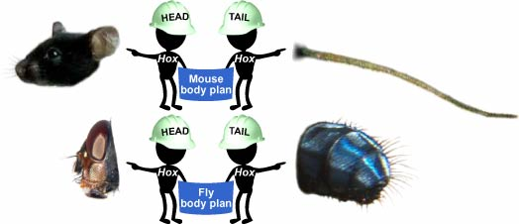
http://ehttp://evolution.berkeley.edu

Hox genes: Hox genes are a subgroup of homeobox genes. In vertebrates these genes are found in gene clusters on the chromosomes. In mammals four such clusters exist, called Hox clusters. The gene name "Hox" has been restricted to name Hox cluster genes in vertebrates. Only genes in the HOX cluster should be named Hox genes. So note: homeobox genes are NOT Hox genes, Hox genes are a subset of homeobox genes.

