UNIT 5 APES NOTES CHPTS CHPT 6 , 12, 14, 21
VIDEOS : Blue gold, last catch : Strange days vol 3aquaculture Dangerous catch
Strange day underground rivers
Tedtalks. Brian Skerry Oceans glory and horror
LAWS : CWA 72, NEPA 1969, SDWA 1974
NEPA(National Environmental Policy Act) : 1969 (requires EIS)The purpose: To declare a national policy which will encourage efforts which will prevent or eliminate damage to the environment and biosphere and stimulate the health and welfare of man; to enrich the understanding of the ecological systems and natural resources important to the Nation. It Requires an EIS (Environmental impact statement): all government agencies must file an EIS for new buildings. How will the environment be impacted

75% of the earths surface is covered with water
3% of the water on the planet is fresh water
.02% is available to drink

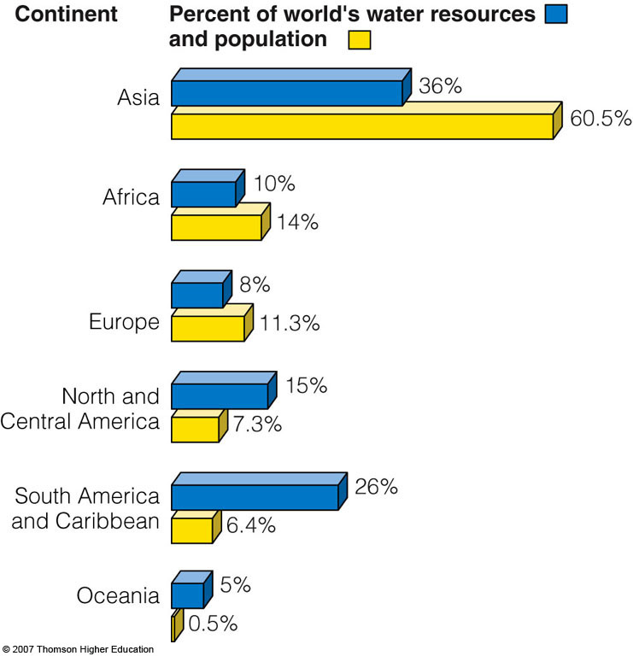
- Irrigation is the biggest user of water (70%), followed by industries (20%) and cities and residences (10%).
The Largest Dam in the world is the Three gorges Dam in China
on the Yangtze river . (largest electricity producer in the world:
606ft high(height of the spaceneedle, 6500ft wide ( more than a mile.
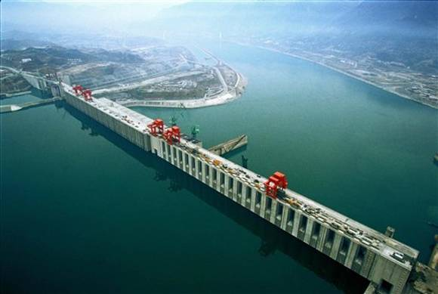
Three Gorges Dam China from other side

(usa law) CWA: Clean water act of 1972
- Primary federal law governing water pollution
- Introduced a permit system for regulating point sources of pollution. Point sources such as…
  - Industrial discharge
  - Municipal waste ( government)
  - Some agricultural (feed lots)
Technology based standards were set.

Also WQA 1987 ( water quality act)
75% of the earth is covered by water.

Coral Reefs : why should we care about coral reefs
Read and Know pg 126 in the book
(great barrier reef coast of Australia and New Guinea )

-Help moderate atmospheric temperature by removing CO₂ from the atmosphere.
-Act as natural barriers that help protect 14% of the world’s coastlines from erosion by battering waves and storms.
-Provide habitats for a variety of marine organisms.
Coral Reef Bleaching:

KEY QUESTIONS
- What are the basic types of aquatic life zones and what factors
influence the kinds of life they contain?

- What are the major types of saltwater life zones, and how do
human activities affect them?

- What are the major types of freshwater life zones, and how do human activities affect them?

NOTE: Saltwater and freshwater aquatic life zones cover almost
three-fourths of the earth’s surface

Organisms in Aquatic environs:
Plankton: Free floating organisms ( limited motility)
- Phytoplankton: photosynthesizing plankton
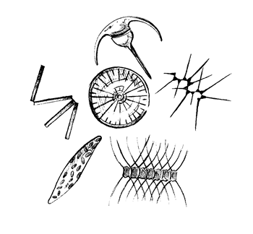 Producers:

- Zooplankton: (primary consumers)
Heterotrophs: feed on phytoplankton
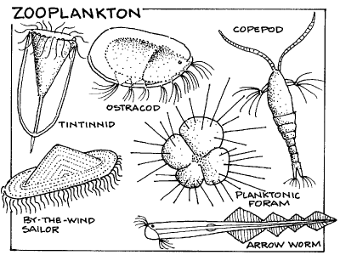
Nekton: swimming consumers: ( fish , turtles, whales)
Benthos: (means bottom) barnacles, oysters, crabs etc.
Decomposers: (mostly bacteria)

ECOLOGICAL VS ECONOMIC SERVICES OF MARINE ECOSYSTEMS
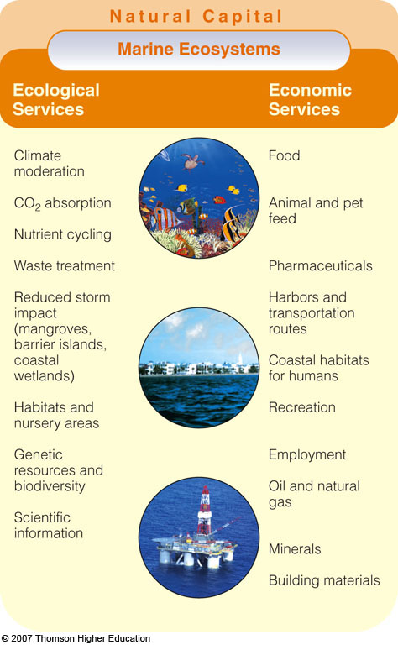

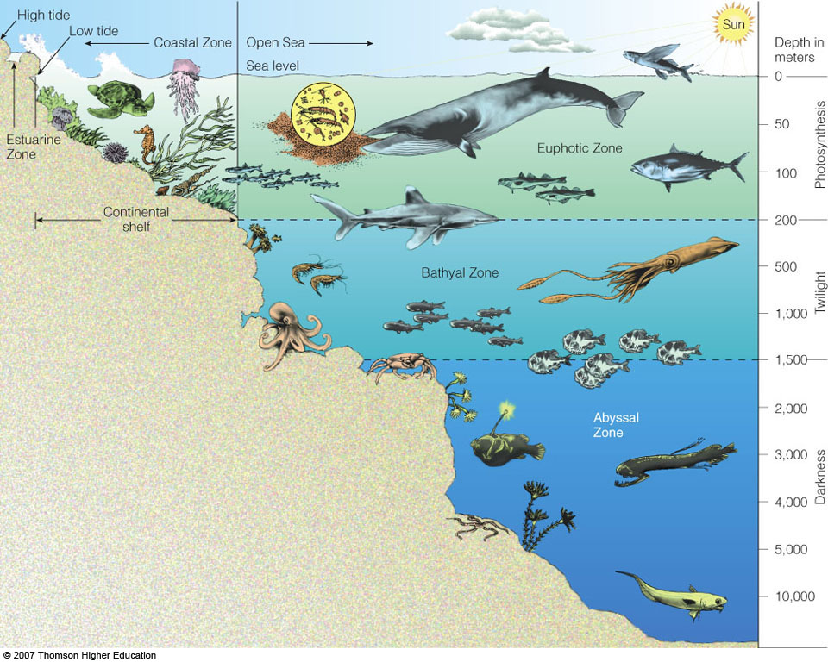

Mangrove forests : Tropical (coastal) filter toxic pollutants, excess plant nutrients, sediments and other pollutants. Food , habitat and nursery sites for aquatic species 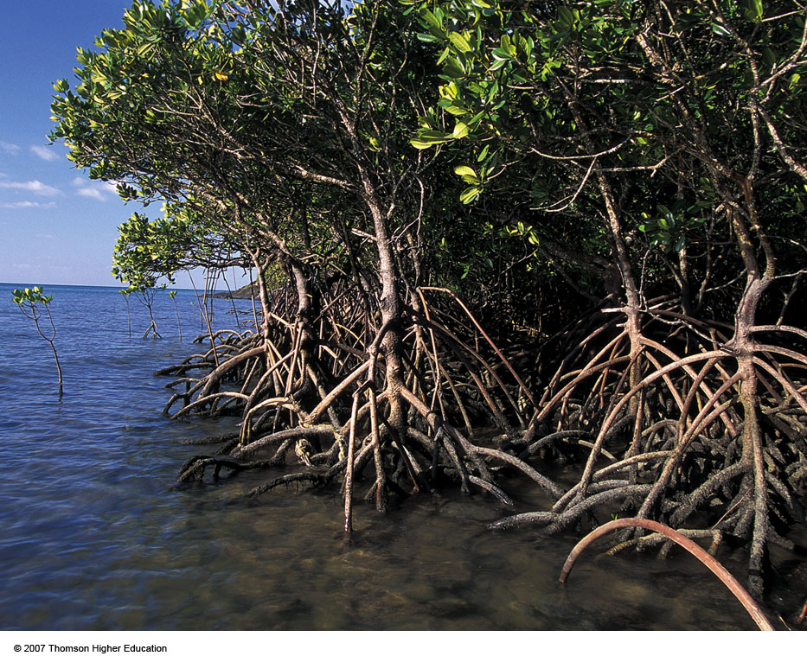

Coastal zone:
Makes up only 10% of ocean zones but contains 90% of all
marine species.
Estuaries and coastal wetlands:
Highly productive ecosystems
Estuary is an area where a river meets the sea. Seawater mixes with freshwater. (in danger from pollutants from streams( sewage, Nitrates etc)
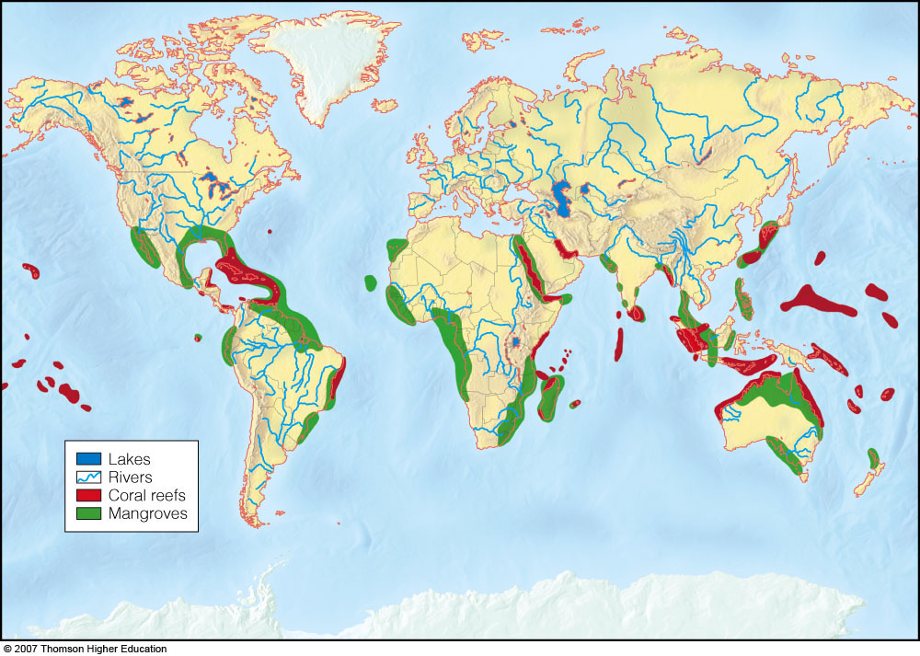
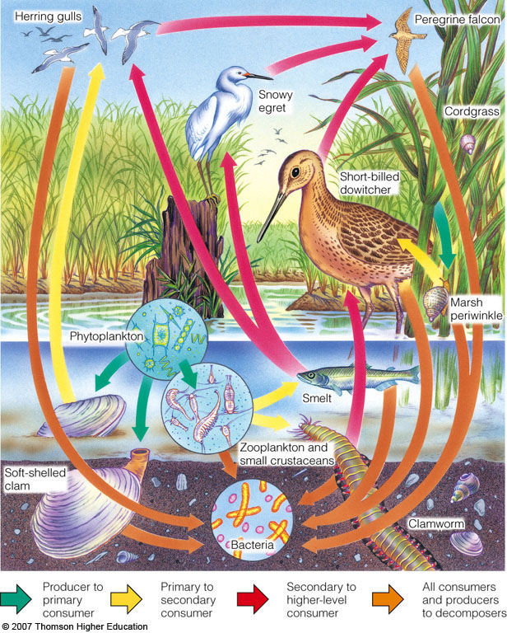
-Estuaries include river mouths, inlets, bays, sounds, salt marshes in temperate zones and mangrove forests in tropical zones.

READING ASSIGNMENT : GULF HYPOXIA ( HYPOXIC ZONE)
Euphotic zones
Bathyal zones
Abyssal zones

Wetlands :
The term "wetlands" encompasses a wide variety of aquatic habitats. Swamps, marshes, bogs, prairie potholes, flood plains, and fen - these are all names for ecosystems known as wetlands.

The Role of Wetlands :
- Prevent flooding
- Filter and purify water
Loss of Wetlands throughout the USA has increased flooding and led to increased pollutants entering rivers from anthropogenic sources ( ie. Oil from cars)
Ground water vs Surface water:
  - Ground water: Water stored in soil , and gravel. Below the earths surface. (The drinking water for about half of the U.S. population and 95% of those in rural areas comes from groundwater.)
Aquifers: underground caverns and porus layers of sand ,
gravel, or bedrock through which groundwater flows.
Surface water: water that does not sink into the ground or
evaporate into the air. (lakes, wetlands)
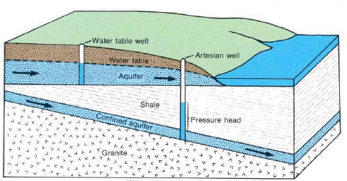
Aquifers have a critical recharge area where water moves through permeable soils and ground to recharge the freshwater supply. Development reduces the recharge area by laying down impermeable materials such as parking lots and buildings. (critical recharge area is reduced)
SDWA 1974
WATER POLLUTION :
- Water pollution is any chemical, biological, or physical change in water quality that has a harmful effect on living organisms or makes water unsuitable for desired uses.
  - Point source: specific location (drain pipes, ditches, sewer lines).
  - Nonpoint source: cannot be traced to a single site of discharge (atmospheric deposition, agricultural / industrial / residential runoff)
Can occur from …
- Chemicals ( toxins)
- Biologicals (bacteria , viruses , parasitic worms,
Giardia, ecoli)
- Physical : excess heat,
Biological
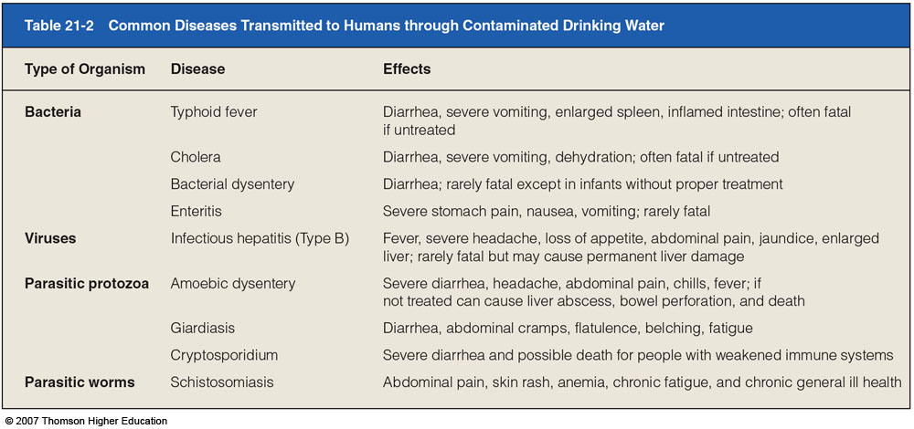
Chemical
By 2003, the EPA had completed the cleanup of 297,000 of 436,000 underground tanks leaking gasoline, diesel fuel, home heating oil, or toxic solvents.

- Eutrophication: the natural nutrient enrichment of a shallow lake, estuary or slow moving stream, mostly from runoff of plant nutrients from the surrounding land.
- Cultural eutrophication: human activities accelerate the input of plant nutrients (mostly nitrate- and phosphate-containing effluents) to a lake.
  - 85% of large lakes near major population centers in the U.S. have some degree of cultural eutrophication.
- Harmful algal blooms (HAB) are caused by explosive growth of harmful algae from sewage and agricultural runoff. ( NO₃⁻ nitrates, PO₄⁻ phosphates supply nutrients for the HAB)

Eutrophication: steps
- Nutrient enrichment of water
- HAB harmful algal bloom
- Superoxygenation of top water sun is blocked from SAV’s ( submerged Aq. Veg. aka benthic plants)
- Bottom plants die. Algae overshoots carrying capacity and dies
- Decomposing bacteria use up all O₂ breaking down algae and plants
- Hypoxia , death, destruction , sadness

- Water quality and dissolved oxygen (DO) content in parts per million (ppm) at 20°C.
  - Only a few fish species can survive in water less than 4ppm at 20°C.

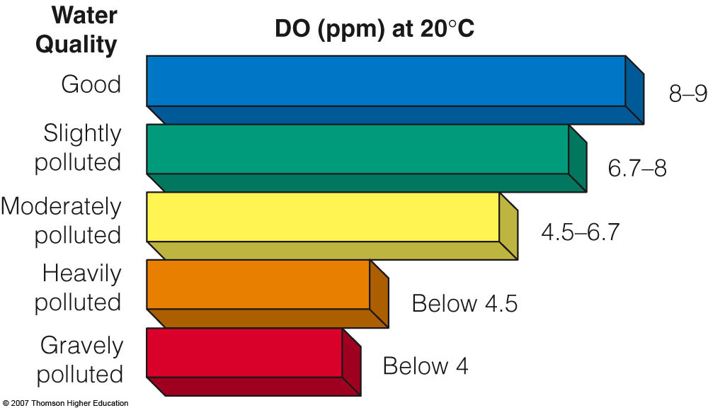

Ocean pollution: Pg 505 know Fig 21-10
- Industry
- Cities
- Hypoxic zones
- Red-tides dino-flagellate bloom( nitrate caused)
- Urban sprawl (sewers , septics)
- Farms
- Toxic chemicals (sediments)

Commercial Fishing techniques: each country has 200miles offshore that are considered sovereign fishing rights
(more than 25% of fish caught in nets are dumped)
- Long line fishing: long line with hooks many miles long
  - Sometimes catches turtles and unwanted fish
- Gill netting: (drift net) huge drifting net catches fish in the net by the gills.
- Trawling: catches shellfish ,shrimp : drag a funnel shaped net along the bottom . ( destroys bottom habitats)
- Purse seine fishing : catches surface fish such as tuna , mackerel, anchovies . ( catches dolphins)
- Bycatch: (unwanted fish caught )
  - Ways to alleviate problem somewhat
    - use of wide meshed nets to allow escape of smaller fish,
    - use net escape devices for birds, and turtles
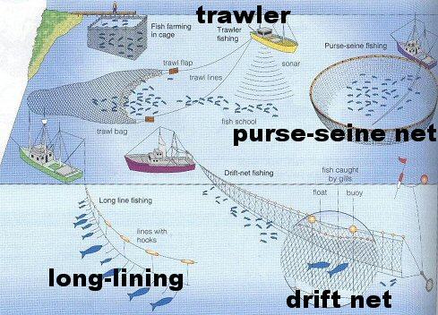
Whaling :
commercial whaling has been banned since 1970 but at least two countries continue to whale. Japan, Norway, Iceland still whale under the guise of scientific research (1300whales/yr)

Whale harvesting in international waters: (Tragedy of the Commons) from 1925-1975 1.5million whales were harvested

Only 3% of the earth’s water is fresh and much of that is not drinkable. Only .02% is available for us to drink

Increasing water supplies by wasting less water
- Irrigation is the biggest user of water (70%), followed by industries (20%) and cities and residences (10%).
- Most aquifers are renewable resources unless water is removed faster than it is replenished or if they are contaminated.
- Groundwater depletion is a growing problem mostly from irrigation. ( sinkholes are the result in some cases)
  - At least one-fourth of the farms in India are being irrigated from over-pumped aquifers.

Irrigation techniques
About 60% of all irrigation water applied worldwide does not reach the targeted crops
- Flood irrigation (least efficient)
- Gravity flow ( 60-80% efficiency)( flood irrigation)
- Drip irrigation (90-95% efficiency) Most efficient
- Center pivot ( 80% - 95% )

Gravity flow Drip Center pivot
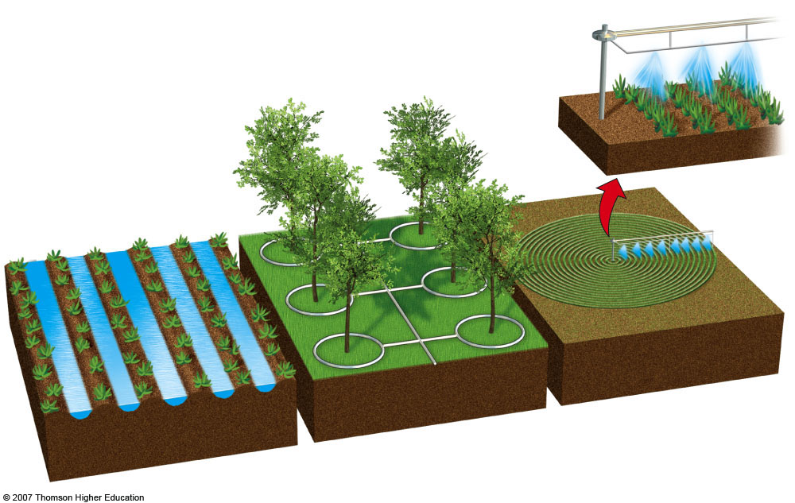

- Diverting water from the Aral Sea and its two feeder rivers mostly for irrigation has created a major ecological, economic, and health disaster.
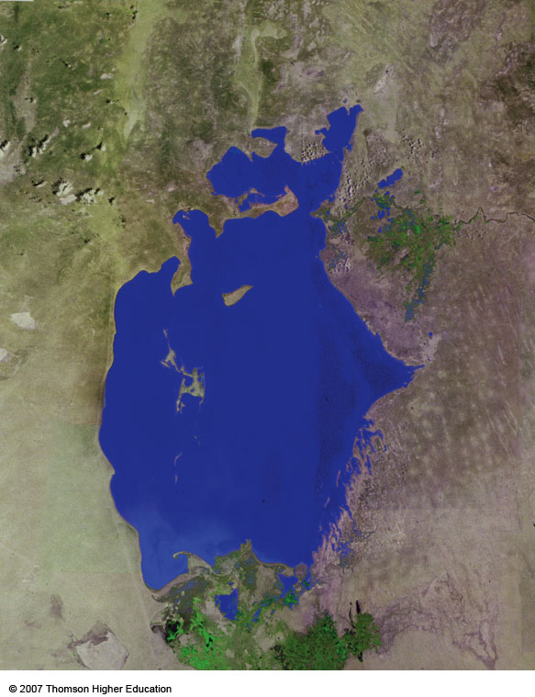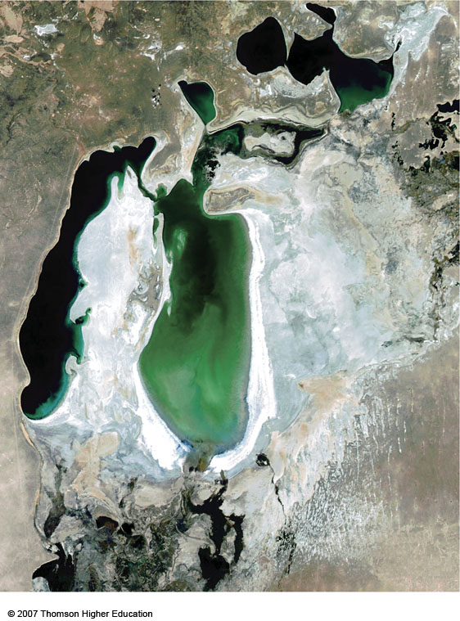
1976 2004
About 85% of the wetlands have been eliminated and roughly 50% of the local bird and mammal species have disappeared.
Since 1961, the sea’s salinity has tripled and the water has dropped by 22 meters most likely causing 20 of the 24 native fish species to go extinct.

Solutions to fresh water shortage?
- Desalination plants ( middle east = 10,000plants)
  - Leads to big piles of salt
- Seeding clouds (KI , and dry ice) ( disputes over cloud ownership) doesn’t work if you don’t have clouds
- Iceberg towing
- Giant baggies of fresh water
The last three are not very cost effective or energy effective

Solution is to use less fresh water
(personal water usage sheet)

We can reduce water use and waste by raising the price of water while providing low lifeline rates for the poor.
When Boulder, Colorado introduced water meters, water use per person dropped by 40%.
A 10% increase in water prices cuts domestic water use by
3-7%.

Too Much water: flooding
Caused by?
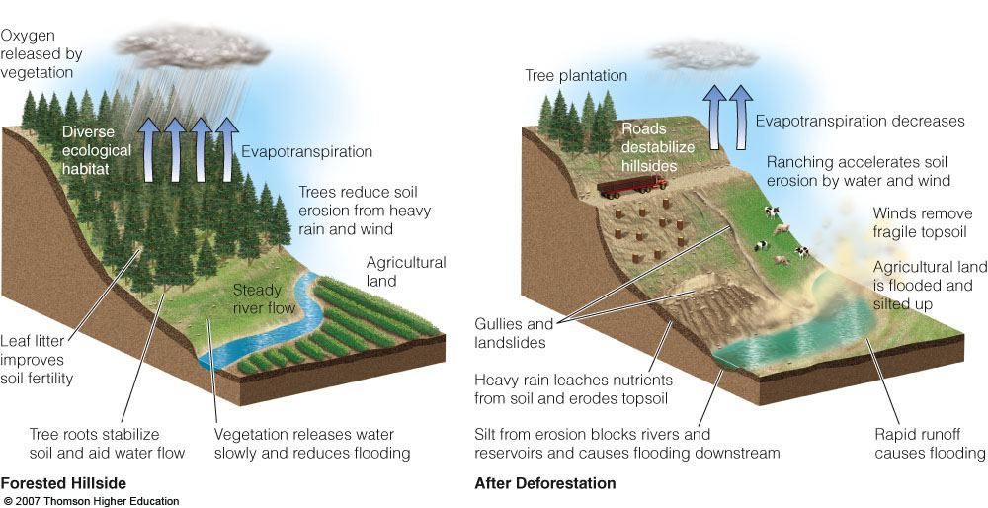

- Removing wetlands
- Clear cutting and taking out other vegetation
- Putting in non-porous surfaces ( urban sprawl)

What Can We Do?
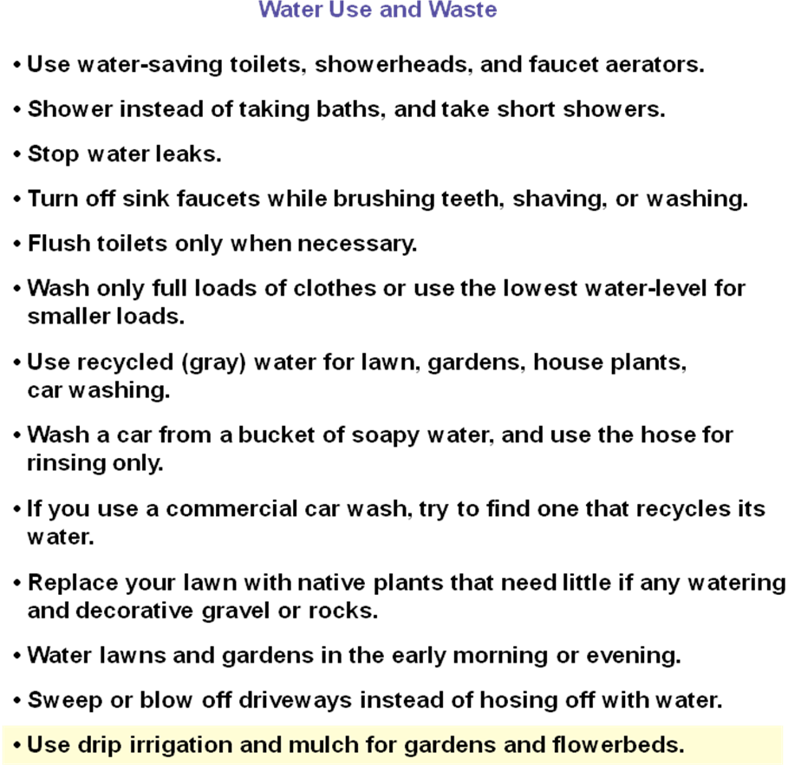

COASTAL WATER POLLUTION
Read Pg 506 Case Study : The chesapeake bay estuary
Once abundant with oysters, crabs and fish have been wiped out due to high levels of nitrates, phosphates, released mainly from sewage, that cause HABs which can lead to hypoxic areas .
Point sources-(sewage treatment and industrial) and
nonpoint sources of pollution (fertilizers animal wastes)
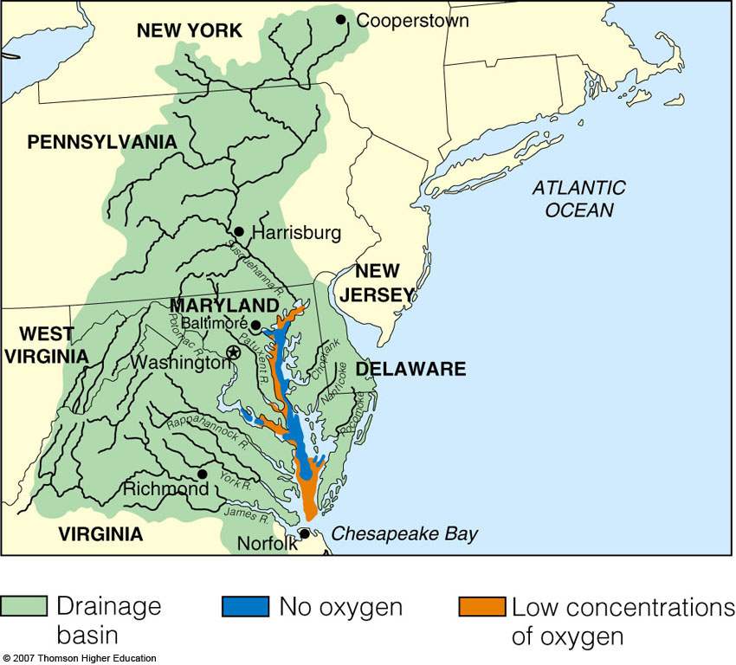
The greatest amount of oil put into the ocean is from urban
runoff and industrial runoff . (not from oil spills)

SOLUTIONS
Prevention Cleanup
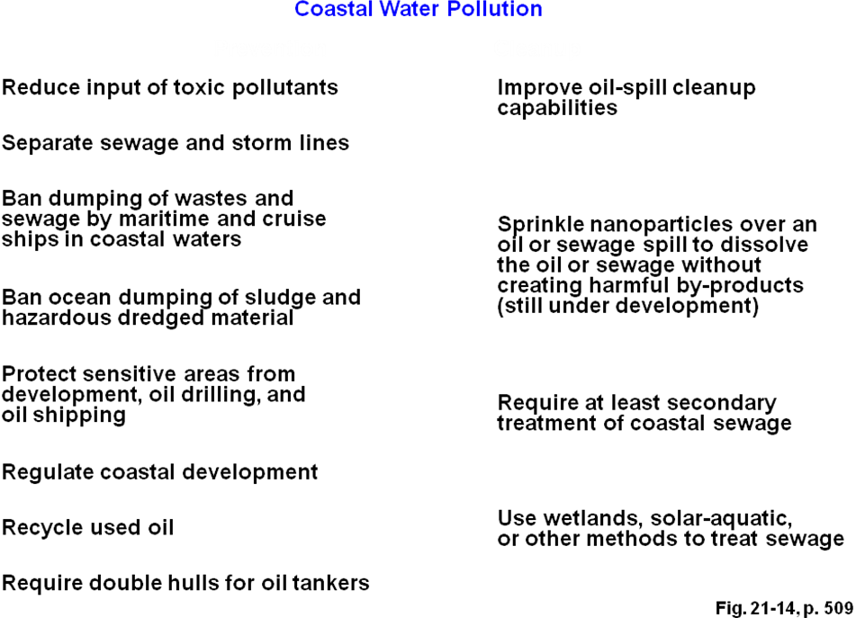

Farmers and builders can help with runoff by
- Building buffer zones between development and bodies of water
- Building feedlots and water troughs away from water supply
  - The U.S. Clean Water Act sets standards for allowed levels of key water pollutants and requires polluters to get permits.
EPA is experimenting with a discharge trading policy similar to that for air pollution control.
SDWA The U.S Safe Drinking Water Act requires the EPA to establish national drinking water standards (maximum contaminant levels) for any pollutant that may have adverse effects on human health.

CWA 1977 Main law that limits pollutants dumped into water

REDUCING WATER POLLUTION THROUGH SEWAGE TREATMENT.
- Septic Tanks
- Sewage Treatment plants
Individual houses have septic tanks
Large community have sewage treatment plants
SEPTIC TANKS
PARTS
- Settling tank: solids fall , grease and oil rise
- Drainage field : water discharged and the plants filter
potential pollutants. Soil bacteria decompose organics.
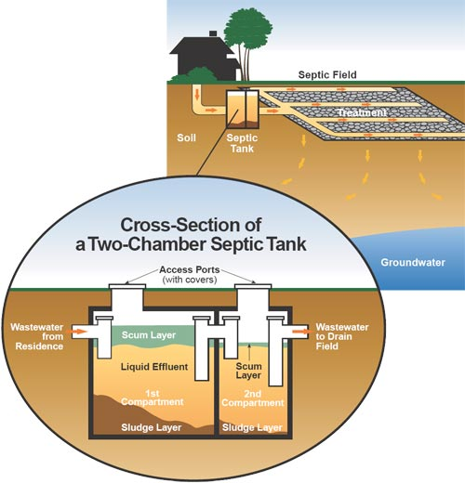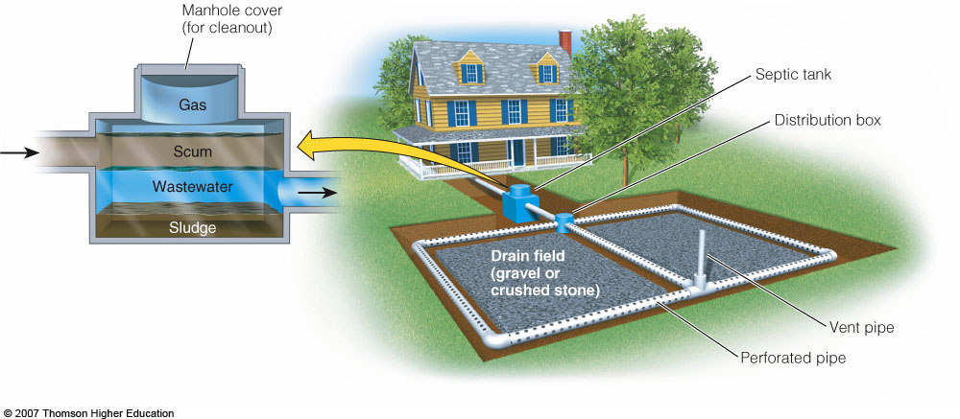

SEWAGE TREATMENT PLANTS:
Series of treatment steps
- Primary Treatment : mechanical
- Secondary Treatment: biological agents ( decomposers)
- Tertiary Treatment : chemical ( chlorine, ozone, UV)

Sewage treatment can not remove
- Insecticides
- Toxins,
- Heavy metals
- POP’s (persistant organic pollutants) dioxins, pcbs
- Endocrine disrupters BPA bisphenol A in plastics,
Phthalates found in plastics

Bar screen
Grit chamber Primary Sewage treatment
Settling tank ------→
Aeration tank
Activated sludge(bacteria) Secondary treatment
Settling tank ----→
Chlorine disinfector Tertiary treatment
Or ozone treatment
Ultraviolet radiation
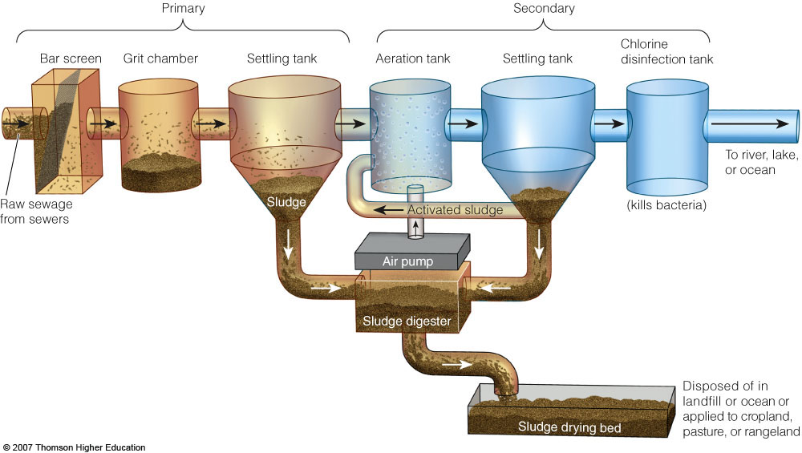
- Raw sewage reaching a municipal sewage treatment plant typically undergoes:
  - Primary sewage treatment: a physical process that uses screens and a grit tank to remove large floating objects and allows settling.
  - Secondary sewage treatment: a biological process in which aerobic bacteria remove as much as 90% of dissolved and biodegradable, oxygen demanding organic wastes.
  - Primary & Secondary remove 95% of suspended solids an oxygen demanding organic waste, 70% of Phosphorus and 50% of nitrates but not pathogens (virus & disease causing bacteria)
  - Advanced or tertiary sewage treatment:
Uses series of chemical and physical processes to remove
specific pollutants left (especially nitrates and phosphates).
Water is chlorinated to remove coloration and to kill
disease-carrying bacteria and some viruses (disinfect).
- Ozone and Uv radiation are also being used to disinfect and kill pathogens
What happens to the sludge?

- Sewage sludge can be used as a soil conditioner but this can cause health problems if it contains infectious bacteria and toxic chemicals.
- Preventing toxic chemicals from reaching sewage treatment plants would eliminate such chemicals from the sludge and water discharged from such plants.

ALTERNATIVES: (Wetlands: natures water filter)
- Natural and artificial wetlands and other ecological systems can be used to treat sewage.
  - California created a 65 hectare wetland near Humboldt Bay that acts as a natural wastewater treatment plant for the town of 16,000 people.
    - The project cost less than half of the estimated price of a conventional treatment plant.

HYDROELECTRIC POWER: How it works!
The theory is to build a dam on a large river that has a large drop in elevation (there are not many hydroelectric plants in Kansas or Florida).
The dam stores lots of water behind it in the reservoir. Near the bottom of the dam wall there is the water intake. Gravity causes it to fall through the penstock inside the dam. At the end of the penstock there is a turbine propeller, which is turned by the moving water. The shaft from the turbine goes up into the generator, which produces the power. Power lines are connected to the generator that carry electricity to your home and mine. The water continues past the propeller through the tailrace into the river past the dam.

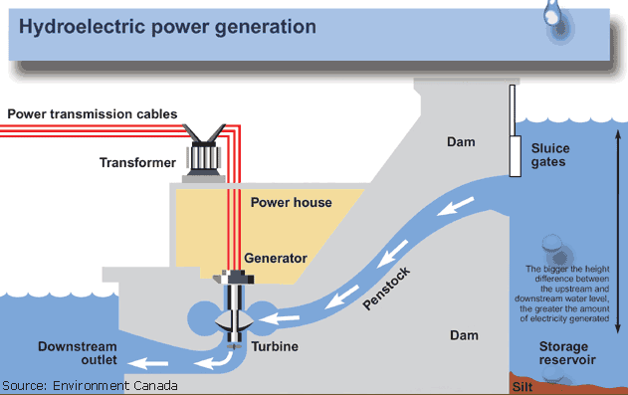

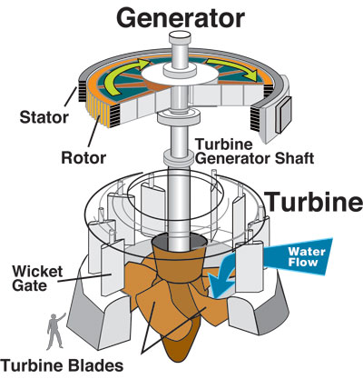

Wind Generation:

