UNIT 4 APES
shark water, cane toads,
The thin green line, unchained Goddess
Invasive species wanted poster
Scurve jcurve activity
http://www.kevinflint.org/ppt/chap5/Animations/global_circ_anim.html
wind cells
ted talk protecting wild salmon Keystone species
Mt St Helens succession

CHAPTER 5,6,7,8
- What factors effect the earth’s climate?
- How does climate determine where the earth’s major biome’s are found?
- What are the major types of desert biomes?
- What are the major types of grassland biomes?
- What are the major types of forest and mountain biomes?
- How have human activities affected the world’s desert, grassland, forest, and mountain biomes?

Read Page 100 in book! ( you will be responsible for on test)
EFFECT OF WIND:
Positive
- Transport of nutrients
- Cools tropical regions
- Keeps rest of the world from freezing

Negative:
- Transport viruses , bacteria , fungi, and toxic chemicals
- Dust storms
- Volcanic emissions
Weather and Climate:
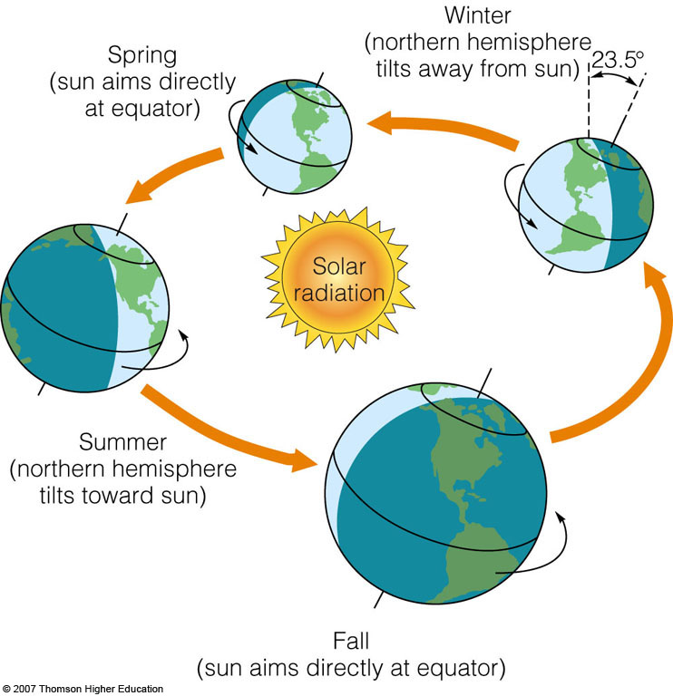

Global air circulation is affected by the uneven heating of the earth’s surface by solar energy, seasonal changes in temperature and precipitation.

Weather
is an area’s temperature, precip. Humidity, wind , cloud
cover over hours or days
Climate:
Is a regions general pattern of atmospheric conditions
over a long time (Years, decades, centuries)

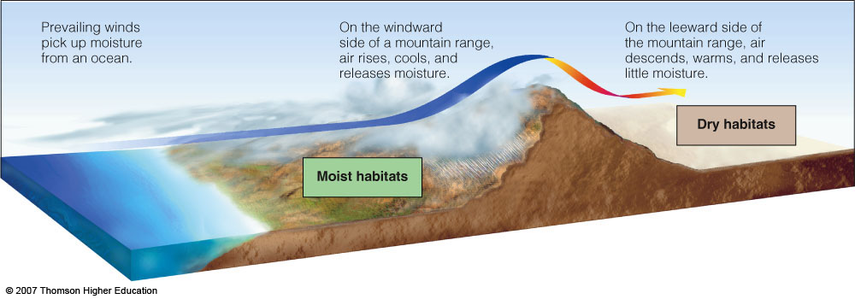
Interactions between land and oceans and disruptions of airflows by mountains and cities affect local climates.

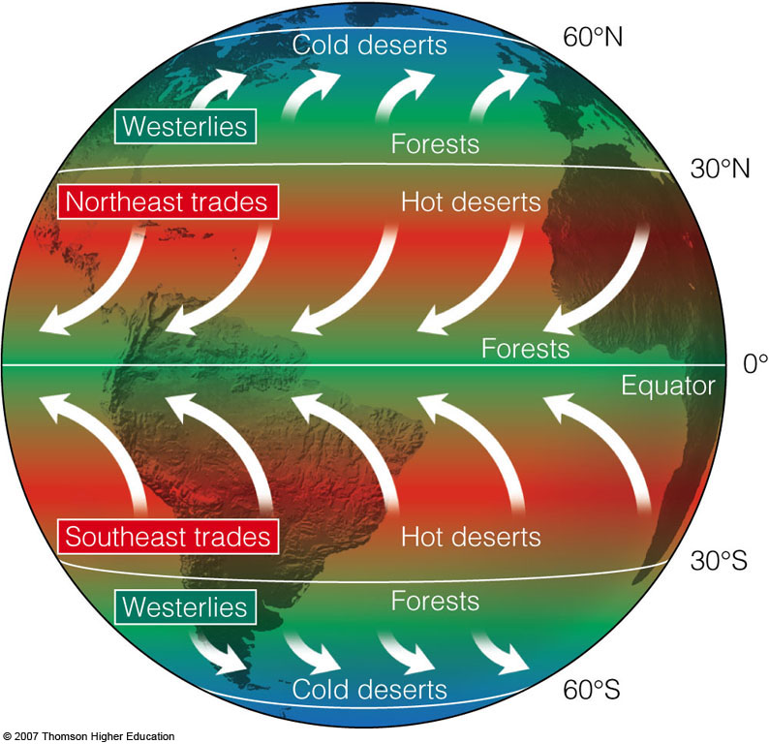
Global air circulation is affected by the rotation of the earth on its axis. Global air circulation is affected by the properties of air water, and land.
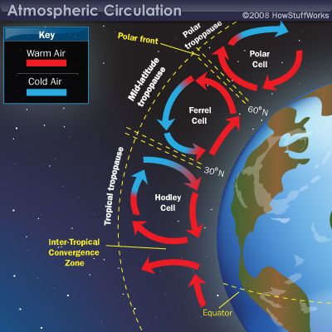

There are three weather cells in each hemisphere. They are created by the uneven heating and cooling of oceanic water and earths land masses .
These cells create weather patterns on earth
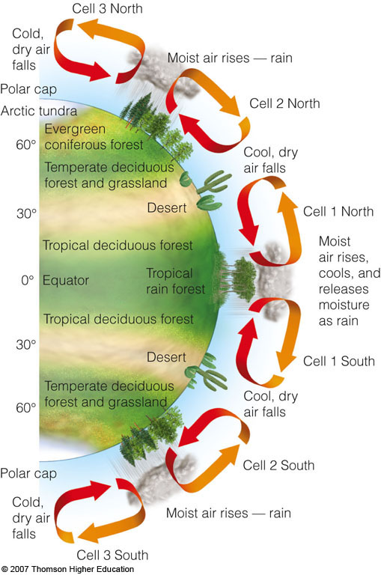
Heat and moisture are distributed over the earth’s surface by vertical currents, which form six giant convection cells at different latitudes
Global warming:
  - Considerable scientific evidence and climate models indicate that large inputs of greenhouse gases from anthropogenic activities into the troposphere can enhance the natural greenhouse effect and change the earth’s climate in your lifetime.
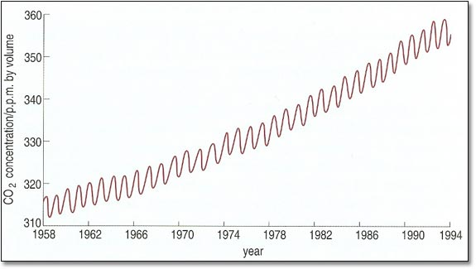
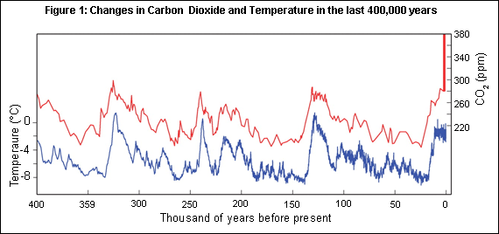

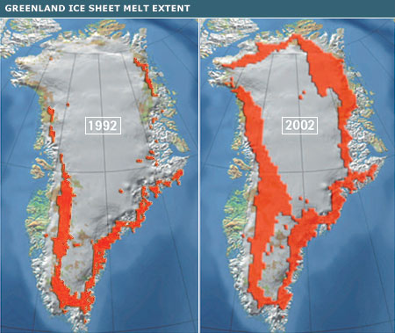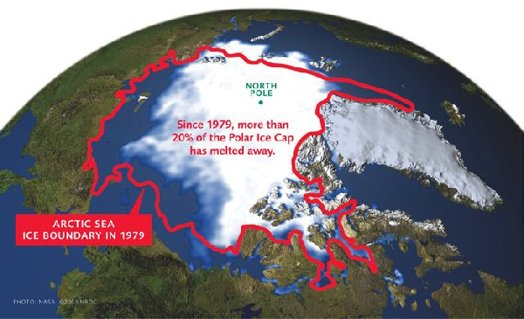

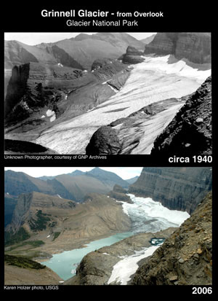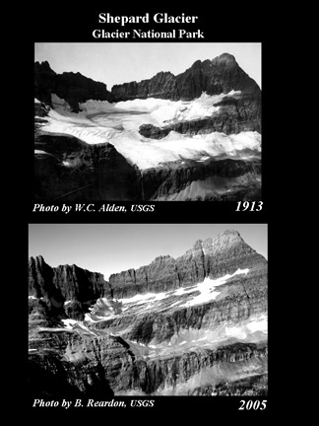
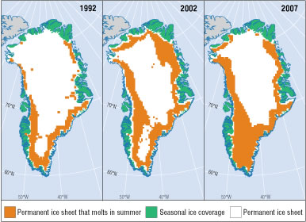
Gaia Hypothesis : Earth functions like a living being that maintains conditions much like homeostasis in a human.
Although can’t be substantiated suggests connections between weather, geology, mineral cycles and organisms on earth.
BIOME PROJECTS:

Biomes are defined by : 3 main a-biotic factors
- Temperature ( this will be defined by latitude or altitude)
- Precipitation
- Soil type
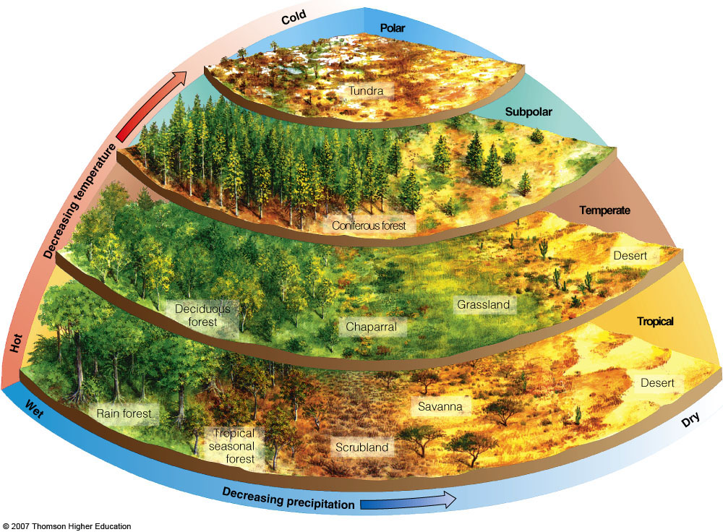

Desert Biomes: ( largest Africa’s Sahara , Antarctica)(least precip)
- Polar
- Temperate
- Tropical
Grassland Biomes: ( largest is steppe of Russia)( moderate precip)
- Polar: Tundra
- Temperate : Grasslands or prairies (Steppe)
- Tropical: Savannahs
Forest Biomes : ( most precip)
- Tropical : ( biggest ex. Amazon rainforest)
- Temperate
  - Deciduous
  - Coniferous (aka : boreal forests)(Taiga)
Largest biome in the world

Shrubland Biomes:
Temperate : Chaparral ( moderate climate : less precip)

Mountain Biomes :

Degradation of Biomes:
Deserts:
1.Large cities in deserts: habitat loss
2. Ground water depletion
Grasslands:
- Use as croplands
- Oil production :
- Grazing lands
Forests:
- clear cutting ( agriculture, fuel, building)
- Off road vehicles : stream pollution
Mountains
- Timber extraction
- Hydroelectric
- Offroad vehicles and other tourism

CHAPTER 7 : COMMUNITY ECOLOGY
Biological communities differ in the types and numbers of species they contain and the ecological roles those species play.
-Species diversity: the number of different species it
contains (species richness) combined with the
abundance of individuals within each of those species
(species evenness).
Ex 40 foxes + 50 bobcats (high evenness)
45 foxes + 130 bobcats ( low evenness)
- Both have the same amount of species richness

- Keystone species: species in an ecosystem that plays a critical role in maintaining equilibrium in an ecosystem.

-Many times keystone species prey on another species that has no other natural predator.
-A classic keystone species is a small predator that
prevents a particular herbivorous species from
eliminating dominant plant species.
- Pisaster ochrareous ochre sea star controls mussel population and allows other organisms to colonize
The intertidal zones .
-Alligator control population of gar
- Kangaroo Rat : in absence , grass filled in prairie
Why?
- Sea otter : eats sea urchins which eat kelp.
Hunted almost to extinction for their fur and
competed for abalone and other shellfish.
Kelp forests almost disappeared ( shore erosion habitat loss for whole food chain)
(toothpaste , beer, icecream)

- NonNative species, Invasive, Alien, introduced
species
Ex. African bees imported to Brazil to help honey
production.
Cane toads, Brown tree snake ( from Australia)
Kudzu
- Indicator Species:
Alert us to harmful environmental changes taking place in biological communities.
Disappearing birds ( declining populations)
Amphibians mutations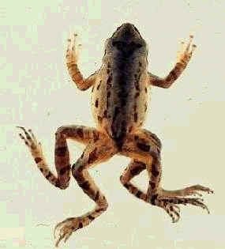
Uvb radiation may kill them directly or their eggs, chemicals in water supply
Amphibians are disappearing worldwide:
- Habitat loss 2. Increase uvb 3. Chemicals 4. Drought & climate change 5. Parasites and fungal diseases 6.
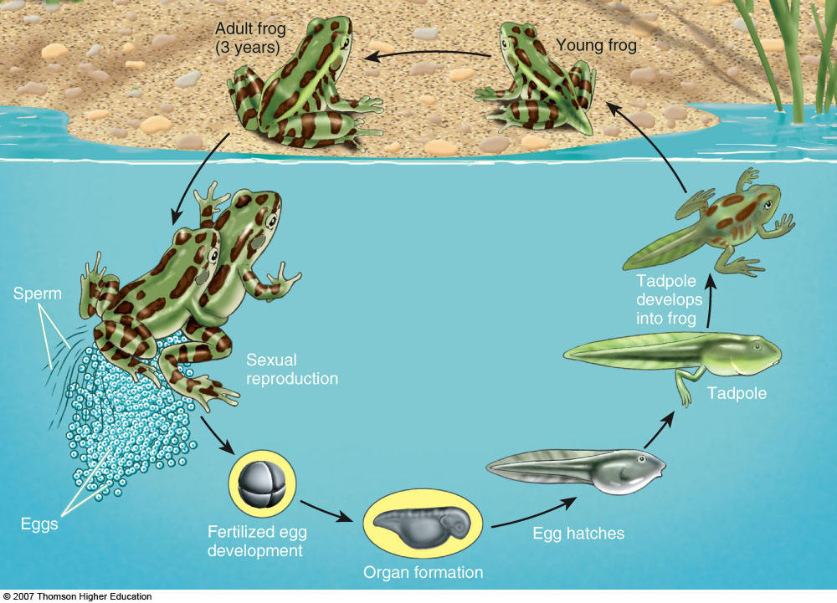
Frogs serve as indicator species because different parts of their life cycles can be easily disturbed.

Video : The thin Green Line

SPECIES INTERACTIONS:
COMPETITION AND PREDATION
Species can interact through
1. competition,
2.predation,
3.parasitism,
4. mutualism,
5. commensalism.
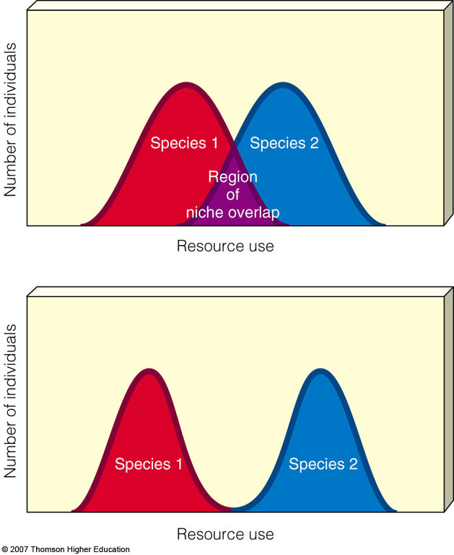
Niches become separated to avoid competition for resources.

Parasitism:
One organism is harmed while the other is helped.
Tapeworm, tick, lamprey
Commensalism:
Some species interact in a way that helps one species but has little or no effect on the other.
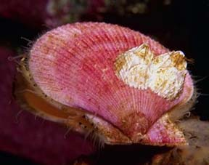

MUTUALISM:
Two species can interact in ways that benefit both of them.
Mycorrhizal fungi living in plant roots ( helps absorb
more water and nutrients)
Lichen: Alice algae to a lichen to Freddy fungus
Their marriage is on the rocks

Mimicry: some organisms have evolved adaptations to look like another organism.

Protection from predators :
Some prey escape their predators or have outer protection, some are camouflaged, and some use chemicals to repel predators.

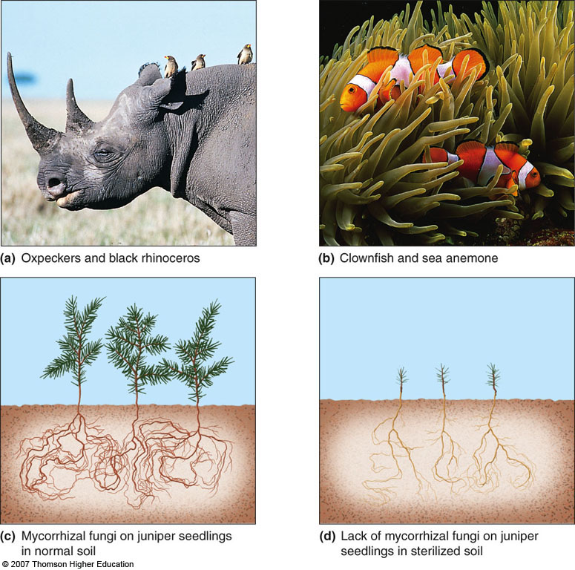

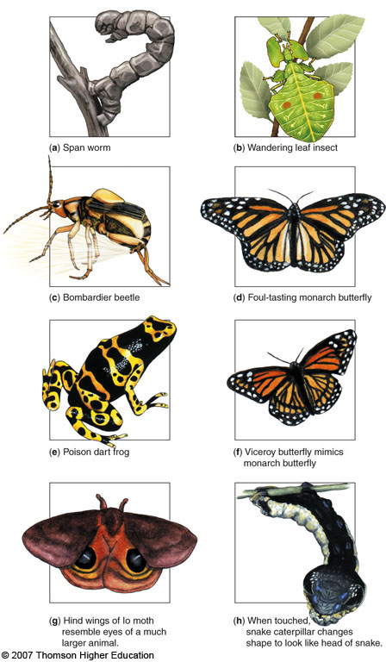
Population dynamics : Chapter 8

Limits on Population Growth:
Biotic Potential vs. Environmental Resistance
BIOTIC POTENTIAL :
The capacity for growth a population has with
unlimited resources.
ENVIRONMENTAL RESISTANCE:
All the factors that act to limit growth of a
population . (let’s name some)
( what limited human population growth? )

NOTE: No population can increase its size indefinitely.
  - Biotic potential(r) is the rate at which a population would grow if it had unlimited resources.

  - Carrying capacity (K): the maximum population of a given species that a particular habitat can sustain indefinitely without degrading the habitat.

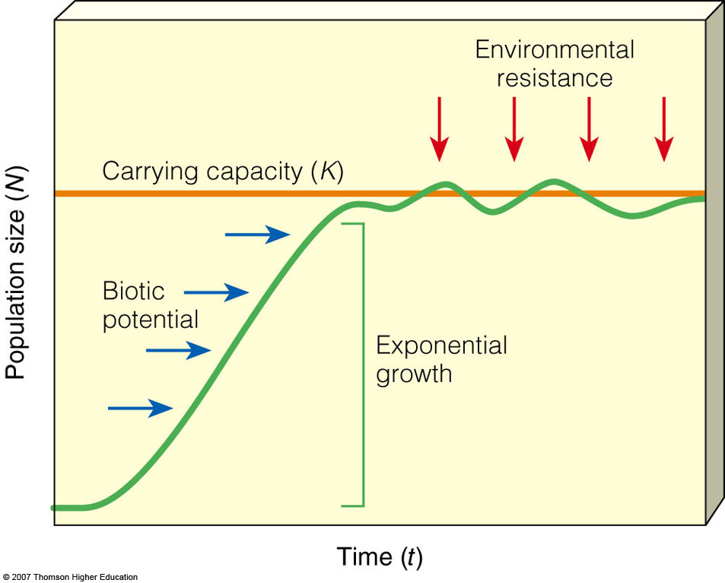

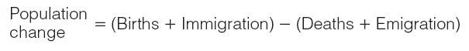

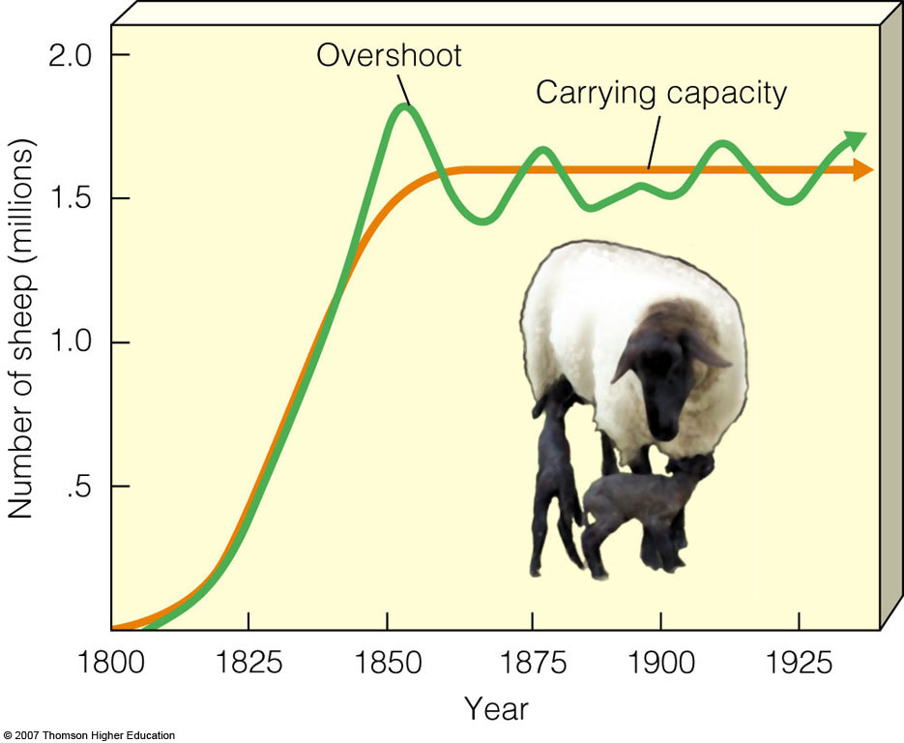
Carrying capacity: (k)
The number of individuals of a particular species that an ecosystem can support w/o a loss in resources.
( thus sustainable environment)
Organisms that exceed carrying capacity in a population have three options:
- Adapt 2. Emigrate 3. die

R-strategy Species: (opportunistic) Species that try to fill every empty crevice in an environment. Reproduce frequently with many offspring (high biotic potential) though not many of the offspring make it to adulthood(Low recruitment).
Examples of r-selected species include insects, frogs, and egg laying fish, dandelions, crabgrass, cockroach.
K-strategy Species: Species that live in stable environments and are strong competitors within their environment. Have only a few offspring (low biotic potential ) but most make it to adulthood(high recruitment) .
Examples of k-selected species include humans , elephants, Whales, Condor .

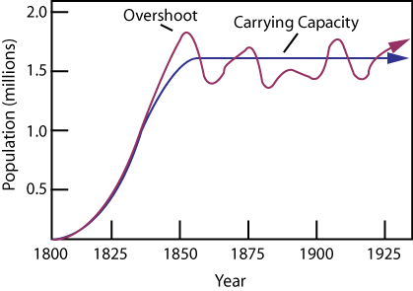

r-selected species tend to be opportunists while
K-selected species tend to be competitors.
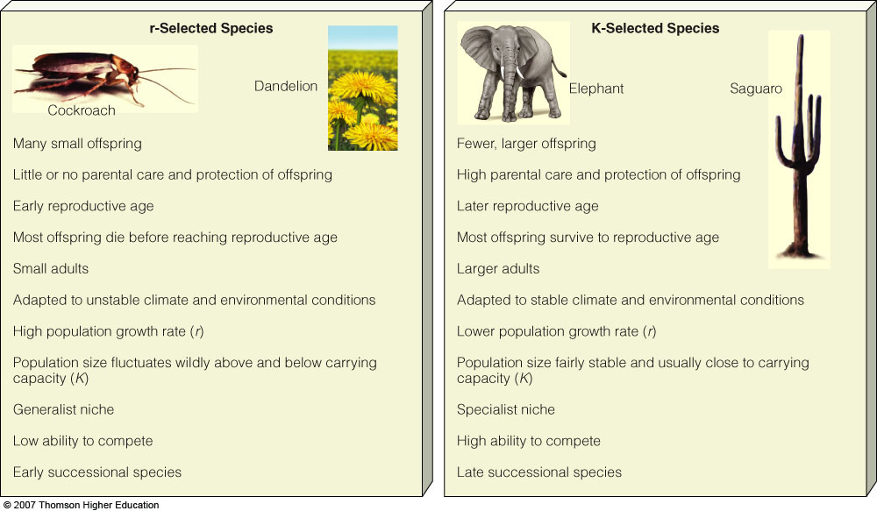

Asexual vs. sexual reproduction:
Sexual Reproduction: ( more often K strategist)
- Advantages
  - New genetic combinations
which leads to possible adaptations
- Disadvantages:
  - One sex gives birth only
  - Increase risk of genetic mistakes
  - Greater energy and time comittment
Asexual Reproduction ( more often r strategist)
- Advantages:
- Little energy useage
- Rapid rate of reproduction
- Disadvantages:
  - Little to know genetic diversity
Binary fission produces genetic clones

Types of Population Change Curves in Nature
Population sizes may stay the same, increase, decrease, vary in regular cycles, or change erratically.
  - Stable: fluctuates slightly above and below carrying capacity.
  - Irruptive: populations explode and then crash to a more stable level.
  - Cyclic: populations fluctuate and regular cyclic or boom-and-bust cycles.
  - Irregular: erratic changes possibly due to chaos or drastic change.

-The populations of different species vary in how long
individual members typically live.
-This is called a survivorship curve
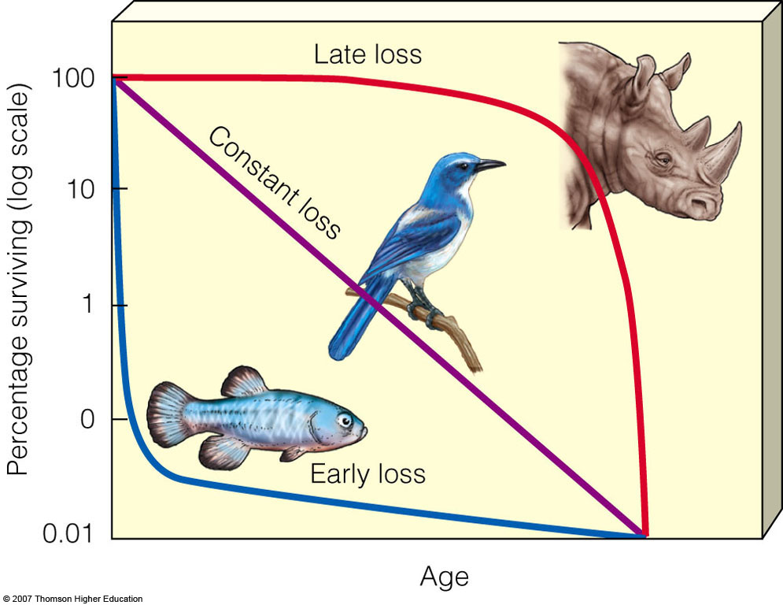

ECOLOGICAL SUCCESSION:
New environmental conditions allow one group of species in a community to replace other groups.

- Primary succession: the gradual establishment of biotic communities in lifeless areas where there is no soil or sediment.
- Secondary succession: series of communities develop in places containing soil or sediment
PRIMARY SUCCESSION: STARTING FROM SCRATCH:
Takes a very , very long time. Thousands of years
- A rock substrate surface
From volcanic flow, earthquake, uplift in an ocean
such as an atoll, receding glaciers. (parking lot)
- Lichens and mosses attach (spores in wind) (pioneer species) Use enzymes and acids to disintegrate rock into sand and soil.
- Seeds from small grasses and mosses grow in soil. Roots crack rock further creating a soil base
- chemical , Physical weathering continues
- Late successional species trees
- Climax community: redwoods, oaks

SECONDARY SUCCESSION: ( hundreds of years at most)
Starting over with some help
- Area natural community has been disturbed .
- Soil already in place ( abandoned farm, fire, clear cut, Land slide)
- Same process

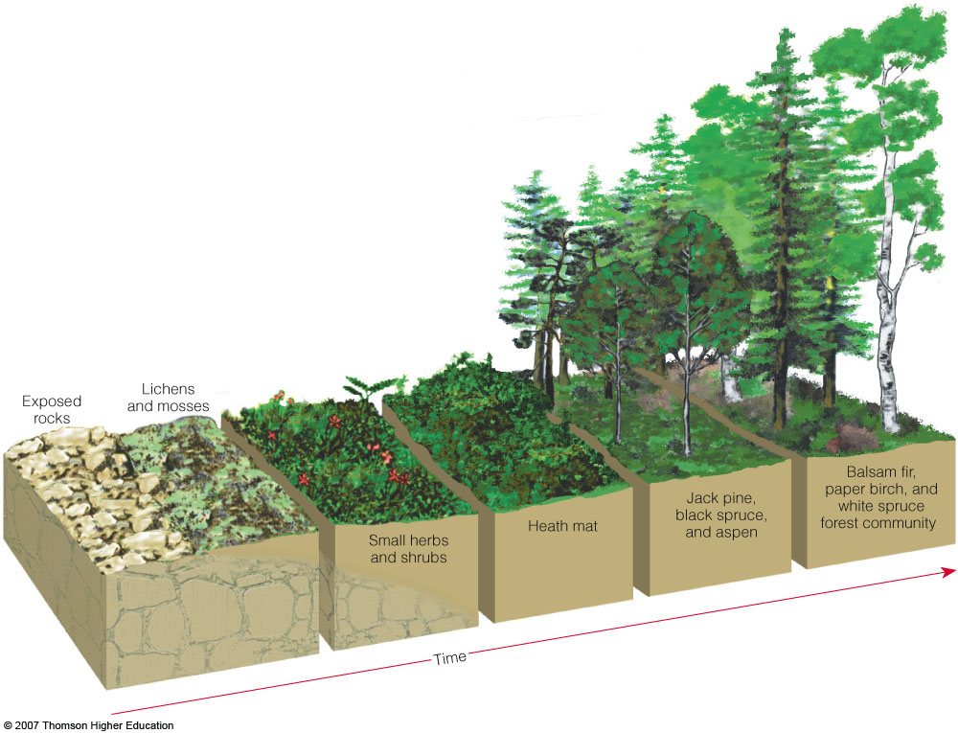

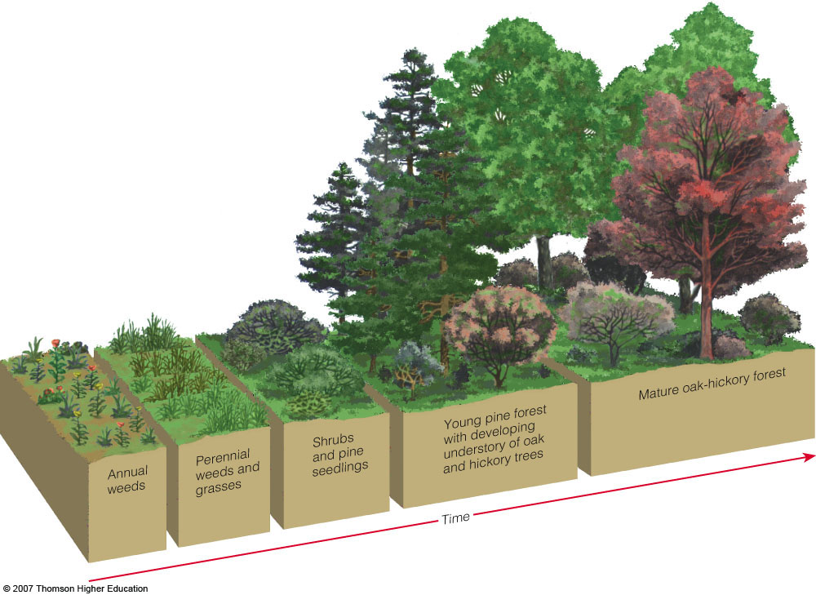

The course of succession cannot be precisely predicted.

Previously thought that a stable climax community will always be achieved.

Succession involves species competing for enough light, nutrients and space which will influence it’s trajectory.

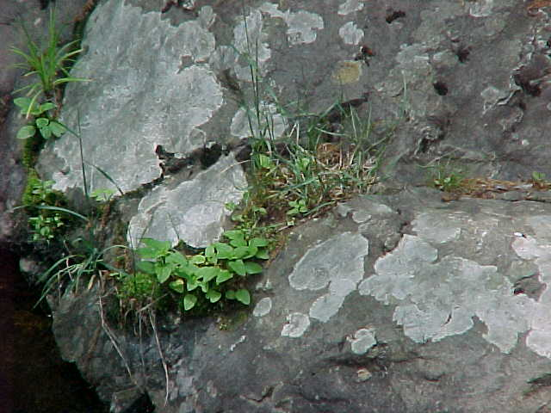

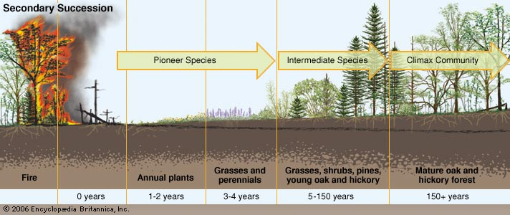
Secondary succession takes place following a major disturbance, such as a fire or flood. Farmland that has been abandoned also can undergo secondary succession. The stages of secondary succession are similar to those of primary succession with one important difference: primary succession always begins on a barren surface, while secondary succession begins in an area that already has soil.
The main difference between primary and secondary succession is that the latter occurs on soil that already exists—that is, in areas where a previously existing community has been removed, most often by disturbances that are relatively smaller in scale and that do not eliminate all life and ...

SPECIES LABELS

- Introduced species
- Invasive species
- Indigenous species
- Keystone species
- Indicator species
- Endangered species
- Nonnative species

