CHAPTER 12
Johann Gregor Mendel: “ The father of genetics”
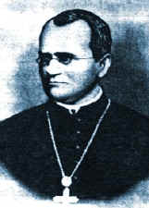
-German Monk 1822-1884

-Worked on Pea Plants at a
monastery in Brunn.

- Around 1843 he described two laws.
- Law of Independent assortment
- Law of segregation
Key Concept:
Most organisms have a pair of genes for each
physical trait. One gene is inherited from each
parent.

Inheritance of Flower Color Experiment:
Mendel crossed a purebred red flower peas with a purebred white flower peas
( These are called parent generation or p₁)

Hybrid: offspring of a genetically mixed strain
( Red x white )

Mendel collected hybrid seeds and planted them to see what traits the f₁ generation had inherited.

f₁ generation were all red flowers

What did he infer about the alleles ( gene forms) for red and white flowers?

Mendel self pollinated the f₁ generation and collected the seeds. He found that 75% turned out red and 25% were white.
Mendel explained: There must be two factors governing flower color ( these are called genes)
Pure bred red flower RR
Pure bred white flower rr
Punnett square:
(Reginald Punnett: English geneticist 1875-1963)
Square that shows every possible gene combination from a male x female allele cross.
R R 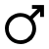
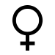 r r
Rr | Rr
Rr | Rr

Allowed to self pollinate R r
R
RR | Rr
Rr | rr
r

Rr = hybrid (heterozygous) for flower color
RR = purebred dominant ( homozygous)
rr = purebred recessive ( homozygous)

Alleles : different forms of the same gene (red, white) ex. Blood type alleles (A,B,O)

One allele is inherited from each parent.

Remember Homologous chromosomes Pg 206
- Same length
- Centromeres in the same location
- Contain genes for the same traits
- Receive one from each parent
- Chromosomes come in pairs therefore so do genes. (800- 1500 nbp)

Phenotype:
The physical trait expressed in the organism
Ex. Brown eyes

Genotype :
The alleles that the individual possesses .
Ex For brown eyes : either Bb , or BB

DOMINANT ALLELES :
The allele that is expressed ( shows up in the phenotype) B= brown eyes b = blue eyes
Brown eyes dominant over blue eyes

Recessive Alleles:
The allele that will be masked in the presence of the dominant allele.
Ex. Bb = brown eyes
Bb= genotype
Brown eyes = phenotype

Homozygous dominant BB = brown eyes
Homozygous recessive bb = blue eyes

LAW OF SEGREGATION : ( MENDEL’S 1ST LAW) 3PARTS :
- Alternative versions of genes account for
variations in inherited characteristics.
This is the concept of alleles.
- For each characteristic, an organism inherits two alleles, one from each parent.
- The two alleles for each characteristic segregate during gamete production.
This means that each gamete contains only one allele for each trait.
- This law describes why tetrads split in meiosis II.

LAW OF INDEPENDENT ASSORTMENT
Mendel’s 2nd Law:
This law states that inheritance of one trait will
not effect the inheritance of another trait.
-This occurs in anaphase I when homologous
tetrads independently migrate to the secondary
gametes
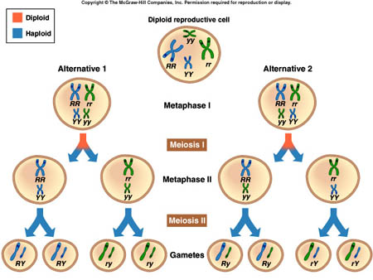

-Some genes will be found on the same chromosome so will not assort independently during anaphase I.
-Linkage groups contradict the Law of independent assortment .

-Many genes are located on the same chromosome, and they do not assort independently, instead, they are inherited together, they won't follow the normal rules of punnet squares, and the ratios obtained from crosses do not have the normal ratios.
Monohybrid: Hybrid for one trait
Bb Brown and blue eyed allele
Dihybrid: hybrid for two traits
Bb Cc eye color and hair straightness
When performing crosses with linkage groups draw a picture of the chromosomes to show how they are inherited.
Example: A fly that is heterozygous for long wings (Ll) and heteroyzygous for long aristae (Aa) is crossed with another fly of the same type. AaLl x AaLl. In both cases the dominant allele is located on the same chromosome.
Before you make a punnett square, you need to consider the linkage groups.
Sketch them!
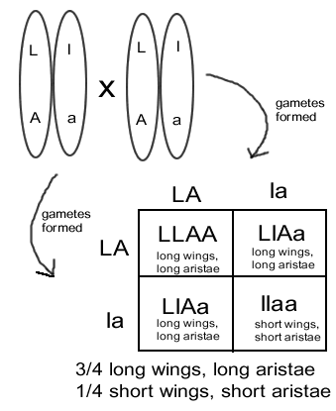

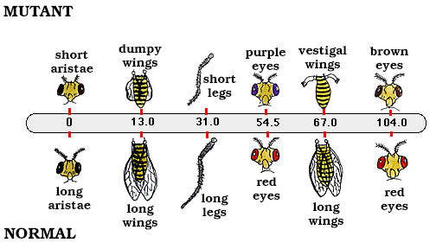

Test Cross:
Test crosses are done to identify an unknown genotype.
Usually crossed w/ an organism that is homozygous recessive for the trait.
Ex. Red Flower x White flower
(unknown genotype) x rr

-If all the offspring are red what can we conclude about the genotype of the redflower?
-If the f₁ has a mix of red and white flowers what can we infer?

R ?
r

r

Dihybrid crosses:
Two different traits or pairs of alleles are being compared.

Peas ex:
Smooth: Dominant (S) wrinkled: recessive (s)
Yellow: Dominant (Y) green : recessive (y)

SSYY X ssyy

Mendel’s Law of independent assortment:
The two pairs of alleles act independently or
each other. They will act like a monohybrid
cross.
( What about linkage groups?)

SY Sy sY sy

INCOMPLETE DOMINANCE :
Neither allele masks the presence of the other
and therefore a heterozygote has a different
phenotype than from either homozygote forms.
Ex.
Red flower x white flower

CODOMINANCE:
- Similar to incomplete dominance
- Both alleles are expressed in heterozygotes phenotype
- In Codominance, the "recessive" & "dominant" traits appear together in the phenotype of hybrid organisms.
  - Ex sickle cells contain
    - 1. Sickle cell hemoglobin
    - 2. Normal hemoglobin
Ex. red x white ---> red & white spotted

LINKAGE GROUPS
Some pairs of genes do not assort independently
- Offspring with two combinations showed up in higher proportions than expected. This occurs because gene pairs are carried on the same chromosome ( linked).
LINKAGE IS COMMON
Example: A fly that is heterozygous for long wings (Ll) and heteroyzygous for long aristae (Aa) is crossed with another fly of the same type. AaLl x AaLl. In both cases the dominant allele is located on the same chromosome.
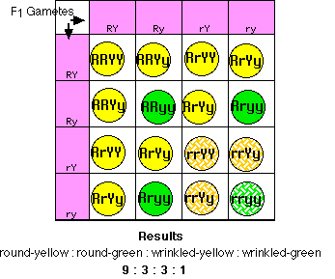
Furthermore, all the seeds were round and yellow, showing that the genes for round and yellow are dominant.

Mating the dihybrids to produce an F₂ generation

- 9/16 of the offspring were round-yellow
- 3/16 were round-green
- 3/16 were wrinkled-yellow, and
- 1/16 were wrinkled-green

Dihybrids that are not linked will turn out phenotypes in 9:3:3:1 proportion.
If they don’t you can assume linkage group

GENETIC RECOMBINATION AND GENE MAPS
There are other problems with preparing genetic maps of chromosomes.
- The probability of a crossover is not uniform along the entire length of the chromosome.
  - Crossing over is inhibited in some regions (e.g., near the centromere).
  - Some regions are "hot spots" for recombination (for reasons that are not clear). Approximately 80% of genetic recombination in humans is confined to just one-quarter of our genome.
- In humans, the frequency of recombination of loci on most chromosomes is higher in females than in males. Therefore, genetic maps of female chromosomes are longer than those for males.
LINKAGE IS COMMON

Crossing over:
Crossing over rearranges genes that were previously linked so now they are on opposite chromosomes. These new chromosomes are called RECOMBINANTS.
Crossing over can occur anywhere on the chromosome.

If genes are close together on a chromosome they will most likely not become unlinked and will be inherited together. The further they are away , the more likely to become unlinked and form new recombinants.

CHROMOSOME MAPS: are constructed for organisms using info. Obtained from the frequency of crossing over. How often they become unlinked. If 10% of the offspring have crossed over chromosomes. (unlinked) then the gene locations are said to be 10map units apart.

Genes for related functions are often located near each other on a chromosome.

****KNOW
THE LAW OF SEGREGATION:
(Mendel’s first Law)

THE LAW OF INDEPENDENT ASSORTMENT
(Mendel’s 2nd Law)

