OPERONS:
Genes for related enzymes (proteins) located on a single stretch of DNA that operates as a single unit.
Usually consists of :
- Structural genes: appr. 3 – 5
Can be enzymes
- Control genes: control the production of structural genes
- Regulator gene
- Promotor gene
- Operator gene
- Regulator gene :
Produces mRNA that is translated into a regulatory protein
- Promotor Gene: (TATA box)
Site where RNA polymerase binds to the DNA for the purpose of coding mRNA for the structural genes
- Operator Gene
Is the binding site for the regulatory protein (coded for by the regulator gene )
OPERONS USUALLY CONTROL A SERIES OF GENES THAT PRODUCE ENZYMES OR OTHER STRUCTURAL PROTEINS
LAC OPERON: ( Described by two French geneticists in 1961 Jacob-Monod)
(found in E. Coli bacteria)
(CODES FOR 3 ENZYMES THAT BREAK DOWN LACTOSE SUGAR)
The regulatory gene lacI produces an mRNA that produces a Lac repressor protein, which can bind to the operator of the lac operon.
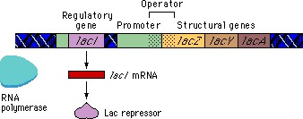
The lacI regulatory gene is called the lacI regulator gene.

Regulatory genes are not necessarily close to the operons they affect.
The general term for the product of a regulatory gene is a regulatory protein.
-The Lac regulatory protein is called a repressor because it keeps RNA polymerase from transcribing the structural genes.
-In the absence of lactose, the Lac repressor protein binds to the operator and keeps RNA polymerase from transcribing the lac genes.

-It would be wasteful for E. coli if the lac genes were expressed when lactose was not present.
The effect of the Lac repressor on the lac genes is referred to as negative regulation.

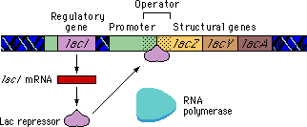

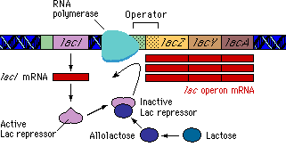A
Lactose binds to an allosteric site on the repressor protein causing a conformational change. As a result of this change, the repressor can no longer bind to the operator region and falls off.
- RNA polymerase can then bind to the promoter and transcribe the lac genes.

NOTE : the Regulator gene can be some distance from the rest of the genes on the chromosome

