CHAPTER 11 EQUILIBRIUM

What is equilibrium?
- For a rxn, when the system attains constant properties and “seems” to have stopped reacting. ( No observable change)
- At equilibrium
1 product 1 reactant

1 reactant molecule turned into a product ; then 1 product molecule will be turned into a reactant molecule. Therefore: no net rxn.

This is a “DYNAMIC” equilibrium

H₂ + I₂ ←-→ 2HI

In this state , the reaction is reversible and depending on temperature and pressure some reactant may be left.
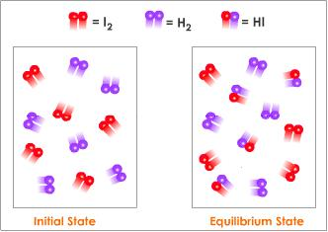

Chemical equilibrium is a dynamic balance between the reactants and the products in a rxn.

How do you Recognize that equilibrium has been achieved?
4 BASIC WAYS:
- Constant temperature maintained
- No substances added or lost (closed system)
- There are no further observable changes
- All properties constant in the system

Effect of pressure N₂ + H₂ ←-→ NH₃
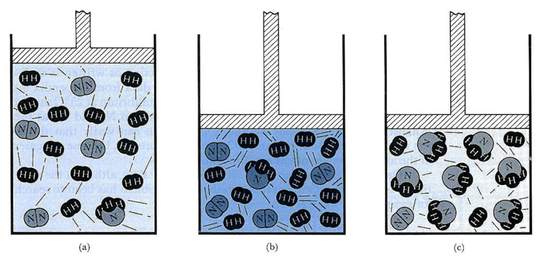
Which side would be favored for an increase in pressure?

DYNAMIC BALANCE BETWEEN REACTANTS AND PRODUCTS.
Note: This does NOT mean there are equal
amounts of reactants and products.

@25ºC
N₂O₄ 2NO₂

@50ºC
N₂O₄ 2NO₂

@75ºC
N₂O₄ 2NO₂

The arrows represent the approximate quantities present @ equilibrium for the specific temperature.

EQUILIBRIUM CONSTANT:
A constant value obtained from a chemical rxn @ constant temperature and pressure by the equation below.
Equilibrium constant expression

K_{eq} = [Products ]
[Reactants]

[ ] = represents concentration

What does the equilibrium expression tell you?
- Simply tells you the ratio of concentrations of products and reactants.
- Keep in mind a change in the Temperature, Pressure, or Volume will take a rxn out of equilibrium.
- The rxn will start running again and after a period of time equilibrium will be achieved again.
This is Called LeChatelier’s Principle
If a closed system at equilibrium is subjected to a change, processes occur that tend to counteract that change.

Hey! Lets look at one of these fun equilibrium constant expressions. Yipee!

BaCl₂ + Al₂S₃ ------→ BaS + AlCl₃

- Balance
- Write the equilibrium expression

NOTE: CATALYSTS DO NOT EFFECT THE EQUILIBRIUM OF A REACTION!

Chemical reactions are rearrangements of molecules and atoms . Each rxn has a specific equilibrium expression and K_{eq}

SOLUBILITY CONSTANT PRODUCT
Most compounds will dissolve or dissociate in an aqueous (water) solution to produce ions. They do this in a specific ratio. They have a constant and expression as well.
This is called the Solubility Product Constant.

K_{SP} LET’S HAVE A LOOK!

BaCl₂ Ba⁺² + 2Cl⁻

The equilibrium expression would look like
K_{eq}= [Ba][Cl]²
[BaCl₂]
How much undissolved reactant is in solution?
Think about it genius!
Zero.
So for K_{sp} we don’t include any undissolved reactant so we leave the reactant out of the equation.
Translation....
BaCl₂ Ba⁺² + 2Cl⁻

K_{sp}= [Ba][Cl]²

ION PRODUCT CONSTANT: K_{w}
This is just the solubility product constant for the compound water, aqua, wa wa

H₂O H⁺ + OH⁻

What would the ion product expression look like?

K_{w} = [H⁺ ][OH⁻]

K_{w}= 1 x 10⁻¹⁴

CALCULATING CONCENTRATIONS OF IONS USING THE SOLUBILITY PRODUCT CONSTANT.
For Cadmium sulfide CdS
What are the concentrations of each ion in a 2L solution ?
- Write the dissociation equation
- Write the K_{sp} expression
- Look up the K_{sp} on the table provided

CdS ←-----→ Cd⁺² + S⁻²
K_{sp} = [Cd⁺²][S⁻²]
Let X = [Cd⁺²]
Let X = [S⁻²]
K_{sp} = [Cd⁺²][S⁻²]= 3.6 X 10⁻²⁹
So …
(X) (X) = 3.6 x 10⁻²⁹
X = 6 x 10⁻¹⁵M
How many moles of each ion are present ?
M=n/L n= MXL
For aluminum hydroxide Al(OH)₃
- What are the concentrations of each ion in a 2L solution ?

- How many moles of each are present?

- How many grams of each ion are present?

EQUILIBRIUM CONSTANT: Keq
A constant value obtained from a chemical
rxn @ constant temperature and pressure.

SOLUBILITY CONSTANT PRODUCT: Ksp
The equilibrium constant for the dissolving
of a slightly soluble salt.
The larger the Ksp, the more soluble the
salt is.

Catalysts :
Do…
- Speed up the reaction
- Lower activation energy
Do not:
- Effect a rxn @ equilibrium
- Shift the amounts of reactants and products formed.

