UNIT 11 and 12
MEIOSIS AND MITOSIS
And Mendelian Genetics

TWO MAIN TYPES OF NUCLEAR DIVISION IN CELLS:
- Mitosis: production of somatic cells
- Meiosis: production of germ cells
Mitosis : produces two identical cells w/ the same
number 2N ( diploid)
of chromosomes. ( called daughter cells)
Unicellular : cells are daughter cells ( clones)
Multicellular:
Begins life as a single cell ( zygote) which
develops into embryo by mitosis. ( this is the
only exception to identical cells. Cells
differentiate into different tissues as division
goes on.
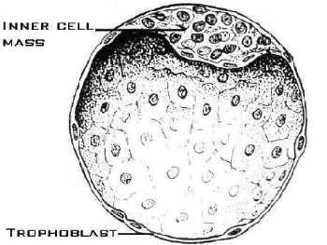. Apprx 120 cells

Meiosis :
Nuclear division that produces new combinations of chromosomes and genes that have only ½ the number of chromosomes found in the original nucleus (1N) haploid
In Animals:
Gives rise to gametes ( sex cells)
In Plants:
Gives rise to spores: - reproductive cells that
are asexual. Spores divide and produce structures that give rise to the sexual gametes.

EUKARYOTIC CHROMOSOMES
Cells chromosomes usually appear as a single , mass of chromatin.
Individual chromosomes can be distinguished only right before and during cell division when they
Condense
That is coil up tightly into short, threadlike structures.
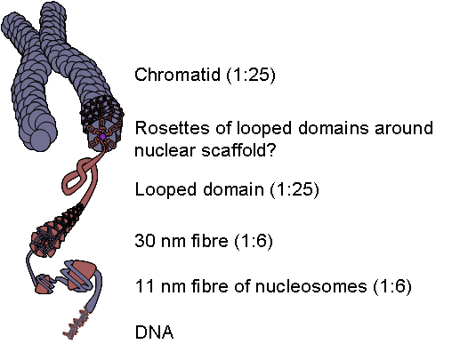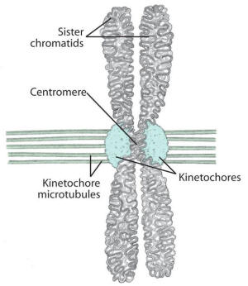

Each chromosome consists of two copies ( sister chromatids ) attached at the center called a centromere.

Haploid 1N 1 set of chromosomes
Diploid 2N 2 sets of chromosomes ( paired )
Humans:Somatic cells = 23 pairs of chromosomes ( 46total)(2N) sex cells = 23 chromosomes not paired ( 1N) 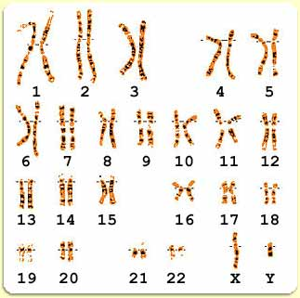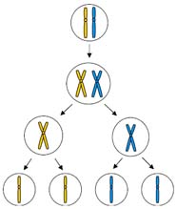

Most plant and animal chrom. Can be matched up in pairs called homologues or homologous chromosomes.

Homologues look alike and have the same length and centromere location . Same light and dark bands when stained. They have the same LOCI: gene locations.

Humans 46 chromosomes ( 23prs) in somatic cells

23 pair is sex chromosomes 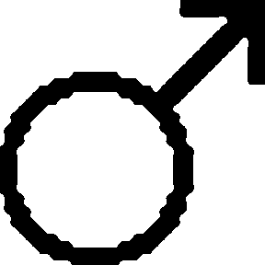 = XY
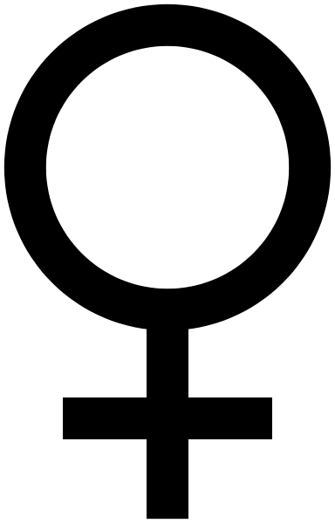 = XX

Other 22 pairs are known as autosomes

In humans only sperm and egg are haploid and undergo meiosis.
-Some plants are tetraploid (4N)
-Other ploidy numbers are rare and many times are caused by mutation ( downs syndrome trisomy 21)This is caused by a chromosomal mutation called nondisjunction
- 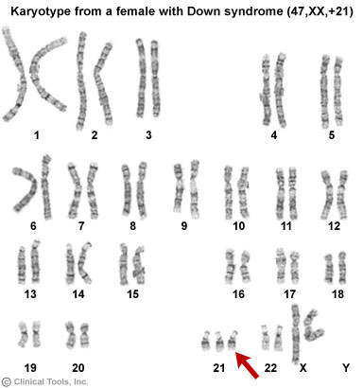

- THE CELL CYCLE:
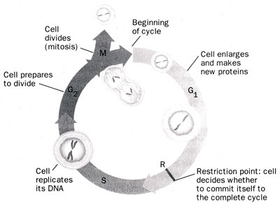
Each cell type has a different life span which begins with cell division and ends with either
1. New division
2. Death
Amoeba = 2 days
Yeast = 2 hours

Early animal embryos divide every 15 – 20 minutes
-Some cells can’t divide once they have reached maturity.
a. Nerve cells
b. Skeletal muscle cells
c. RBC’s (live about 120 days)

In animals, cell division requires at least two factors besides nutrients:
- Growth factors
- Attachment to something outside the cell .

Growth factors:
A cells membrane receptors must bind to a certain number of one or more growth factors which are specific proteins found in body fluids in tiny amounts.
Cells compete for these so at any one time only a limited # of cells can divide
Attachment to something:
Insures that cell doesn’t’ becom a tumor in
another pare of the body.

Potency Types | Description | Sources
Totipotent | The master cells of humans. Each cell can develop into a new human. | Cells from the first few divisions of the fertilized egg only - early embryos (1 to 3 days old)
Pluripotent | Cells can form ANY cell type such as muscle, nerve, blood, etc. (over 200 in the body) | Cells from a blastocyst (embryo that is 5-14 days old)
Multipotent (aka somatic or lineage-restricted cells) | Cells that have already differentiated, but can still form a limited number of other tissues | Found in Fetal tissue, cord blood, and adult stem cells.

Blastocyst:
preimplantation embryo of about 150 cells (˜5 days old)

3 germ layers: found in the blastocyst ( early embryo)
- Ectoderm: outer most layer of blastocyst :
  - gives rise to nervous, sensory organs and skin
- Mesoderm: middle layer of cells :
  - Gives rise to bone, muscle , connective tissue, kidneys
- Endoderm: inner most layer of blastocyst :
  - gives rise to lungs, digestive organs (gut)
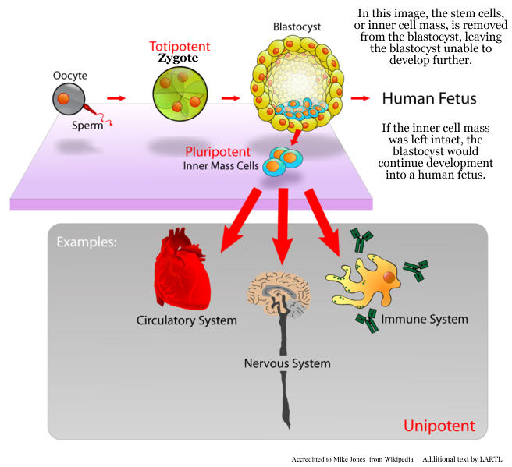

CELL CYCLE:
Defined as the life of a acell from the time the cell is
formed by division until it divides again.

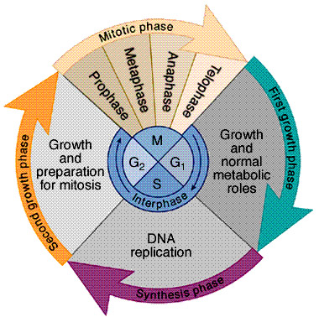
INTERPHASE: The period in which cell growth and
maturity occurs. This is split into three periods
- G₁ (Gap 1) : Cell growth
  - Produce RNA
  - Produce Proteins and enzymes
  - Cell grows larger
- S (Synthesis) : Time of DNA synthesis for
  - preparation of the next cell division.
  - DNA replicates
- G₂ ( Gap 2) : Lasts from the end of DNA syn.
  - to start of cell division.
  - Cell continues to grow
  - Produces more proteins
  - Lots of microtubules produced
  - ( actin and myosin protein)

CELL DIVISION:
It has 4 periods while dividing PMAT pg 188 fig 11-5
- Prophase:
- Metaphase
- Anaphase
- Telophase

- Interphase : this is G1 , s, G2 phases
Most of the time the cell is here.
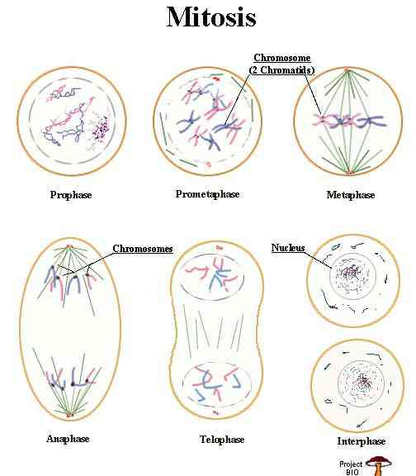

A telomere is a region of repetitive DNA at the end of chromosomes, which protects the end of the chromosome from destruction. ( lengthens its life)
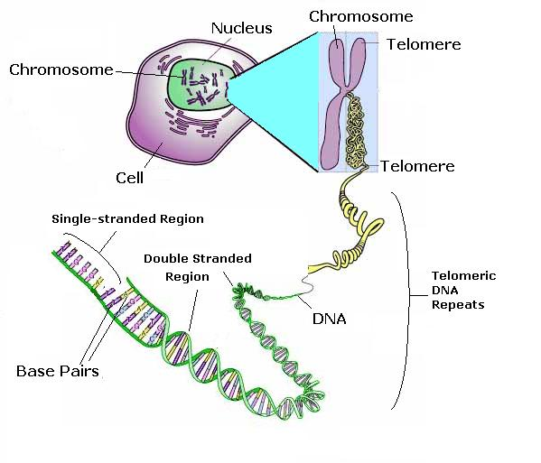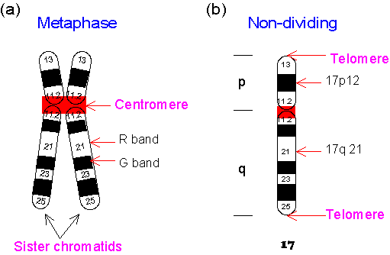
Figure 1-C-2. Schematic drawing of chromosomes. (a) During the metaphase of cell division, a chromosome becomes two sister chromatids attached at the centromere. (b) Notations about the chromosome bands. This figure uses human chromosome 17 as an example.

Sister Chromatids are identical to one another because one has been copied from the other.

Homologous chromosomes that have replicated and have formed tetrads during mitosis or meiosis.

Mitosis
- Interphase:
  - replicated chromatin condenses into
  - distinct chromosomes visible as sister chromatids
- Prophase:
  - Nucleolus disappears
  - Kinetochore : a complex of proteins assembles on each chromatid
  - Nuclear membrane disappears
  - Mitotic spindle begins to form :
(made of microtubules)
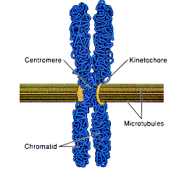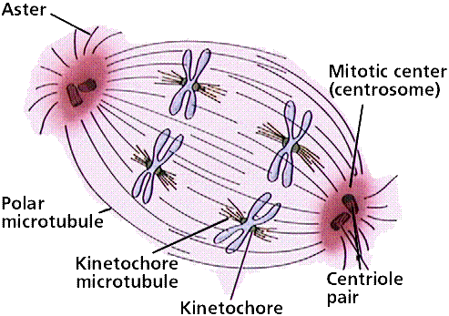

- Metaphase:
  - Mitotic spindle is completed
  - Made up of 2 types of microtubules
    - Polar fibers: extend from poles past the equator.
    - Kinetochore fibers : which grow from poles until they attach to kinetochores of chromatids
-Each kintetochore is pulled toward its pole.
-The farther the chromatid is from the pole the stronger the pull. This is why they end up at the equator.
4. Anaphase:
- Begins abruptly
**b) sister chromatids separated ebcoming
independent chromosomes pulled to
opposite poles of the spindle
      - Polar fibers push the poles farther apart making cell longer
5.Telophase
a. 2 new nuclei are organized
b. chromosomes at the poles uncoil into
tangled chromatin
c. new nuclear envelope forms
d. Nucleoli become visible
e. Cleavage furrow and finally pinch the
cytoplasm in ½ .

- Colchicine : is a chemical that blocks mitosis by blocking formation of the spindle fiber.

This process is a little different in plants because they are surrounded by a cell wall.

Pg 193 fig 11-10
- Golgi complex release vesicles containing material for a new partition between the cells to be.
- The vesicles move along the spindle microtubules to the middle of the cell
- Here they fuse and form a flat disc called the Cell plate
- The cell plate and surrounding membrane grow around the edges by addition of more vesicles
- Soon the cell plate extends completely across the cell cutting it in two.
- Cell plate becomes the middle lamella
- The cell wall of each new cell forms on the outside of the middle lamella.

Cytokinesis divides up
- Cytoplasm
- Ribosomes
- Golgi complex
- Mitochondria
- Plastids

MEIOSIS
The process of nuclear division in which (1N) haploid nuclei are formed from a diploid # (2N)

- Takes two divisions to reduce (Pg 194 old )
  - Meiosis I
  - Meiosis II

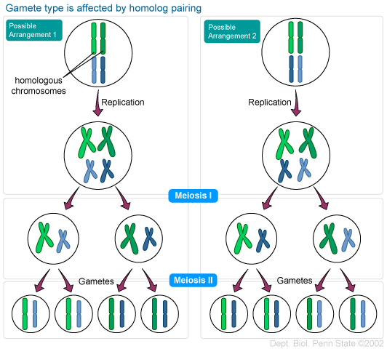
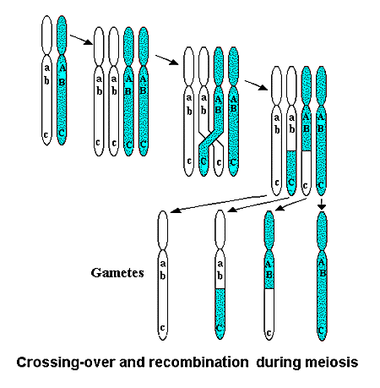

Prophase I
- Replicated chromosomes condense
- Form tetrads
- Homologous chromatids cross over in point to point precision called chiasma.
Crossing over is common . Each tetrad has at least one chiasma.

Metaphase I
Same as metaphase in mitosis except…
- Tetrads don’t pull apart ( split)

Anaphase I
Same as mitosis except
- Tetrads don’t split
- Chiasmata come apart ( centromeres don’t separate.

Telophase I
Same as mitosis
In some the nuclear membrane reappears in other cells it does not.

MEIOSIS II
** NOTE: There is no DNA duplication between
meiosis I and Meiosis II.

INTERKINESIS : Period of time between the two
meiotic divisions. Chromosomes must condense
again before the second division.

PROPHASE II: New spindle forms

METAPHASE II: Tetrads line up at equator then split
releasing individual chromosomes

ANAPHASE II: Chromosomes move toward the poles.

TELOPHASE II
- Four haploid nuclei are formed
- Nuclear membrane reforms
- Cytokinesis occurs

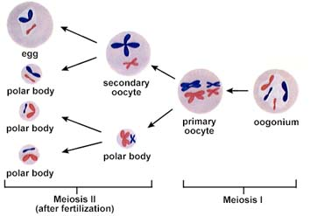

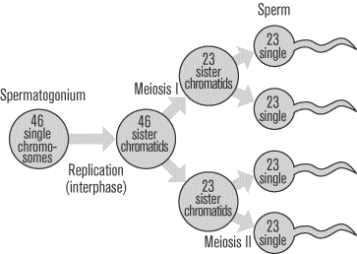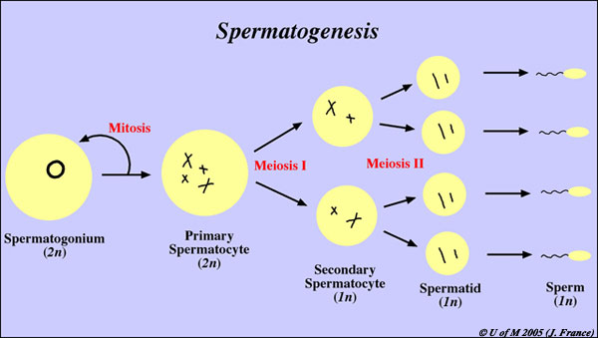

GAMETE FORMATION IN ANIMALS
Formation of sperm and eggs differ somewhat from
eachother.
- Spermatozoa (sperm) formation ( male gamete)
- Contains very little cytoplasm
- Swims using flagellum
- Spermatogenesis:
Male spermatogonia divide continously by mitosis some of these new cells become spermatocytes which undergo meisosis.

Primary spermatocyte --→ MI
Produces two secondary spermatocytes
which undergo MII> Secondary
divide + produce four haploid
spermatids.

SPERMATOGONIA (2N)

DIVIDES BY MITOSIS DIVIDES BY MEIOSIS
(differentiation factors)
(2N) SPERMATOGONIA
mitosis
PRIMARY SPERMATOCYTE (2N)
(Tetrads w/ sister chromatids)

MEIOSIS I
2N secondary
spermatocyte
2N secondary spermatocyte

MEIOSIS II
1N spermatid
1N spermatid

1N spermatid

1N spermatid

Differentiation and maturation
1N
1n
1n
1n

Mature Spermatozoa
OOGENESIS :
Formation of female gametes ( ova, ovum sing.)

Eggs are the largest cells in a female

Because the egg cell is the main source of stored food, ribosomes, and mRNA that support the embryo
develop early.

In oogenesis nuclear division is accompanied by unequal cytokinesis so the original diploid cell produces only one large ovum and two or three tiny polar bodies.

Oogonia divide by mitosis in the ovary and eventually they stop dividing and differentiate into primary oocytes which enter Prophase I

Meiosis is arrested for years until the female reaches sexual maturity. During this time the oocytes absorb nutrients from nearby somatic cells.

Oogonia undergoing
Mitosis in ovary (2N)

Primary oocyte (2N→4N)
2ndary oocyte (2N)

MEIOSIS I

1ST POLAR BODY
2N
1N OVUM
1N

MAY OR MAY NOT DIVIDE INTO 2 1N BODIES

SECOND POLAR BODY

M MATURE EGG : MEIOSIS II doesn’t occur until
Fertilization of the 2ndary oocyte.

CHAPTER 12
Johann Gregor Mendel: “ The father of genetics”
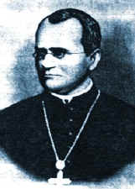
-German Monk 1822-1884

-Worked on Pea Plants at a
monastery in Brunn.

- Around 1843 he described two laws.
- Law of Independent assortment
- Law of segregation
Key Concept:
Most organisms have a pair of genes for each
physical trait. One gene is inherited from each
parent.

Inheritance of Flower Color Experiment:
Mendel crossed a purebred red flower peas with a purebred white flower peas
( These are called parent generation or p₁)

Hybrid: offspring of a genetically mixed strain
( Red x white )

Mendel collected hybrid seeds and planted them to see what traits the f₁ generation had inherited.

f₁ generation were all red flowers

What did he infer about the alleles ( gene forms) for red and white flowers?

Mendel self pollinated the f₁ generation and collected the seeds. He found that 75% turned out red and 25% were white.
Mendel explained: There must be two factors governing flower color ( these are called genes)
Pure bred red flower RR
Pure bred white flower rr
Punnett square:
(Reginald Punnett: English geneticist 1875-1963)
Square that shows every possible gene combination from a male x female allele cross.
R R 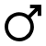
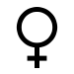 r r
Rr | Rr
Rr | Rr

Allowed to self pollinate R r
R
RR | Rr
Rr | rr
r

Rr = hybrid (heterozygous) for flower color
RR = purebred dominant ( homozygous)
rr = purebred recessive ( homozygous)

Alleles : different forms of the same gene (red, white) ex. Blood type alleles (A,B,O)

One allele is inherited from each parent.

Remember Homologous chromosomes Pg 206
- Same length
- Centromeres in the same location
- Contain genes for the same traits
- Receive one from each parent
- Chromosomes come in pairs therefore so do genes. (800- 1500 nbp)

Phenotype:
The physical trait expressed in the organism
Ex. Brown eyes

Genotype :
The alleles that the individual possesses .
Ex For brown eyes : either Bb , or BB

DOMINANT ALLELES :
The allele that is expressed ( shows up in the phenotype) B= brown eyes b = blue eyes
Brown eyes dominant over blue eyes

Recessive Alleles:
The allele that will be masked in the presence of the dominant allele.
Ex. Bb = brown eyes
Bb= genotype
Brown eyes = phenotype

Homozygous dominant BB = brown eyes
Homozygous recessive bb = blue eyes

LAW OF SEGREGATION : ( MENDEL’S 1ST LAW) 3PARTS :
- Alternative versions of genes account for
variations in inherited characteristics.
This is the concept of alleles.
- For each characteristic, an organism inherits two alleles, one from each parent.
- The two alleles for each characteristic segregate during gamete production.
This means that each gamete contains only one allele for each trait.
- This law describes why tetrads split in meiosis II.

LAW OF INDEPENDENT ASSORTMENT
Mendel’s 2nd Law:
This law states that inheritance of one trait will
not effect the inheritance of another trait.
-This occurs in anaphase I when homologous
tetrads independently migrate to the secondary
gametes
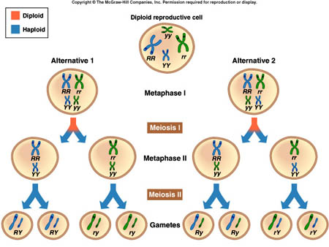

-Some genes will be found on the same chromosome so will not assort independently during anaphase I.
-Linkage groups contradict the Law of independent assortment .

-Many genes are located on the same chromosome, and they do not assort independently, instead, they are inherited together, they won't follow the normal rules of punnet squares, and the ratios obtained from crosses do not have the normal ratios.
Monohybrid: Hybrid for one trait
Bb Brown and blue eyed allele
Dihybrid: hybrid for two traits
Bb Cc eye color and hair straightness
When performing crosses with linkage groups draw a picture of the chromosomes to show how they are inherited.
Example: A fly that is heterozygous for long wings (Ll) and heteroyzygous for long aristae (Aa) is crossed with another fly of the same type. AaLl x AaLl. In both cases the dominant allele is located on the same chromosome.
Before you make a punnett square, you need to consider the linkage groups.
Sketch them!
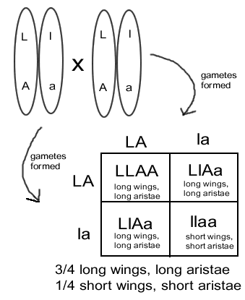

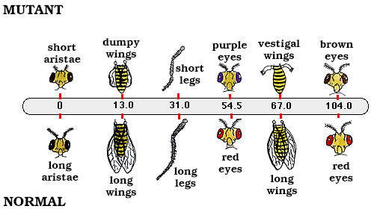

Test Cross:
Test crosses are done to identify an unknown genotype.
Usually crossed w/ an organism that is homozygous recessive for the trait.
Ex. Red Flower x White flower
(unknown genotype) x rr

-If all the offspring are red what can we conclude about the genotype of the redflower?
-If the f₁ has a mix of red and white flowers what can we infer?

R ?
r

r

Dihybrid crosses:
Two different traits or pairs of alleles are being compared.

Peas ex:
Smooth: Dominant (S) wrinkled: recessive (s)
Yellow: Dominant (Y) green : recessive (y)

SSYY X ssyy

Mendel’s Law of independent assortment:
The two pairs of alleles act independently or
each other. They will act like a monohybrid
cross.
( What about linkage groups?)

SY Sy sY sy

INCOMPLETE DOMINANCE :
Neither allele masks the presence of the other
and therefore a heterozygote has a different
phenotype than from either homozygote forms.
Ex.
Red flower x white flower

CODOMINANCE:
- Similar to incomplete dominance
- Both alleles are expressed in heterozygotes phenotype
- In Codominance, the "recessive" & "dominant" traits appear together in the phenotype of hybrid organisms.
  - Ex sickle cells contain
    - 1. Sickle cell hemoglobin
    - 2. Normal hemoglobin
Ex. red x white ---> red & white spotted

LINKAGE GROUPS
Some pairs of genes do not assort independently
- Offspring with two combinations showed up in higher proportions than expected. This occurs because gene pairs are carried on the same chromosome ( linked).
LINKAGE IS COMMON
Example: A fly that is heterozygous for long wings (Ll) and heteroyzygous for long aristae (Aa) is crossed with another fly of the same type. AaLl x AaLl. In both cases the dominant allele is located on the same chromosome.
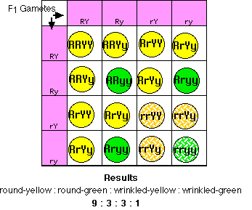
Furthermore, all the seeds were round and yellow, showing that the genes for round and yellow are dominant.

Mating the dihybrids to produce an F₂ generation

- 9/16 of the offspring were round-yellow
- 3/16 were round-green
- 3/16 were wrinkled-yellow, and
- 1/16 were wrinkled-green

Dihybrids that are not linked will turn out phenotypes in 9:3:3:1 proportion.
If they don’t you can assume linkage group

GENETIC RECOMBINATION AND GENE MAPS
There are other problems with preparing genetic maps of chromosomes.
- The probability of a crossover is not uniform along the entire length of the chromosome.
  - Crossing over is inhibited in some regions (e.g., near the centromere).
  - Some regions are "hot spots" for recombination (for reasons that are not clear). Approximately 80% of genetic recombination in humans is confined to just one-quarter of our genome.
- In humans, the frequency of recombination of loci on most chromosomes is higher in females than in males. Therefore, genetic maps of female chromosomes are longer than those for males.
LINKAGE IS COMMON

Crossing over:
Crossing over rearranges genes that were previously linked so now they are on opposite chromosomes. These new chromosomes are called RECOMBINANTS.
Crossing over can occur anywhere on the chromosome.

If genes are close together on a chromosome they will most likely not become unlinked and will be inherited together. The further they are away , the more likely to become unlinked and form new recombinants.

CHROMOSOME MAPS: are constructed for organisms using info. Obtained from the frequency of crossing over. How often they become unlinked. If 10% of the offspring have crossed over chromosomes. (unlinked) then the gene locations are said to be 10map units apart.

Genes for related functions are often located near each other on a chromosome.

****KNOW
THE LAW OF SEGREGATION:
(Mendel’s first Law)

THE LAW OF INDEPENDENT ASSORTMENT
(Mendel’s 2nd Law)

Forms of reproduction:
1.Sexual reproduction: partners mating
2. Asexual reproduction: doing it on your own
a. Cloning: man made
b. Binary fission: amoeba
c. Budding : coelenterate ( coral)
c. Parthenogenesis : (from the Greek "virgin", + genesis, "creation") is a form of asexual reproduction found in females, where growth and development of embryos occurs without fertilization by a male.
Occurs in : invertebrates, shark, lizards , turkeys , has been artificially induced in rabbits and mice
  - offspring of parthenogenesis will be all female if two like chromosomes determine the female sex (such as the XY sex-determination system),
  - They will be male if two like chromosomes determine the male sex (such as the ZW sex-determination system (aves), because the process involves the inheritance and subsequent duplication of only a single sex chromosome.

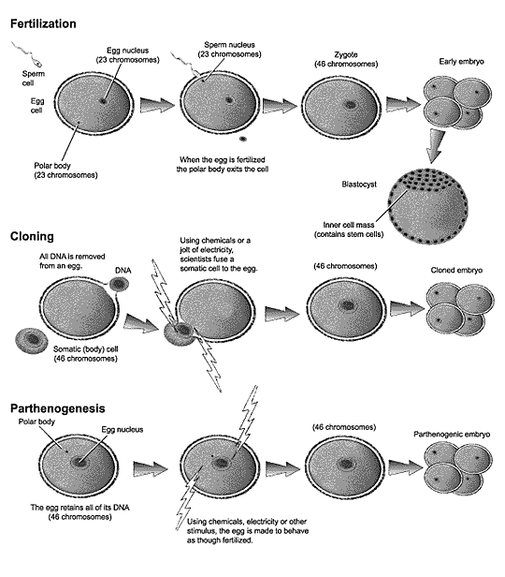

Trisomy 21 : down syndrome. Caused by nondisjunction of the 21st pair of chromosomes during oogenesis.
Individuals with Down syndrome have a lower than average cognitive ability, ranging from mild to moderate developmental disabilities
