OXIDATION –REDUCTION REACTIONS
AKA REDOX REACTIONS

What is Oxidation?
The process by which e⁻ are apparently removed from an atom or ion
Ex. Fe rusting FeO, Carbon burning CO₂
What is Reduction?
The process by which e⁻ are added to atoms or ions

LEO goes GER Lose Electrons Oxidized Gain Electrons Reduced

Oxidizing Agent: the substance in a reaction that gains electrons
Reducing agent: the substance in a reaction that loses electrons

OXIDATION NUMBERS:
The number assigned to an element’s atoms or a compound’s atoms which shows its combining ability
(# of electrons gain or lose to be stable)
-oxidation number is usually the same as the valence

Ex. MnO₄⁻¹

FINDING OXIDATION NUMBERS:
Rules:
- The oxidation of a free element is always zero
Ex O₂ = 0 He = 0 N₂ = 0 C = 0

- The oxidation number of a monatomic ion equals the charge of the ion. Na⁺
- The usual oxidation number of Hydrogen in a compound is +1
- The usual oxidation number of oxygen in a compound is -2
- The oxidation number of a Group IA element in a compound is +1.
- The oxidation number of a Group IIA element in a compound is +2.
- The oxidation number of a Group VIIA element in a compound is -1
- The sum of the oxidation numbers of all of the atoms in a neutral compound is 0.
- The sum of the oxidation numbers in a polyatomic ion is equal to the charge of the ion.
So we can use the oxidations of know elements to find unknown elements
Example SO₄⁻² S + O₄ = -2
S + -8 = -2
S = +6
Lets try some practice problems
Find the oxidation numbers of all elements in the following.

Cr₂O₇⁻² , NO₂, MnO₄⁻¹

IDENTIFYING OXIDATION REDUCTION REACTIONS:

2Na + Cl₂ -----→ 2NaCl

Note: remember atoms in elemental state = 0
+1 -1
2Na + Cl₂ ------→ 2NaCl
- 0

Which was oxidized ?
Which was reduced ?

2Na ----→ 2Na⁺¹

Cl₂ --→ 2Cl⁻

Reduction reaction:
3Cu⁺² + 2Fe ---→ 2Fe⁺³ + 3Cu
Which is reduced ?

Which is oxidized ?
Electrochemical Cells
What is an electrochemical cell?
A cell that converts chemical energy into electric energy
Also called a “battery”

Wet Cells= Have a liquid solution
Ex. Car battery uses H₂SO₄
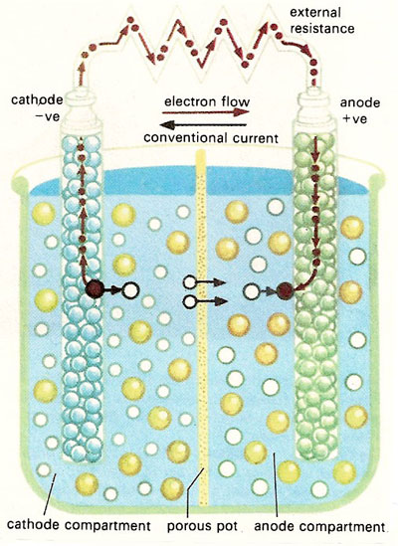

At the ANODE (the so-called "negative" terminal of the battery):
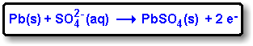
At the CATHODE (the "positive" terminal of the battery):
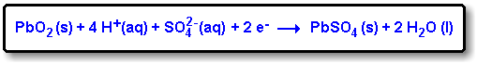
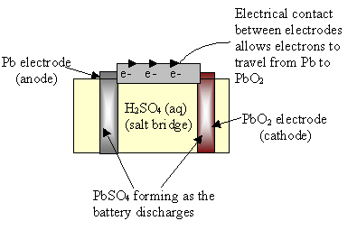
Figure 6
This schematic of a lead-acid battery shows the oxidation-reduction reaction between lead and lead (IV) oxide, mediated by sulfuric acid. Pb is the anode and PbO₂ is the cathode.
The overall reaction (during discharge) is therefore
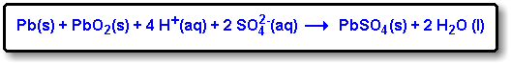

Electrodes:
In an electrochemical cell, electrons enter and leave through electrical conductors called electrodes
Cathode: electrode where reduction occurs (positive terminal)
Zn⁺² + 2e --------Zn
Anode: electrode where oxidation occurs ( negative terminal)
Cu--------→ Cu + 2e

Redox reactions release energy, and this energy can be used to do work if the reactions take place in a voltaic cell. In a voltaic cell (sometimes called a galvanic cell), the transfer of electrons occurs through an external pathway instead of directly between the two elements.

The anode is the electrode at which oxidation occurs; you can remember this if you remember the phrase “an ox”—“oxidation occurs at the anode.” Reduction takes place at the cathode, and you can remember this with the phrase “red cat”—“reduction occurs at the cathode.” An important component of the voltaic cell is the salt bridge, which is a device used to maintain electrical neutrality; it may be filled with agar, which contains a neutral salt, or be replaced with a porous cup. Remember that electron flow always occurs from anode to cathode, through the wire that connects the two half-cells, and a voltmeter is used to measure the cell potential in volts.

Flow of electrons is always from anode to cathode in the wire outside of the wet cell.

Oxidation half-reaction:
Pb (s) + SO₄²⁻ (aq) ↔ PbSO₄ (s) + 2e-
Reduction half-reaction:
PbO₂ (s) + SO₄²⁻ (aq) + 4H⁺ (aq) + 2e- ↔PbSO₄ (s) + 2H₂O

During discharge (when the battery is being used to generate electricity), the sum of the two half-reactions is the following cell reaction:
Pb (s) + PbO₂ (s) + 2 H₂SO₄ (aq) ↔ 2 PbSO₄ (s) + 2 H₂O (l)
Notice that as the cell reaction proceeds, PbSO₄ precipitate forms on both electrodes.

Dry Cells : Radio batteries
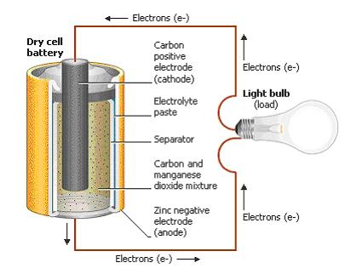
Electrodes :

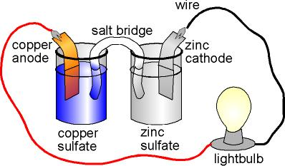

Anode = +
Cathode = -

AN OX
RED CAT

Anode ( oxidation)
PbSO₄(s) + 5H₂O(l) ←→ PbO₂(s ) + 3H₃O⁺ + HSO₄⁻ + 2e-

Cathode(reduction)

PbSO₄(s) + H₃0+(aq) + 2e- ←-→ Pb(s) + HSO₄⁻ + H₂O

