SOLUTIONS (Soln)

What is a Solution?

A mixture in which one substance is dissolved
evenly in another substance.

- Solute: The substance that gets dissolved
- Solvent: The substance that does the dissolving

Solution = Solute + solvent

SOLUTIONS ARE ALWAYS HOMOGENEOUS MIXTURES ( The properties of the mixture are the same throughout)
Types of solutions
Gas in gas ( air)
Liquid in liquid Alcohol in water
Solid in liquid: ex. Salt water
Solid in solid ( must have been liquid @ 1 time)
Ex Alloys , Granite

Water: is known as the universal solvent.

The solvent is most times the substance that is found in the greatest amount in a soln.

POLAR MOLECULES:
Molecules that have partial negative and positive charges at either end of the molecule.
Water is a dipole (dipolar: two poles)

O⁻
+H H+

Polar substances usually have ionic bonds

NonPolar substances are usually covalently bonded
( Organic substances are NonPolar
H H H H H
H—C—C—C—C—C—H
H H H H H

Mixture: Any two or more substances that are mixed physically
Homogeneous mixture: A mixture in which all
substances are mixed evenly. ( a solution)
Heterogeneous mixture: A mixture in which all
substances are not mixed evenly.

Dissociation
This term is used to describe the dissolving of solid substances in a liquid solution. ( usually aqueous)

Dissociation: The process in which ionic compounds dissolve in water to become ions.

NaCl in water ------→ Na⁺ + Cl⁻

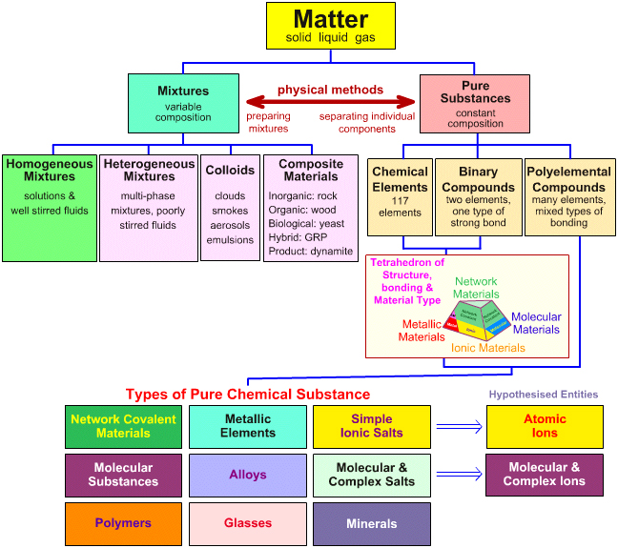

CONCENTRATION VS SOLUBILITY
Concentration:
A term that describes the amount of solute
dissolved in a solution.
There are different units used to measure
Concentration: Molarity, Molality, Mole fraction,
Normality , etc.
Solubility:
A term that describes the ability of a solute to dissolve in a solution. There is a solubility point which is a specific conc. at which no more solution will dissolve.
Insoluble: Refers to substances not able to be dissolved
( insoluble products precipitate out of soln)

CaCl₂ + Na₂CO₃ ----→

Unsaturated solutions:
A solution in which more solute can be
dissolved
Saturated solutions:
A soln. in which you are at solubility point. (no more solute can be dissolved.
Supersaturated solutions:
A soln. in which an excess of solute is found in the soln. ( some not dissolved because past solubility point)
MEASURING CONCENTRATION USING MOLARITY
MOLARITY
Measures the moles of the solute dissolved in a
specific volume of solution.
MOLARITY = Moles of solute ÷ Liters of soln.

M= n/L

Lets calculate molarity shall we?

Problem 1
5grams of potassium chloride are dissolved in
500ml of a solution. What is the concentration
of this solution?

PROBLEM 2
512 grams of HCl are dissolved in 1000ml of an aqueous solution. What is the concentration of this solution in M?

MEASURING CONCENTRATION USING MOLALITY

mOLALITY(m) = n of solute ÷ kg of solvent

Molality(m) is the amount of moles of solute dissolved in 1 kilogram of solvent.

Ex. Problem:
50g of sodium chloride are dissolved in 5 Liters of solution. The salt occupies 23ml.
What is the conc. of the soln. in molality?

MEASURING CONCENTRATION USING MOLE FRACTION:
Mole fraction of a soln. is simply the ratio of …
Moles of solute to total moles in soln.
Or mole of solvent to total moles in soln.

n of solute = Mole Fraction
n of solute + n of solvent

To find mole fraction for solvent it is

n of solvent = Mole Fraction
n of solute + n of solvent

Ex.

Find the mole fraction for both solute and
solvent in a potassium chloride solution that
has 20grams of KCl dissolved in 400ml of
water.

SUSPENSIONS VS COLLOIDS:

Colloids

Colloids are mixtures with particle sizes that consist of clumps of molecules. The particles that can’t be observed w/ the naked eye. The colloid looks homogeneous to the naked eye. (Ex. Smoke, Fog and milk )
Colloids frequently appear "murky" or "opaque". The particles are large enough to scatter light. You have experience with the way fog interacts with the light from car headlights.
Colloids generally do not separate on standing.
They are not separated by filtration.

Suspensions

Suspensions are homogeneous mixtures with particles large enough so they are visible to the naked eye. (Ex. Dirt and water)
Suspensions are "murky" or "opaque". They do not transmit light. Suspensions separate on standing. The mixture of particles can be separated by filtration.

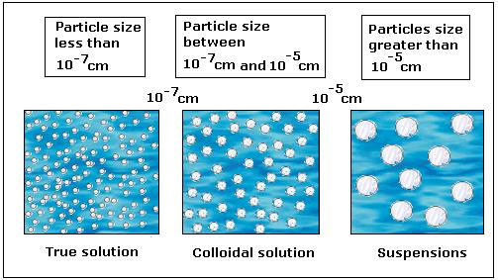

ELECTROLYTES:
Any substance that dissolves in water to conduct an
electric current.
3 major groups of electrolytes are :

- Acids : HCl , H₂SO₄ , HNO₃, HC₂H₃O₂
- Bases : NaOH, Ba(OH)₂, NH₃
- Salts : NaCl, MgI₂

All of these substances will dissociate in water to form ions that will then conduct an electric current.
Major electrolytes in your body?

Sodium, Potassium, Calcium, Mg,
chloride, Sulfate

FACTORS EFFECTING SOLUBILITY OF SOLNS.
(ex. salt water: solid- liquid)
( ex. carbonated pop: gas- liquid)

- Temperature :
Increases solubility for solid-liquid soln
Decreases solubility for gas-liquid soln
- Pressure:
Increases solubility for gas –liquid soln
Decreases solubility for a solid-liquid soln

CALCULATING CONCENTRATION OF EACH ION IN A SOLUTION:

Ex. 50grams of Calcium Chloride is dissolved in 4 Liters of soln.

Find the concentration of each ion in the soln.

Step 1: Write the dissociation equation and balance.

Step 2: Calculate the moles of electrolyte dissolved in
the solution.

Step 3: Calculate the concentration of the known
quantity. ( in this case CaCl₂)

Step 4: Compare the coefficients to determine the
Concentrations

Solubility rules

1. salts containing any alkali metal ions and ammonium ions are soluble

2. salts containing nitrate, acetate, and perchlorate ions are soluble

3. salts containing halide ions (excludes F⁻) are soluble except Pb²⁺, Hg₂²⁺, and Ag⁺

4. salts containing sulfate ions are soluble except Pb²⁺, Sr²⁺, Ca²⁺, Ba²⁺, Hg₂²⁺, and Ag⁺

5. salts containing chromate ions are soluble except Ba²⁺, Sr²⁺, Pb²⁺, Hg₂²⁺, and Ag⁺

6. except as noted above, salts containing sulfide, carbonate, and phosphate ions are not soluble

7. except as noted above plus Ba²⁺, salts containing hydroxide ions are insoluble; Sr²⁺ and Ca²⁺ are partially soluble

