UNIT 8
DNA AND GENETICS

DNA:
Deoxyribonucleic acid
Structure:
Double helix composed of
- Deoxyribose sugar
- Nitrogenous bases ( 4)
  - Adenine purines
  - Guanine
  - Cytosine pyrimidines
  - Thymine
- Phosphate PO₄⁻³

-DNA is foud in the nucleus and organized into
long strands called chromosomes.

- Chromosomes have specific segments that code for a single trait. These are called Genes
- Genes of a chromosome are made up of a series of nucleotides. ( monomer of DNA)
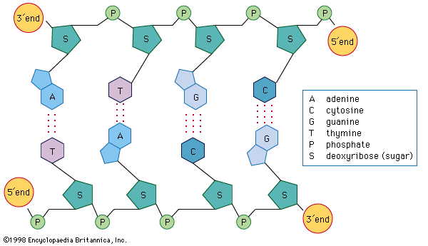
The genetic code of DNA is said to be expressed in the form of a protein.

DNA---→RNA----Protein

Transcription Translation

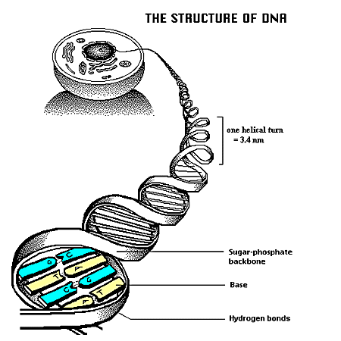
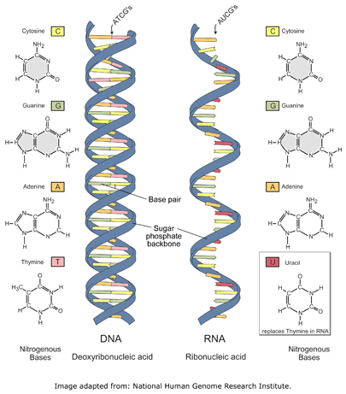

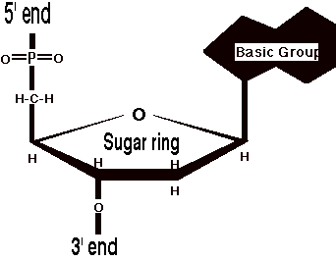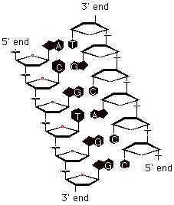

3' end/5' end: A nucleic acid strand is directional, and the "5 prime end" has a free hydroxyl (or phosphate) on a 5' carbon and the "3 prime end" has a free hydroxyl (or phosphate) on a 3' carbon (carbon atoms in the sugar ring are numbered from 1' to 5'; RNA is single stranded Sometimes single-stranded (ss) DNA.
For double-stranded (ds) DNA it's not so obvious - each strand has a 5' end and a 3' end, and the 5' end of one strand is paired with the 3' end of the other strand (it is "antiparallel.

A cells DNA controls what proteins are made.
James Watson and Francis Crick made the first model of the DNA double Helix in 1952.

1928 Fred Griffith studied pneumonia caused by bacteria (Streptococcus pneumonia)
( Didn’t know about DNA)
- Worked with 2 strains
- Virulent strain with a capsule
- Avirulent strain no capsule
- He found that if heated dead virulent were mixed w/ live nonvirulent , then the nonV. Became virulent.
- This proved that DNA could move from one Bacterium to another. This is called
Bacterial Transformation: The transfer of genetic material (DNA) from one bacterium to another.
Bacteriophage:
Virus that attack bacteria. These were used to further that DNA is the genetic material.
A phage injects DNA into bacteria. The bacteria begins to make new Phages – This is evidence that DNA is genetic material 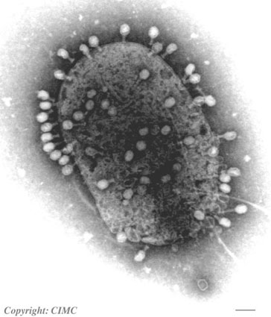
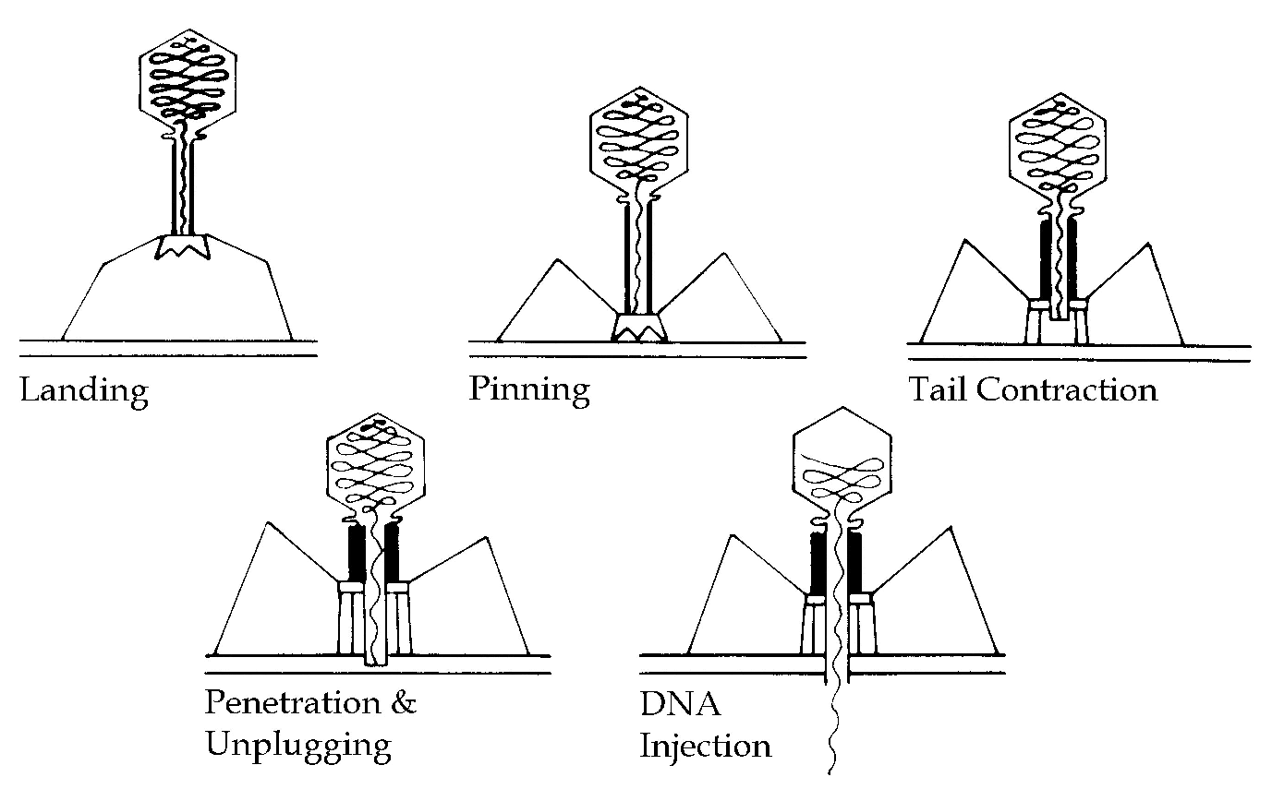
Lytic and lysogenic cycles of Viruses

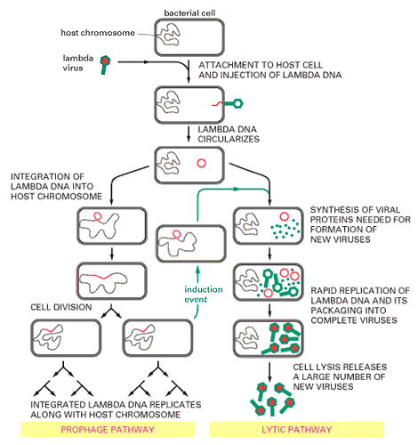
Lytic Cycle:
The phage injects it’s DNA or RNA and uses the bacterium’s metabolic pathways to make more phages until the cell lysis and releases many more phages
Lysogenic Cycle(prophage pathway):
The phage genetic material is incorporated into the genome of the bacterium and it goes on making more bacteria until induction
Somatic cells: (2N) (body cells)
-humans 2 pairs of chromosomes 46
23 pairs of chromosomes

Germ cells: (sex cells) (1N) 23 chromosomes (not paired)

DNA is stable – little turnover – not created or destroyed much.
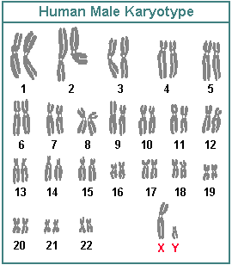
Nitrogenous bases: purines and pyrimidines
- Nitrogenous bases ( 4)
  - Adenine purines
  - Guanine
  - Cytosine pyrimidines
  - Thymine
Equal amounts of A=T and G C
They are bonded by hydrogen bonds
STRUCTURE OF DNA: DOUBLE HELIX

Equal amounts of A=T and G C
Erwin Chargaff 1949 discovered that a=t and g=c

(pg 150 figure 9-4, figure 9-5)

Prokaryotes contain a single long strand of DNA attached at the end to make a circle. This is called “cyclic DNA” ( cyclic bacterial DNA is folded many times)

DNA REPLICATION:
Note: Human chromosomes range in length from 51 million to 245 million base pairs.

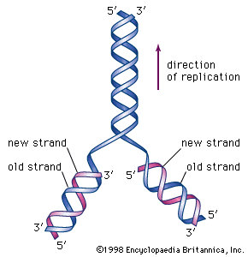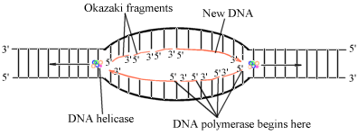
Eukaryotic replication Prokaryotic replication

Before a cell divides into two daughter cells its DNA is replicated .
-Each new cell receives a copy which is identical.
- Each strand as they separate act as a template for the replication
of a new strand.
DNA polymerase only synthesizes from 5’ to 3’
Lagging strand has Okazaki fragments
Leading strand has the DNA polymerase
Prokaryotic DNA is arranged in a circular shape, and there is only one replication origin (OriC). ,
Eukaryotic DNA is linear. When it is replicated, there are as many as 1000 replication origins. Despite these differences, however, the underlying process of replication is the same for both prokaryotic and eukaryotic DNA. (Both are double helical in nature)
Replication is bi-directional
Bacterial Replication Origins
• Bacterial chromosomes are usually circular
• ONE replication origin - OriC
DNA Replication is BIDIRECTIONAL

The Replication Fork
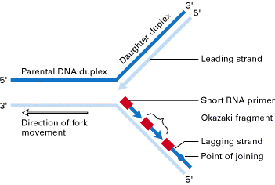
Remember DNA polymerase can only add nucleotides to the 3’ end
In viral DNA, many replication “Bubbles” are visible with the electron microscope
Summary
• DNA replication
copies DNA from DNA
• is carried out by DNA polymerase
• starts at origins of replication
• is bidirectional

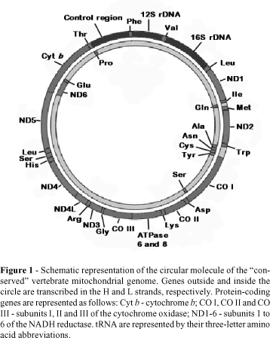
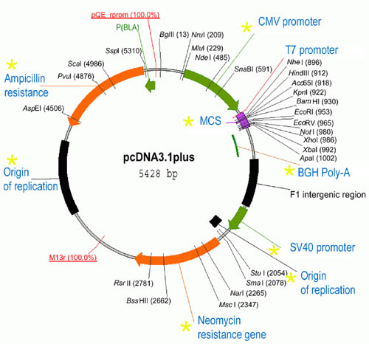

Bacterial DNA

COMPLEMENTARY STRANDS:
- One of the two strands of DNA is complementary to the other.
- Bases are complementary A-T, and C-G
- A,G double ringed (purines)
- C,T are single ringed (pyrimidines)

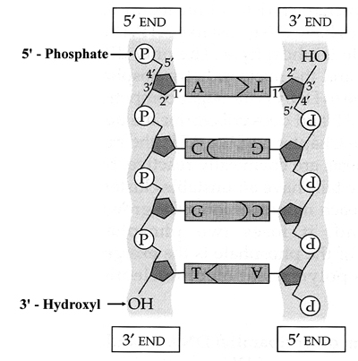

Before replication can occur the DNA double helix unwinds and the two strands unzip by breaking the weak hydrogen bonds that hold the bases together. The enzyme DNA Polymerase moves along joining the new nucleotides bonding them by the bases .
- In eukaryotes replication may start at as many as 1000 places along the DNA molecule
- In prokaryotes there is a single replication origin. Replication then travels in both directions.
- DNA polymerase makes very few mistakes
Any mistakes made are corrected by enzymes that “proof read” the nucleotides add. If the nucleotide added is not correct it is removed and replaced w/ the correct one.
- Fewer than 1 mistake in a billion nucleotides
- DNA Replication is said to be semi-conservative because each strand replicates a complementary strand of itself

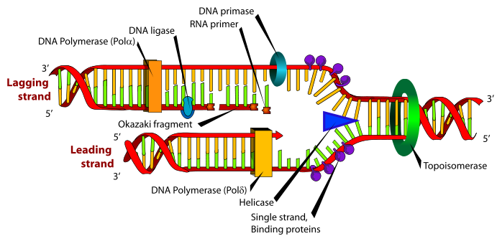

DNA Polymerase can only synthesize a new DNA strand in a 5' to 3' direction
Lagging strand 3’ end
Leading strand 5’ end
DNA REPAIR:

DNA is subject to damage from agents including body heat and aqueous environments. Any change in the DNA molecule could result indisastrous change in proteins produced.
- Only about 3 stable changes in DNA occur in a year because of a group of approx. 20 different DNA repair enzymes.
-DNA is a major target of oxidative damage which, has been linked to human diseases associated with aging, including cancer. 8-oxoguanine (8OG) is one of the most common forms of oxidative DNA damage; failure to repair this lesion prior to DNA replication leads to G:C to A:T transversion mutations in bacterial and mammalian cells.
Accurate repair of DNA damage is critical to the survival of all living organisms.

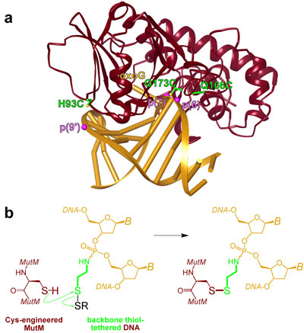
- Structure of the lesion-recognition complex (LRC) of MutM (crimson) bound to oxoG-containing DNA (gold).

MUTATIONS :
Are inheritable changes in DNA molecules that result from uncorrected errors in replication that are not repaired.

The wrong DNA sequence continues to be replicated .

The amount of change in mutated DNA is not necessarily correlated with its effect on the organism.
Ex. One nucleotide change may…
- Do no damage
- Be lethal

Types of mutations:
- Substitution
- Insertion
- Deletion
- Frameshift
- Substitution:
A substitution is a mutation that exchanges one base for another. (Ex. switching an A to a G)
-sickle cell anemia is caused by a substitution in the beta-hemoglobin gene.
-change a codon to one that encodes the same amino acid and causes no change in the protein produced. These are called silent mutations
- Insertion
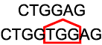
are mutations in which extra base pairs are inserted into a new place in the DNA.
- Deletion:
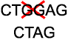
Deletions are mutations in which a section of DNA is lost, or deleted.
- Frameshift
Since protein-coding DNA is divided into codons three bases long, insertions and deletions can alter a gene so that its message is no longer correctly parsed.
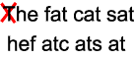
These are called frameshifts.

MUTATIONS are inherited when they are copied during DNA replication.
MUTATIONS: in egg or sperm can be passed down to the next generation.
Frequencies : Human egg or sperm
1-250/ million
- A small amount of mutation is advantageous – produces variation
- Much more harmful than helpful
MUTAGENS:
Mutation causing agents
-radiation, x-rays, heat, chemicals (to name
a few)
CARCINOGENS:
Cancer causing agents
TERATOGENS: Agents causing fetal abnormalities during gestation
Ex alcohol, rubella, diabetes, PCB’s

STRUCTURE OF EUKARYOTIC CHROMOSOMES

Human somatic cells contain 46C 23 pairs
With a total of about 6, 000,000,000, base pairs
Each chromosome is a DNA strand

DNA is associated with a substance called chromatin which contains :
DNA
PROTEIN
- Histones are proteins that protect the DNA molecule from breaking & tangling . They wrap the DNA into compact chromosomes .
- Histones are made of alkaline amino acids. 1. Arginine 2. Lysine
- Found in eukaryotes, archea(not eubacteria )

The + charged R groups of the amino acids bind strongly to the negatively charged phosphate group of the DNA molecule
-Histones are found in great quantities
- Average human chromosome = 5cm
- All chromosomes = 2m in length
DNA is wound around the histones forming a string of beadlike particles called a Nucleosome. 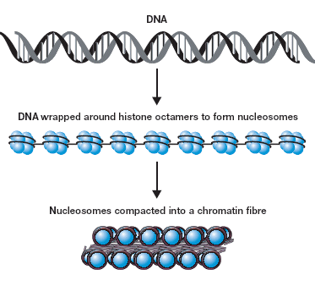
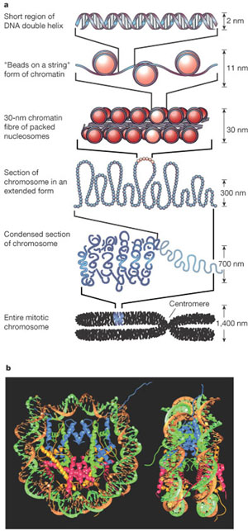
- Chromosome is further folded into large loops called “ looped domains”
- Chromatin packed up tightly as possible is said to be “condensed”
GENOME
- A cells genome is the total of all its genes
- A populations genome is the total of all its genes.
- In prokaryotes genes directing RNA and protein synthesis make up most of the genome
- In Eukaryotes (plants and animals) less than 10% of the genome serves the function of making proteins.
- So what do they do??
INTRONS AND EXONS
- Introns = intervening sequences
- Exons = expressed sequences
Most eukaryotic protein-encoding genes are interrupted. The coding regions are divided into numerous blocks called "exons" and the exons are separated by "introns."
An example is shown below. The triose phosphate isomerase (TPI) gene from maize is composed of 9 exons and 8 introns. (Triose phosphate isomerase is one of the enzymes in the glycolysis/gluconeogenesis pathway.)
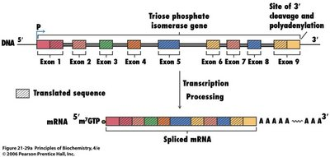
This is a representation of the TPI gene with each exon in a different color. The thick gray lines between them represent the introns.
The long primary RNA transcript contains both intron and exon sequences.
The introns are spliced out and the exon sequences are fused to form the mature mRNA.
This mRNA is then transported to the cytoplasm where it is translated into protein.
JUMPING GENES ( TRANSPOSABLE ELEMENTS)(Transposons)
In 1970 it became clear that transposons are widespread.
Transposons or “jumping genes” are genes that move from one location to another on a chromosome. In the pigmented layer of corn grains, the position of transposons block pigment production in some cells. For example, if the transposon moves adjacent to a pigment-producing gene, the cells are unable to produce the purple pigment.

Transposons may bring about mutation when
they jump around in the genome. ( Mclintock)
( Maize, snap dragons , Drosophila (fruitfly) )

Transposons can be found in eukaryotes and
Prokaryotes (bacteria – antibiotic resistance)

When genes jump out of one organism’s genome into another’s, it’s called horizontal transfer — as opposed to vertical gene transfer from parent to child.
Mostly this happens among bacteria, it has been shown that genes moved between millet and rice plants millions of years after the families of those two species could no longer breed.
It’s the first well-documented case of this sort of interspecies hanky-panky: specifically, the movement of outside DNA into the nucleus of a plant’s reproductive cells.
A section of DNA here, but it acts more like a parasite," he says. "It would seem like science fiction if it [weren’t] reality."
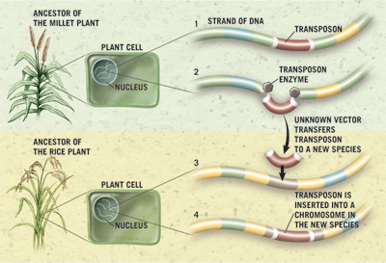
Illustration by Carin Cane
Scientists have been tracking these jumping genes — or transposable elements — since the 1950s. They already knew transposons moved around on a single genome, creating variations such as striped kernels in corn. These jumping genes also have been tracked in bacteria. But scientists didn’t realize these genes could leap from one species to another until now.
Genes that make bacterium drug-resistant can
move from one bacterium to another

Instead of each species having to develop adaptations on its own and pass them on through offspring, they can pick up genes—and the traits that go with them—from the organisms around them.
That’s how bacteria often develop resistance to multiple antibiotics:
- Transposons ( jumping genes) are widespread in the human genome.
Satellite DNA:
Consists of millions of copies of very short
sequences of nucleotides. Found near the centromeres or telomeres on the chromosome.
Mostly considered junk DNA

REPETITIVE DNA
Most genes are present only once, however
some are found that have many copies of a
gene. ( telomeres )
Ex. 400copies of ribosomal RNA genes and
30 to 40 copies histone making genes.

JUNK DNA:
Sequences of DNA that no known use is known.
Usually introns ( intervening sequences)

PLASMID:
- A small circular molecule of DNA that occurs in bacteria and yeasts
- Plasmids may be transposed into the genome of another organism.

- Bacterial Chromosome Structure; Bacterial Cell Division
- Eukaryotic Chromosome Structure
- Eukaryotic Chromosome condensation
- Eukaryotic Cell Division: Mitosis and Meiosis

Bacterial Chromosome Structure
Prokaryotic cells (bacteria) contain their chromosome as circular DNA. Usually the entire genome is a single circle, but often there are extra circles called plasmids. The DNA is packaged by DNA-binding proteins.
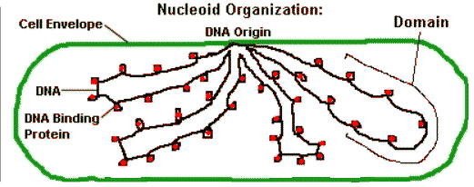
The bacterial DNA is packaged in loops back and forth. The bundled DNA is called the nucleoid. It concentrates the DNA in part of the cell, but it is not separated by a nuclear membrane (as in eukaryotes.) The DNA does form loops back and forth to a protein core, attached to the cell wall.
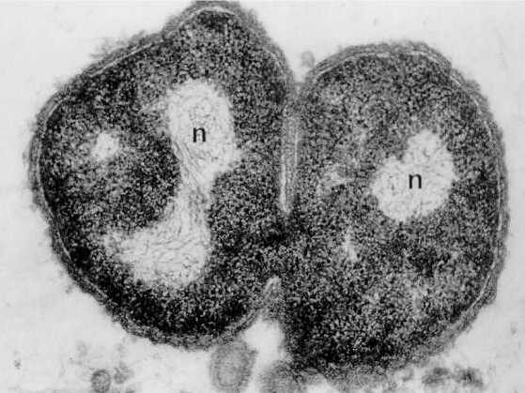
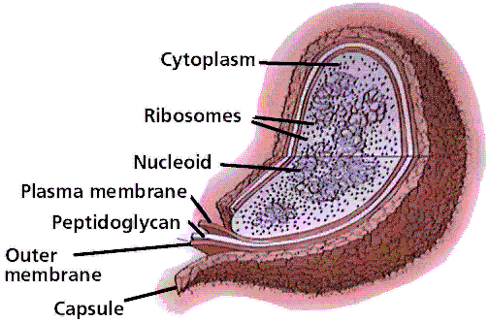
From Bacterial Diversity

The DNA is accessible to enzymes that make RNA and protein In the bacterial cell, the DNA gets transcribed to RNA, and the RNA gets translated to protein before it is even completed. How does this differ from a eukaryotic cell?

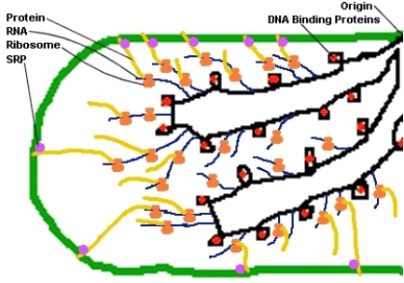

Eukaryotic Chromosome Structure
Eukaryotic cells contain their DNA within the nuclear membrane.
The DNA double helix is bound to proteins called histones. The histones have positively charged (basic) amino acids to bind the negatively charged (acidic) DNA. Here is an SDS gel of histone proteins, separated by size (those migrating down farthest are smaller). | 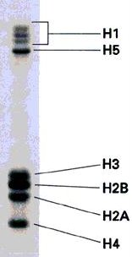
From Virtual Fly Lab
The DNA is wrapped around the histone core of eight protein subunits, forming the nucleosome. The nucleosome is clamped by histone H1. About 200 base pairs (bp) of DNA coil around one histone. The coil "untwists" so as to generate one negative superturn per nucleosome.
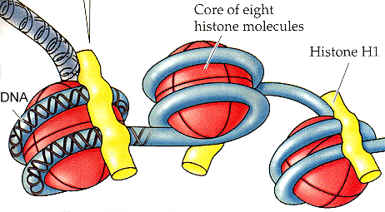
This form of DNA is active chromatin; it can be "expressed" (transcribed and translated) to make RNA and proteins
How is the chromatin "read"? How does the cell know which genes to use when? Part of the answer comes from the histone code of histone modifications (as well as DNA modifications). For example:
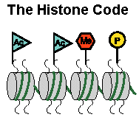 | - Methylation of histone or of DNA usually turns a gene off.  - Acetylation of histone usually turns a gene on.  - Phosphorylation -- we're not sure what that does.

PROMINENT GENETICISTS & HISTORY OF DNA DISCOVERY.

Fred Griffith 1928 (Bacterial Transformation)
- Genetic information could be transferred from one bacterium to another.
- Injected mice w/ virulent pneumonia
- Injected mice w/ nonvirulent pneumonia
- Injected some w/ nonvirulent live and virulent
  - dead bacteria and the nonvirulent became virulent.
Barbara McLintock : 1942 ( jumping genes in maze)
Oswald Avery 1944 : ( DNA not protein is the
genetic carrier) Proved this by showing DNA
changes caused nonvirulent bacteria to become
virulent not proteins.

Erwin Chargraff 1950 ( equal A:T , C:G)
DNA is a species has almost the same
nucleotide composition. (thru chem analysis)
Hershey and Chase 1952 (Radioactive isotopes)
- Showed DNA contains P but not S
- Bacteriophages don’t enter intact because they have a protein coat. Using radioactive S and P isotopes they showed no S entering bacterium
Rosalind Franklin 1952 ( XRay diffraction dble helix)
Helical periodicity of DNA
Watson Crick 1952 (Determined and described the DNA structure, double helix)

OPERONS:
Genes for related enzymes (proteins) located on a single stretch of DNA that operates as a single unit.
Usually consists of :
- Structural genes: appr. 3 – 5
Can be enzymes
- Control genes: control the production of structural genes
- Regulator gene
- Promotor gene
- Operator gene
- Regulator gene :
Produces mRNA that is translated into a regulatory protein
- Promotor Gene: (TATA box)
Site where RNA polymerase binds to the DNA for the purpose of coding mRNA for the structural genes
- Operator Gene
Is the binding site for the regulatory protein (coded for by the regulator gene )
OPERONS USUALLY CONTROL A SERIES OF GENES THAT PRODUCE ENZYMES OR OTHER STRUCTURAL PROTEINS
LAC OPERON: ( Described by two French geneticists in 1961 Jacob-Monod)
(found in E. Coli bacteria)
(CODES FOR 3 ENZYMES THAT BREAK DOWN LACTOSE SUGAR)
The regulatory gene lacI produces an mRNA that produces a Lac repressor protein, which can bind to the operator of the lac operon.
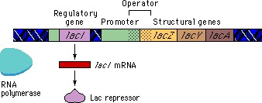
The lacI regulatory gene is called the lacI regulator gene.

Regulatory genes are not necessarily close to the operons they affect.
The general term for the product of a regulatory gene is a regulatory protein.
-The Lac regulatory protein is called a repressor because it keeps RNA polymerase from transcribing the structural genes.
-In the absence of lactose, the Lac repressor protein binds to the operator and keeps RNA polymerase from transcribing the lac genes.

-It would be wasteful for E. coli if the lac genes were expressed when lactose was not present.
The effect of the Lac repressor on the lac genes is referred to as negative regulation.

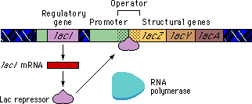

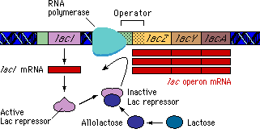A
Lactose binds to an allosteric site on the repressor protein causing a conformational change. As a result of this change, the repressor can no longer bind to the operator region and falls off.
- RNA polymerase can then bind to the promoter and transcribe the lac genes.

NOTE : the Regulator gene can be some distance from the rest of the genes on the chromosome

TATA box
The TATA box (also called Goldberg-Hogness box) is a DNA sequence found in the promoter region of many genes in eukaryotes and archaea.
It is the core promoter sequence, it is the binding site of either transcription factors or histones (the binding of a transcription factor blocks the binding of a histone and vice versa) and is involved in the process of transcription by RNA polymerase.
The TATA box has the core DNA sequence 5'-TATAAA-3'.
Usually located 25 base pairs upstream of the transcription site. The sequence has remained consistent throughout much of the evolutionary process, possibly originating in an ancient eukaryotic organism.
The TATA box is usually found as the binding site of RNA polymerase.

    - When lactose is present, an isomer of lactose, allolactose, will also be present in small amounts. Allolactose binds to the allosteric site and changes the conformation of the repressor protein so that it is no longer capable of binding to the operator
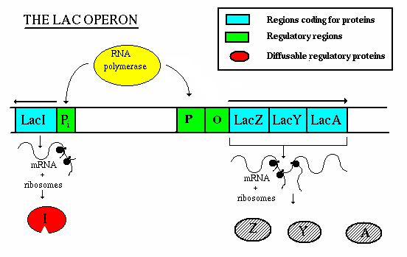

Operation - If lactose is not present:
- the repressor gene produces repressor, which binds to the operator. This blocks the action of RNA polymerase, thereby preventing transcription.
