ADVANCED PLACEMENT BIOLOGY
CLASS SYLLABUS 2015
FREEMAN HIGH SCHOOL

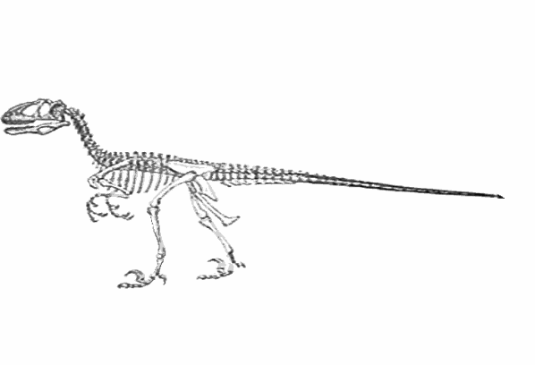ADAPT, MIGRATE, OR DIE! 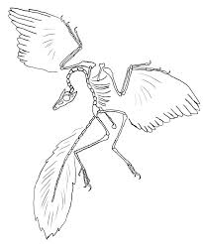

COURSE: A one year advanced placement course taught to secondary
Juniors and Seniors.
PREREQUISITES: One year of Biology and one year of College Prep
Chemistry.
TEXTBOOKS: Campbell : Biology in Focus 2014
Starr Taggart: The Unity and Diversity of Life Tenth
edition 2004

GENERAL COMMENTS:
- An advanced placement Biology course gives outstanding competent students the opportunity to earn college credits while in high school thus saving students both time and money.
- A.P. Programs help students gain admission to the college of his or her choice.
- This course is designed to meet the standards of a first year college Biology course. Course lab work and subject matter will be at the level of a college biology course.
Students enrolled in this course that strive for college credit and an “A”
out of this class should expect to spend a minimum of 12 hours per week study time out of class. Some material that is assigned in the book may not be covered in class but may turn up on the test. So read assigned pages in the text!
- To be successful in a class of this caliber you must stay on top of your
work. Don’t allow yourself to fall behind. If you are in an
extracurricular activity or absent make sure to get your work early or
makeup work.
- I am available to give you help before school from 7:15am - 8:00 every
morning. Please come see me if you need help. Remember the only
dumb question is the one that didn’t get asked.

WHO SHOULD TAKE ADVANCED PLACEMENT BIOLOGY?
Highly motivated Juniors and Seniors in High school that plan on pursuing a career in a science related field. Engineering, medicine, Environmental, Biological, Chemical fields.
WHY TAKE AP CLASSES
- More and more colleges are looking at student rigor in High School to determine admittance into colleges. These classes may help you get in to the college you would like
- More colleges are weighing AP classes higher on a GPA than standard classes
- AP classes help college bound students get ready for the rigor of College level classes
WHY NOT TO TAKE AP CLASSES
- If you are highly concerned about GPA and don’t believe you will be able to receive the grade you would like.
- If you don’t have the foundation from prerequisite classes
- If you are not emotionally or intellectually ready to put in the study necessary
MAJOR TOPICS:
- Molecules and Cells
- Biological Chemistry
- Gel Electrophoresis
- Energy Transformations, : ATP, Chemiosmotic ATP Synthesis
coupled rxns.
- Gene Mapping, DNA fingerprinting, Bacterial and viral transformations
- Genetics and Evolution: Molecular, RNA: transcription, Recombinant DNA
- Meiosis, Mitosis , Alleles, chromosomes
- DNA and RNA, viruses , and retro-viruses
- Origin of life, natural selection, Hardy-Weinberg Principle, allelic frequencies
- Principles of Taxonomy and systematics, Five Kingdom system
- Plants: Classification, Phylogeny, Ontogeny, adaptations, structure, physiology of vascular plants
LABORATORY:
- Lab work is 20-25% of the work in this class. It is very important that you pay
attention to detail and enter all work in the laboratory work book
- You will find that the labs are much more in depth and detailed. It is very
important that you read the lab carefully before class and do the prelab work.

AP BIOLOGY
GRADING POLICY
60%= TESTS, RESEARCH PAPERS, RESEARCH PROJECTS
- Tests consists of multiple choice, T/F, essay, and problem solving.
- Research papers will include a reference page with a minimum of 5 sources no older 5 years. Word processed.

15%= DAILY WORK, HOMEWORK, QUIZZES, LAB REPORTS
- Don’t take this percentage lightly. It has made the difference between a “C” and an “F”
or an “A” and a “B”

25%= LABORATORY WORK: VERY IMPORTANT ASPECT OF THIS
CLASS
- Laboratory work is required to be in the Lab composition book.
For specifics see attached laboratory book sheet

ABSENCES:
People that are in extracurricular activities must have your assignments turned in before you leave for the activity. If you are absent due to sickness or family business, then it is your responsibility to get the makeup work done. Students that are gone a lot from school have a hard time staying on top of things and usually receive lower grades than those students with good attendance practices.

SEATING ASSIGNMENTS:
There will be none unless necessary

CLASS RULES:
The Golden Rule!

STUDENT MISCONCEPTIONS ABOUT AP BIOLOGY:

- Mr Hays doesn’t really mean that 12 hours of study a week are necessary to excel in this class. He is just trying to scare us.
- The tests aren’t as hard as Mr. Hays says. Once again he is just trying to scare us
- I can get an A in this class just by reading through my notes.
- This class is not really as hard as a college biology class. It is just a glorified high school class.
- I don’t really have to do any outside reading for this class to ace the class.
- I can get a 4 or 5 on the AP test by showing up and doing my classwork

