1. Three changes in wave direction:
   1. Reflection b. Refraction c. Diffraction:

**Law of reflection:**

The angle of incidence is equal to the angle of

Reflection

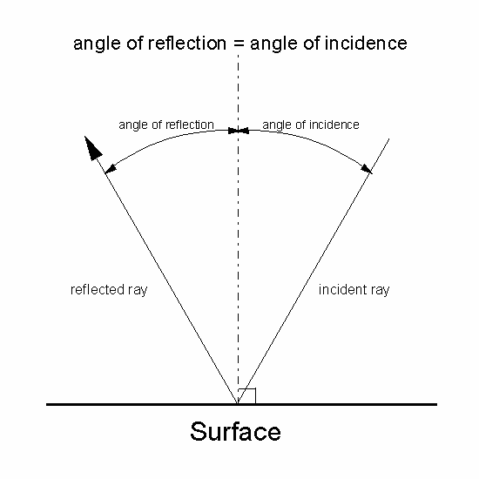

Dashed line is the **normal** to the surface( perpendicular)

The lines on the diagram above represent wave series or pulse and are called **Rays.**

**Total internal Reflection**:

Occurs when light falls on the surface of a less optically dense medium at such an angle that no refracted ray may be produced.

The angle of incidence that allows the refracted ray to lie along the border of the boundary is called the **Critical angle**

() Ic

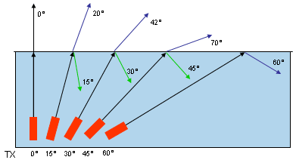

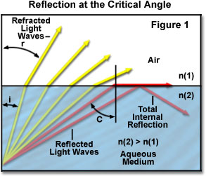

**Refraction:**

The bending of waves when they pass into a new medium . (effects: rainbow, heat waves, puddle effect)

When wave fronts approach a parallel boundary to another medium at an angle other than 90 degrees. The first part of the wave has its velocity change and thus the wave bends due to the change in density of the new medium. ( wave son a beach, optics)

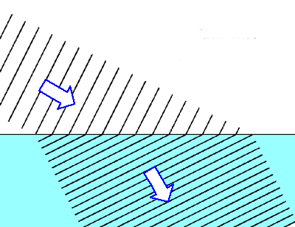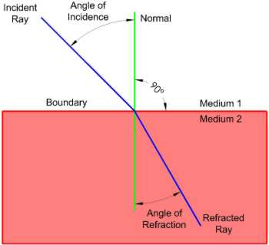

|  |
| --- |
| http://csep10.phys.utk.edu/astr162/lect/light/refraction.gif |
| **Refraction of light** |

Pg 286 8-10 old book

**Diffraction:** The bending of a wave around an obstacle .

( light coming into a dark room from a door slightly

Open, water waves around a rock in the water)

Optical Density: property of the medium that determines the speed of light in the medium. ( more optically dense, the slower the lights velocity)

Light will bend toward the normal if its velocity slows down and away from the normal if the velocity speeds up.

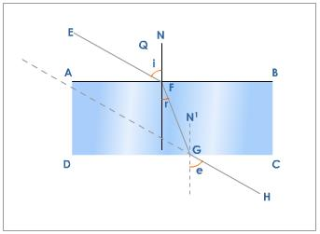

Snell’s Law:

For a given medium a ray of light bends in such a way that the ratio of the sine of the angle of incidenc to the sine of the angle of refraction is a constant. n this is called the index of refraction: each medium has a different index of refraction

n= Sin i for any two media Snell’s law may be

Sin r written as n1Sin I = n2 Sin r

ns = c where c = speed of light in air

vs vs = speed of light in other media

so if the index of refraction is known ns then to find the speed of light in that medium rearrange above equation to

Vs = c Prob 1 pg 282 old

ns Prob 2-6 pg 284 old book

Prob 8-10 pg 286 old book

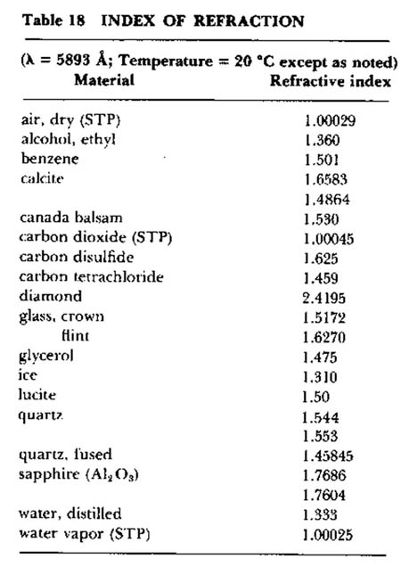

Diffraction

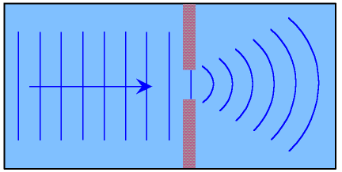

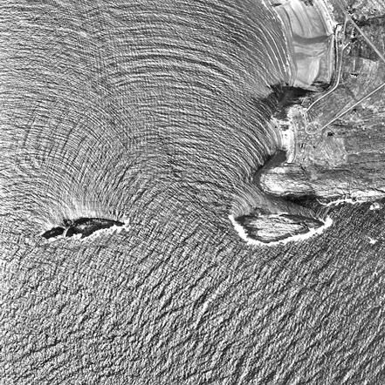

Transmission and absorption of light:

1. Transparent material
   1. Transmit light w/o distorting the rays
2. Translucent material
   1. Transmit light but light rays are distorted

Ex. lamp shades

1. Opaque material :
   1. Substances that don’t transmit light. They either reflect or absorb them.

**Doppler Effect: (Show video)**

A change in the observed frequency of waves when

a wave source and an observer are in relative

motion.

λ is shorter in front of the moving source and

longer behind the moving source.

Ex. sonic boom is caused by the Doppler effect

Ex. Red shift of stars: caused by the Doppler effect

[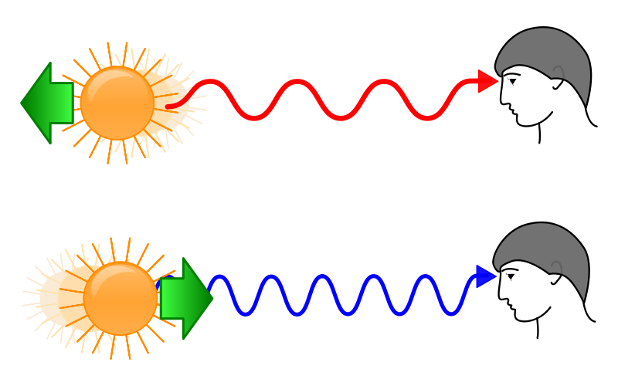](http://upload.wikimedia.org/wikipedia/commons/e/e4/Redshift_blueshift.svg)

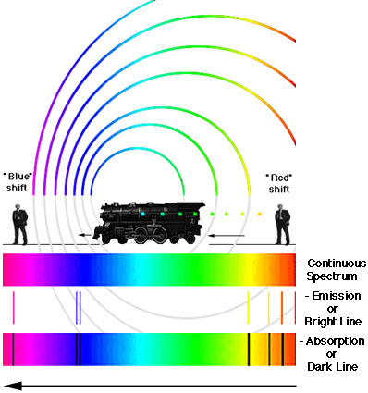

Why do stars appear to change color sometimes?

Has to do with the refraction of light through the atmosphere. Lights are separated out similar to a prizm.

Pg 397 pr 35 , 36, 37,39 Pg 255 old book Q 1-21 Pg 256 pr 1-9