**CHAPTER : ACIDS , BASES AND SALTS**

What is an Acid? What is a Base?

CHARACTERISTICS OF …

ACIDS BASES

1. Sour 1. Bitter
2. Corrode metal 2. Usually contains a metal
3. Contains hydrogen 3. Usually contains hydroxide(OH-)
4. pH below 7 4. pH above 7
5. Form hydronium ions 5. Form hydroxide ions in a

In aqueous soln. (H3O+) aqueous soln. (OH-)

1. Turns litmus paper red 6. Turns litmus paper blue

pH stands for :

Presence of hydrogen it is equal to the negative logarithm of the hydrogen ion concentration.

0-14 scale: for each number change there is a 10X change in acid or base strength

PH = -log[H+]

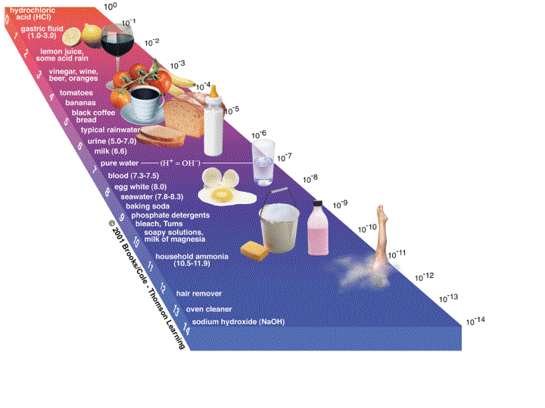

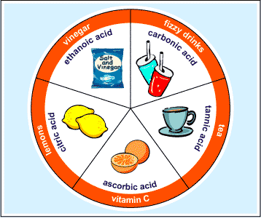

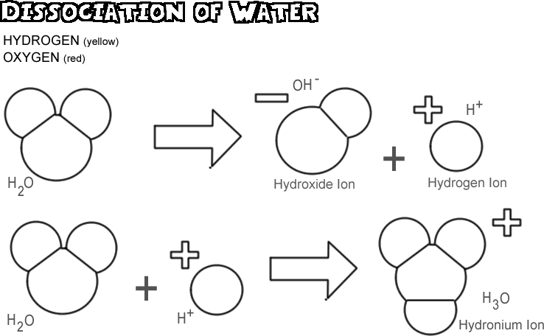

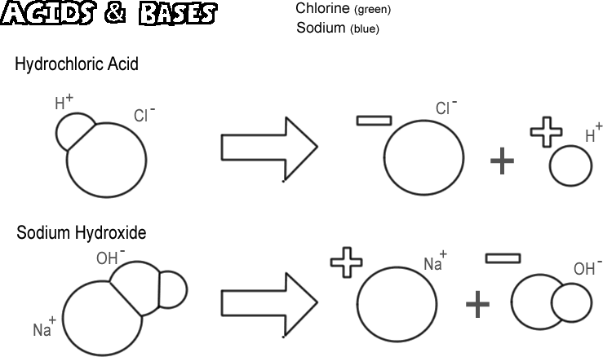

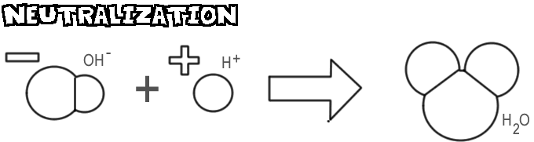

**DEFINITIONS:**

Arrhenius Acid ( follows pH scale 0-14)( pH 7 neutral)

### The Arrhenius definition of an acid is a substanc that when dissolved in water increases the concentration of hydrogen ion, H+*(aq)*. (also known as hydronium (H3O+)

For pure water

H2O + H2O-----🡪 H3O+ + OH-

hydronium hydroxide

So HCl + H2O -----🡪 H3O+ + Cl-

Arrhenius base: ( follows pH scale 0-14)( pH 7 neutral)

A base is a substance that when added to water increases the concentration of hydroxide ion, OH-*(aq*

### NaOH -----🡪 Na+ + OH-

### Sodium hydroxide is a strong base

### http://scienceprofonline.googlepages.com/acidsbasessalts.jpg/acidsbasessalts-full.jpg

### BRONSTED- LOWRY DEFINITION OF ACIDS AND BASES ( Doesn’t follow pH scale )

### Idea: acids and bases don’t always react in a water (aq) solution.

### Acid: Anything that donates a proton (H+ donor)

### HCl + H2O 🡨-------🡪 H3O+ + Cl-

### Base: Anything that accepts a proton

### NH3 + H2O 🡨------🡪 NH4+ + OH-

### Conjugate acid- base pairs

### In B-L definition:

### For any acid found on one side of the equation there is a conjugate base found on the other side.

### NH3 + H2O 🡨------🡪 NH4+ + OH-

### 

### HCl + H2O 🡨-------🡪 H3O+ + Cl-

 WHAT IS PH?

pH stands for the presence of hydrogen ion.

* The greater the concentration of hydrogen ion, the greater the acidity and the lower the pH
* pH scale goes from 0 to 14
* In pure water the hydronium concentration and the hydroxide concentration are equal
* H2O + H2O-----🡪 H3O+ + OH-

hydronium hydroxide

How to Calculate pH

pH = -log [H3O+ ]

H3O+ = hydronium ion = acid ion

OH-  = hydroxide ion = base ion

Prob : What is the pH of a solution that has a

hydronium concentration of 1 x 10-5M ?

What is the pH of a soln with a hydronium

conc. of 1 x 10- 9M?

H2O + H2O-----🡪 H3O+ + OH-

For the dissociation of water , what would the

solubility product constant expression look

like?

Kw = [H3O+] [OH-] this is called the ion product constant

Kw  = 1 x 10-14 ( it is a constant so it always equals this)

So if the two concentrations are equal the

concentrations will each equal 1 x 10-7M.

NEUTRALIZATION REACTIONS:

When an acid and a base react they always form the products a salt and water

Salt: is the product of a neutralization rxn and contains a metal and nonmetal. pH=7

For a monoprotic acid:

HCl + NaOH ------🡪

For a diprotic or triprotic acid

H2SO4 + NaOH ------🡪

H3PO4 + Ba(OH)2 -----🡪

ACID AND BASE ANHYDRIDES:

(Anhydrous : means w/o water)

Molecules that are derived from acids or bases by removing water.

NaOH - H2O -----🡪 Na2O

H2SO4 - H2O ----🡪 SO3-

ACIDS TO KNOW FOR TEST:

HCl

H2CO3

H2SO4

HNO3

H3PO4

**ACID BASE TITRATIONS:**

**Titration** is a laboratory method of quantitative/[chemical analysis](http://en.wikipedia.org/wiki/Analytical_chemistry) used to determine the [concentration](http://en.wikipedia.org/wiki/Concentration) of a substance(acid or base). Because volume measurements are used , it is also known as *volumetric analysis*.

A [reagent](http://en.wikipedia.org/wiki/Reagent), called the *titrant*, of known concentration is used to find the unknown.

Titrations often use [visual](http://en.wikipedia.org/wiki/Visual) indicators (the reactant mixture changes color).

In simple [acid-base titrations](http://en.wikipedia.org/wiki/Acid-base_titration) a pH indicator is used, [phenolphthalein](http://en.wikipedia.org/wiki/Phenolphthalein), which becomes pink @ slightly over pH 7 when a certain pH is reached or exceeded.

Indicators:

Base: Phenolphthalein, Litmus(blue), pH hydrion

Anthocyanin: blue/green

Acid: Litmus ( red) , pH hydrion paper

Anthocyanin: red

Calculating unknown concentrations with titration

techniques:

Question: An unknown concentration of acid is

titrated with a .2M concentration of NaOH.

The volume of the base used was 40ml and it

took 20ml of the unknown acid to neutralize the

base.

What is the concentration of the unknown?

Equivalence point: Point at which ….

Moles of acid = Moles of base

na = nb

(M X V)a = (M x V)b

Keep in mind that volume will be measured in Liters so……

M=n/L

(M X V)a = (M x V)b

( n/L X L )a = ( n/L x L )b

na = nb