**ORGANIC CHEMISTRY:**

Carbon compound:

Any substance that is made up of a carbon chain skeleton is an organic compound.

̃90% of all known compounds are organic ( carbon compounds.

“organic” means compound containing carbon chains.

**The study of the chemistry of carbon is called…**

“Organic Chemistry”

Carbon molecules are found in….?

Oil, coal, petroleum, sugar, nylon, plastic, diamond, wood cellulose, fabric , cotton, all living matter, alcohol, gasoline.

Hydrocarbons:

Compounds tha contain only carbon and

Hydrogen.

ALKANE SERIES: This names carbon chains by the number of carbons present.

**Table: Structural Formulas of the First Ten Continuous-chain Alkanes**

|  |  |  |  |
| --- | --- | --- | --- |
| Name | Molecular Formula |  |  |
| Methane | CH4 |  |  |
| Ethane | C2H6 |  |  |
| Propane | C3H8 |  |  |
| Butane | C4H10 |  |  |
| [Pentane](http://www.3rd1000.com/chem301/pentane.htm) | C5H12 |  |  |
| [Hexane](http://www.3rd1000.com/chem301/hexane.htm) | C6H14 |  |  |
| [Heptane](http://www.3rd1000.com/chem301/heptane.htm) | C7H16 |  |  |
| [Octane](http://www.3rd1000.com/chem301/octane.htm) | C8H18 |  |  |
| [Nonane](http://www.3rd1000.com/chem301/nonane.htm) | C9H20 |  |  |
| [Decane](http://www.3rd1000.com/chem301/decane.htm) | C10H22 |  |  |

TYPES OF FORMULAE:

1. Molecular formula:

Shows how many atoms of each element are present. Ethane C2H6

1. Empirical formula

Shows the smallest whole number ratio of atoms of each element present.

For ethane (empirical formula ) CH3

Note: for all alkanes this would be the empirical formula

1. Structural formula:

Shows how each atom in the molecule is bonded together.

H H

H---C---C---H Structural formula for

H H Ethane

* Important: Carbon has 4e- in outer shell so it will always form 4 bonds ( covalent always)
* The most stable form of carbon is one in which it is bonded to 4 other atoms

H

CH4 methane H---C---H

H

Saturated vs. Unsaturated Hydrocarbons

**Saturated** = single bonded

Saturated molecules end in the suffix -ane

Unsaturated = double or triple bonds somewhere in the chain

Unsaturated end in

For double - ene

For triple - yne

Lets look at an exciting example shall we?

C—C Ethane (Saturated)

C==C Ethene

(Unsaturated)

C C Ethyne

ISOMERS :

Molecules that have the same molecular formula but different structural formulae.

C4H10  molecular formula

How many different structural formulae can

you draw from this?

**NAMING HYDROCARBONS**

All organic compounds are named according to their longest chain.

The atoms in the carbon chain are designated by numbers.

1. The carbon atoms in the longest chain are numbered according to where the branch is
2. Branches end in –yl
3. The name of the longest branch comes last
4. If it is unsaturated the number precedes the name . ( Bond location takes precedent)
5. Functional groups take precedent over hydrocarbon branches.

6.   Use prefixes for more than 1 substitution group  
7.   Use alphabetical order for morethan 1 type of substitution group

Substitution groups ( aka : Functional groups)

Elements other than hydrogen and carbon that give an organic compound different chemical properties.

Common Functional Groups you always wanted to know!

* NH2 Amine (found in amino acids
* OH Alcohol ( found in alcohols) ..what a surprise!
* C==O (R-COOH) Carboxylic acid group

OH ( found in amino acids)

* Cl Chloro group
* F Fluoro group ( found in Teflon)

F F F F F F

Teflon R—C—C – C – C – C – C –R

F F F F F F

PTFE

**Precedent Rules for naming organics**. ( THE FINAL WORD!)

1. Double and triple bonds take precedent over everything
2. Functional groups take precedent over hydrocarbon branches
3. Longer branches take precedent over shorter branches

CFC’s chlorofluorocarbons

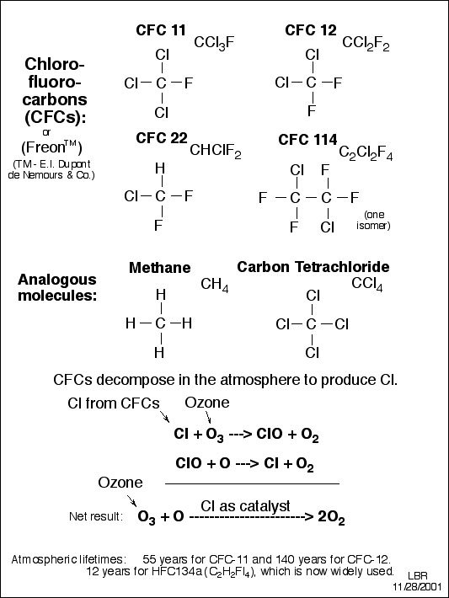

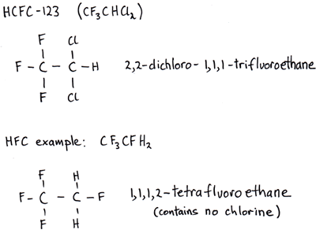

POLYMERS: Very large molecules that repeat the basic structure over and over again ( functional unit is called a monomer)

Monomer: Smallest functional unit of a polymer

Ex. Amino acid monomer for proteins

F F

—C—C –– Teflon functional unit

F F

POLYMERIZATION: Is the process in which monomers are put together to form a polymer .

ORGANIC COMPOUNDS IN LIVING SYSTEMS:

(4 Groups) , , CHONPS

1. Carbohydrates CHO,
2. Lipids CHO
3. Nucleic Acids CHONP
4. Proteins CHONS
5. **Carbohydrates ( ef. CH2O ) sugar like**

Use: High energy molecules broken down to produce energy for living systems

Saccharides: sugars (monomer of carbs)

1. Monosaccharide: one sugar

Glucose: C6H12O6 blood sugar

1. Polysaccharides : many sugars

Molecules attached together repeating over and over

-sugar-sugar-sugar-sugar-sugar-

1. Starches:

Very large polymers of sugars

1000’s of polysaccharides

The starch found in animals is glycogen.

Energy monosacc polysacc Starch Fat

1. **LIPIDS (Fats and oils) CHO**

Function: 1.energy storage,

2. insulation,

3.Electrical impulse speed

**Functional groups** : Carboxylic acid group

-COOH

Fats are solid @ room temp.

Come from animals

Oils are liquid @ room temp.

Come from plants

LIPIDS are nonpolar ( hydrophilic )

Fats: Triglycerides are made of two type of

molecules:

1. Fatty acid:
   1. Saturated vs unsaturated fatty acids
   2. 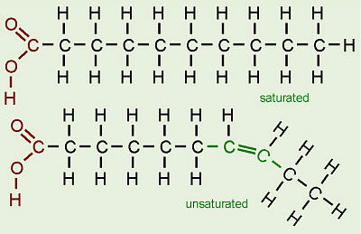
2. Glycerol

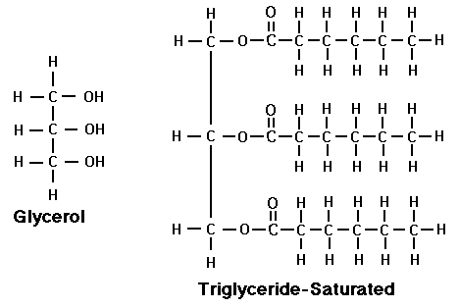

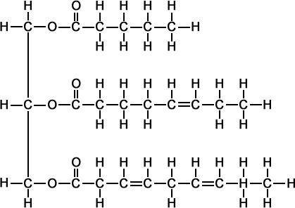

Unsaturated triglyceride

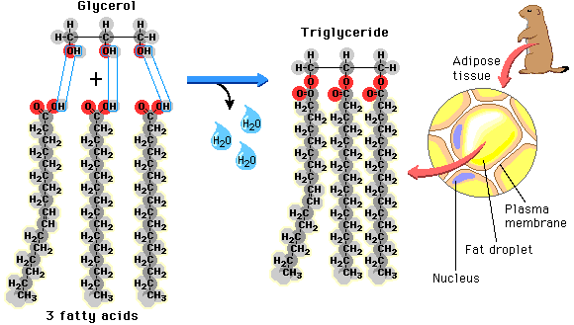

1. **NUCLEIC ACIDS: (CHONP)**
2. DNA, RNA, ATP
3. USE: information storage for making proteins.
   1. Make up chromosomes
   2. DNA-🡪 RNA🡪 Proteins

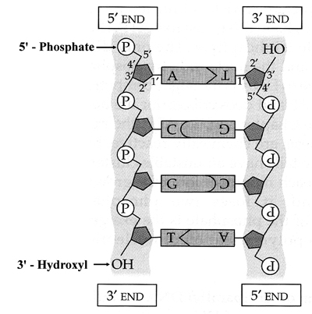

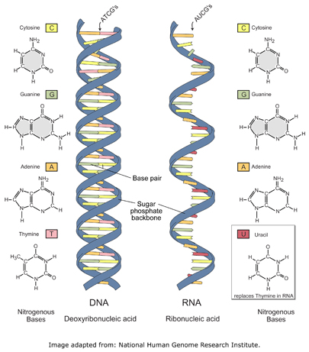

1. **PROTEINS (CHONS)**

Function:

* 1. Structural unit of the body
  2. Enzymes are proteins that act as

biological catalysts. Speeding up

reactions, repairing things and

decomposing things.

* 1. Monomer: amino acid ( 20 different)

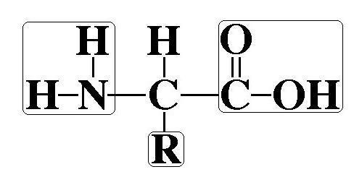

Amine group Carboxyl group

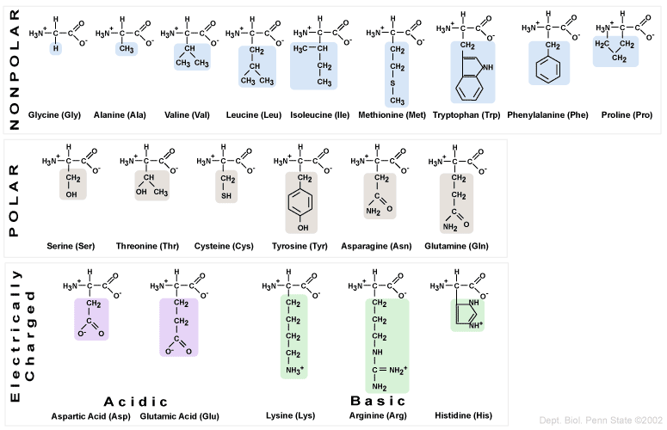

Enzymes : are proteins that act as catalysts .

Enzymes as catalysts act to lower the activation energy of a reaction

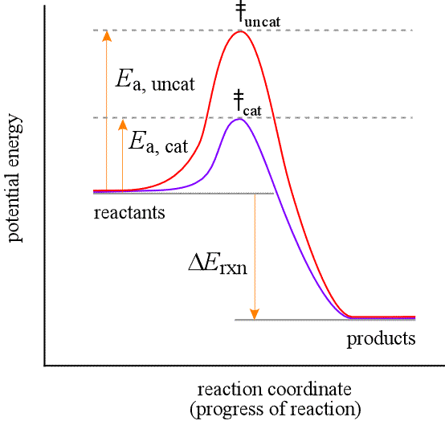

Protein bonding and structure

Proteins have four levels of structure

1. Primary
2. Secondary
3. Tertiary
4. Quaternary

PROTEINS

-Proteins make up more than 50% dry weight of

animals and bacteria.

-(Hair, fingernails are made of fibrous protein:

collagen)Collagen is the most abundant protein by

mass in animals.

-Hemoglobin is an oxygen carrying protein

- The most numerous class of proteins are the

enzymes. ( end in –ase)

Enzymes: speed up chemical reactions

Amino acids are attached by Covalent bonds called

Peptide bonds : formed during the condensation rxn.

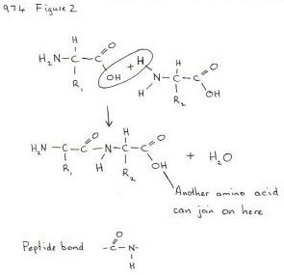

Dipeptide :

2 amino acids

Polypeptide:

Long string

100-300 amino acids

Protein:

Def: a functional unit composed of one or more

polypeptide chains.

**PROTEIN STRUCTURE**

Proteins are long unbranched chains of Amino acids

There are four levels of protein structure

1.primary structure

2.secondary structure

3.tertiary structure

4. quaternary structure

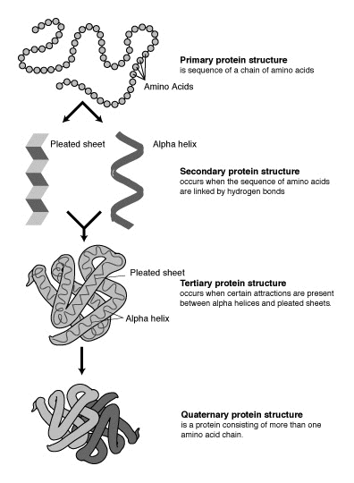

1.Primary Structure: is the sequence of amino acids in the polypeptide chain ( help by peptide bonds)

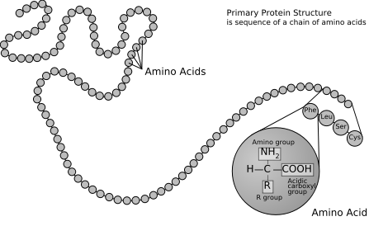

2.Secondary structure: (hydrogen bonding)

Is the localized structure caused by hydrogen

bonding across a polypeptide chain.

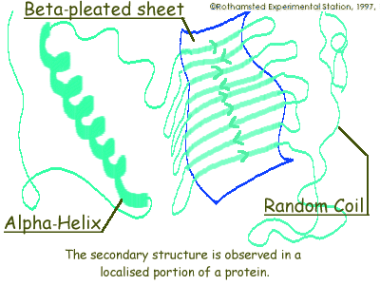

#### Secondary Structure of a Protein or Polypeptide

#### http://fig.cox.miami.edu/~cmallery/255/255prot/ecb4x10b.jpg

3.Tertiary Structure of a protein

4 Interactions effects these

1. Ionic bonds
2. Hydrogen bonds
3. Disulfide bonds
4. Hydrophobic interactions

Nonpolar sections are pushed together by

Water

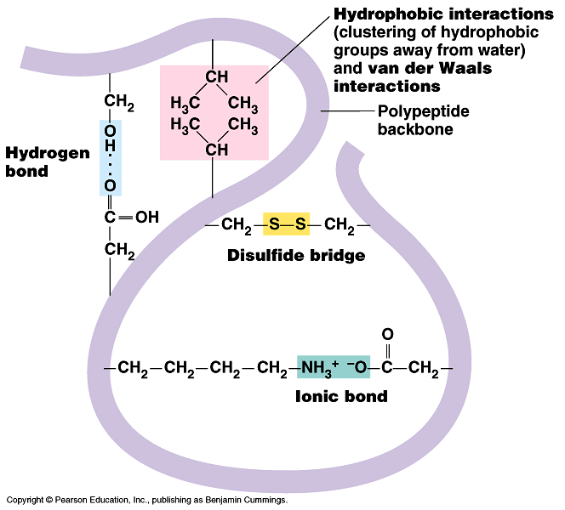

4.Quaternary structure: defined by the way the polypeptides fit together(fig 3-19 pg 47)

When polypeptides lose their shape their function and structure are destroyed and they are said to be **Denatured : (**caused by heat or chemicals )

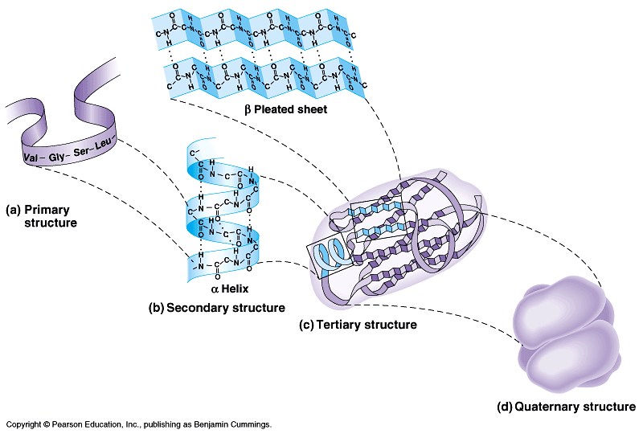

ENZYMES:

All enzymes are proteins

1. Proteins act as biological catalysts.. that is they speed up chem. Rxns. (lower activation energy)

* Substrates:

The reactants in an enzyme-catalyzed rxn are called substrates

* Enzymes are named according to their substrates and the rxns they catalyze.

Ex. RNA polymerase , Sucrase, Lipase

-Over 2000 known enzymes

-Some carry out condensation + hydrolysis rxns

**FACTORS EFFECTING ENZYME ACTIVITY:**

1. Concentration of substrate present
2. Inhibitors:

Decrease an enzymes rxn rate.

* 1. Some bind to active site ( competition)
  2. Some disrupt enzymes 3 dimens. Structure and destroy its function.

1. Temperature: (denatures the protein if too high)

Generally temperatures above 60o denature enzymes.

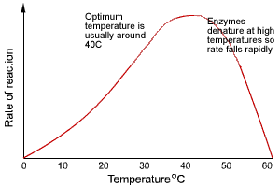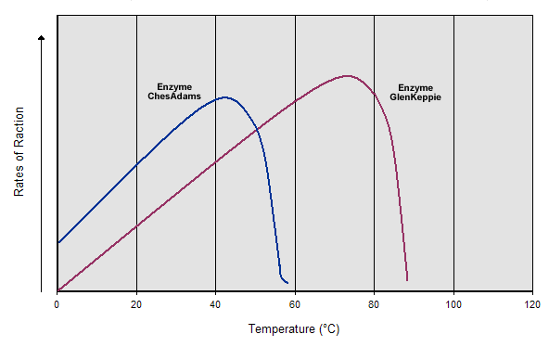

1. pH: pH acids change the shape of the enzymes 3 dimensional structure because H+ ion changes overall charge of the molecule and disrupts ionic and hydrogen bonding interactions. (optimum pH for living systems?)

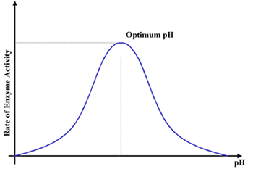

**Pg 51 ALLOSTERIC ENZYMES (ALLOSTERIC INTERACTIONS)**

Allosteric Enzymes:

Enzymes that can exist in two or more different shapes

-Allosteric enzymes have

1. Active site

2. Regulatory site

When molecules bind to the regulatory site, it

alters the enzymes shape and therefore its activity.

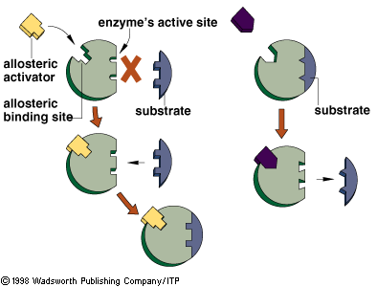

**ALLOSTERIC INHIBITORS:**

Molecules that when bound to the regulatory site cause a change in the active site so it doesn’t function anymore.

**Stimulatory molecules:** when attached to the R.S. correct the

shape of the active site and let the rxn occur.

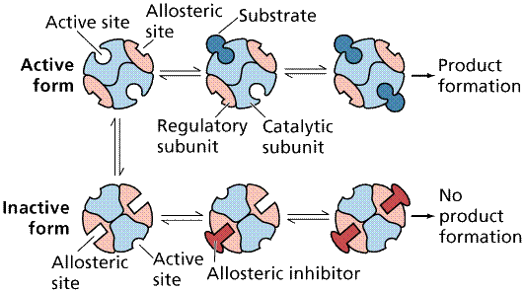

Allosteric feedback loop: ( negative feedback loop)

Often the beginning enzyme is allosteric and the final

substrate product is the inhibitor for the regulatory site

on the allosteric enzyme.

Enzyme 1 ---🡪 product 1C------🡪 Product 2C--🡪 Product 3c----

Enzyme 2 Enzyme 3

Allosteric inhibitor

🡪 Product 4c------🡪 Product 5C ---🡪 Product 6C (glucose)

Enzyme 4 Enzyme 5

Glucose becomes the allosteric inhibitor for enzyme 1

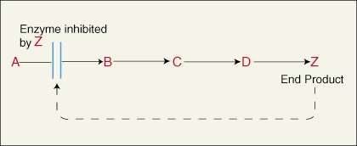

|  |  |
| --- | --- |
| *SIMPLE PROTEINS: on hydrolysis include only amino acids:             1.* [*Albumins*](http://www.worthington-biochem.com/BSANF/default.html) *- soluble in water (distilled),*  *most enzymes              2.* [*Globulins*](http://en.wikipedia.org/wiki/Globulin) *- soluble in dilute aqueous solutions;              3.* [*Protamines*](http://en.wikipedia.org/wiki/Protamine) *- not based upon solubility; small*  *MW proteins with 80% Arginine & no*  *Cysteine               4.* [*Histones*](http://www.worthington-biochem.com/H/cat.html) *- unique/structural: complexed w*  *DNA,  high # basic aa's - 90% Arg, Lys, or*  *His             5.*[*Collagen*](http://www.worthington-biochem.com/CL/cat.html) *= high Glycine, Proline, & no Cysteine*  *when boiled makes gelatin* [*Keratins*](http://en.wikipedia.org/wiki/Keratin) *- proteins of skin & hair high*  *basic aa's (Arg, His, Lys), but w Cys*  *Complex Proteins:      on hydrolysis yield amino acids + other*  *molecules* |  |
| ***lipoproteins*** *-   (+ lipids)                  blood, membrane, &   transport proteins* |
| ***glycoproteins -****(+ carbohydrates)                  antibodies, cell surface proteins* |
| ***nucleoproteins -****(+ nucleic acids)                  ribosomes & organelles* |

FUNCTIONAL GROUPS TO KNOW

R- OH ALCOHOL GROUP

R- NH2 AMINE GROUP

R- C=O R-COOH CARBOXYL GROUP

|

OH

C—C –C ISOPROPANOL

|

OH

3 MAIN KINDS OF CHEMICAL BONDS:

1. Covalent: nonpolar ( ex peptide bonds)
2. Ionic: polar
3. Hydrogen: polar

Weak bond between two atoms w/ opposite partial electric charges

Polar vs Nonpolar organics:

Hydrogen bonding : weak bonds between two partially electrically charged molecules: usually occurs between

Oxygen, sulfur, nitrogen, or phosphorus in organic molecules:

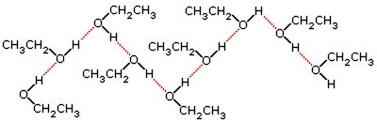

PROPERTIES OF WATER: WHAT MAKES WATER SO UNIQUE??

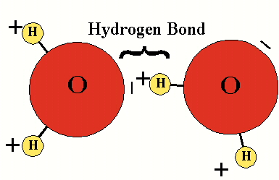

Water 18g/n Density = 1g/ml

Hydrogen and oxygens are bonded by covalent bonds

Water is a Dipole. It is polar

Because of this water has certain properties that allow life to exist on earth.

70% of the body is H2O

30% interstitial

40% in cells

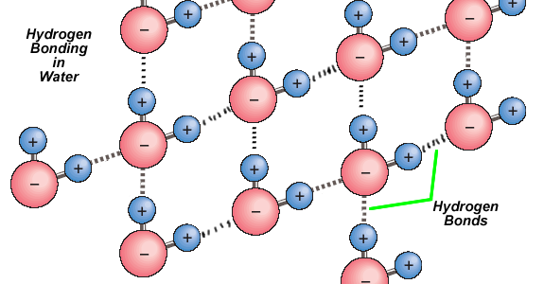

PROPERTIES OF WATER:

1. COHESION:
   1. Due to hydrogen bonds causes surface tension

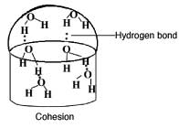

1. ADHESION:
   1. Attachment to different substances

