**The Endocrine system**

Learning goals : I can describe the functions of the endocrine system

I can describe how the endocrine system works with other systems to maintain homeostasis

**The Endocrine System** : controls many body processes by means of chemicals. ( Chemical messengers)

1. Hormones
2. Local messengers: Histamines
3. Pheromones
4. Second messengers:
   1. cAMP ( signal transduction)
   2. Ca+2  ( nerve impulse: action potential , muscle contraction

I. Functions:

1. **System produces chemicals that control many of the bodies daily processes** 
   1. Made of up of glands. A gland is an organ that produces or releases a chemical.
   2. Unlike sweat glands, glands of the endocrine system do not have delivery tubes.
   3. Produce and release the chemical messengers **directly into the bloodstream** .
2. Hormones: Chemical messengers produced by the E.S. that turn on, turn off, speed up , or slow down activities in different organs and tissues.
   1. Hormones are carried by the bloodstream
   2. Hormones can regulate activities in cells, tissues, or organs that are not close to the glands that produce them
3. The E.S. regulate long term changes such as growth and development

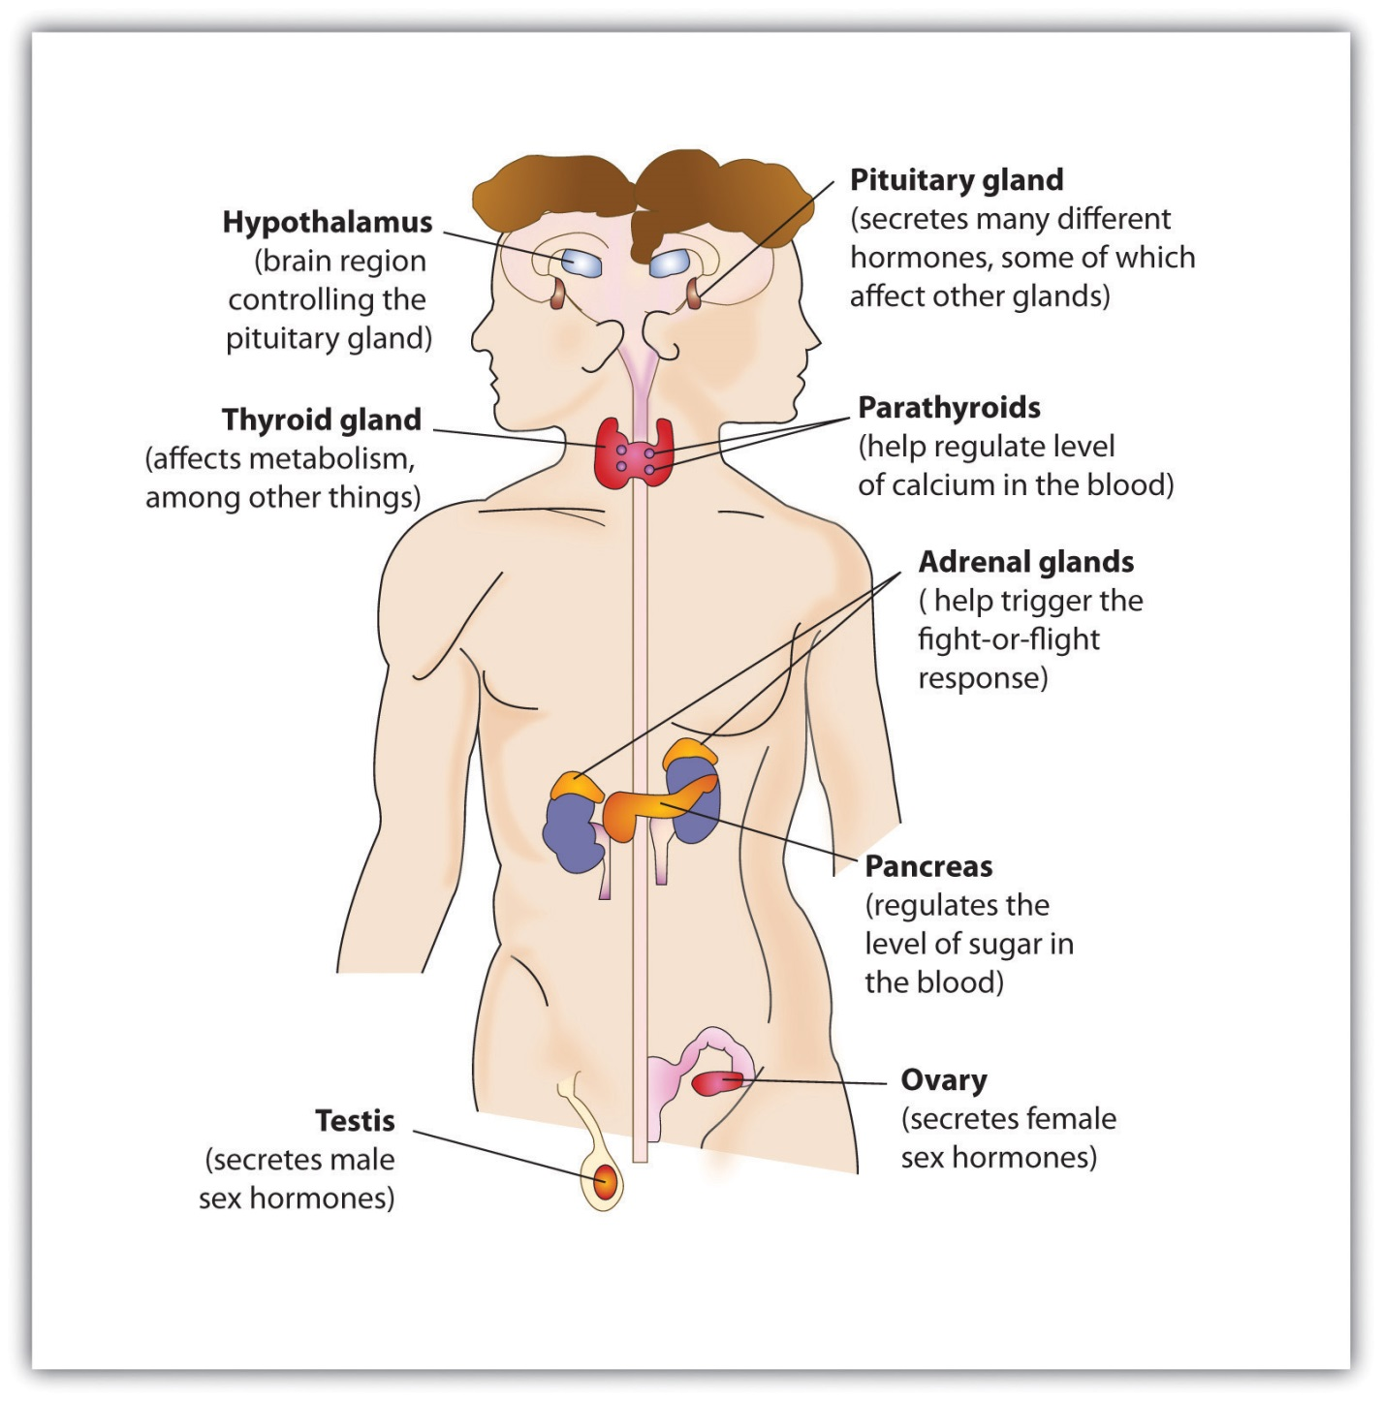

II. System interactions: body systems respond to the chemical

messenger

* 1. **Circulatory system:**

E.S. releases hormones into the blood and the blood transports them throughout the body.

* 1. **Nervous system:**

E.S. has many hormones produced in the Pituitary gland in the brain and in the thalamus both parts of the brain but also parts of the endocrine system

1. body receives an external stimulus

2. brain receives message and responds by sending a signal to produce hormones in one of a variety of organs:

**Pituitary:**

HGH

Vasopressin ( Anti-diuretic hormone)

Oxytocin

Follicle stimulating hormone

**hypothalamus:** regulates body temp: major role in maintaining homeostasis in the body

**adrenal gland**: epinephrine

**pancreas :** insulin/glucagon

**Thyroid gland:** calcitonin

**Ovaries:** estrogen

**Testes:** testosterone

* 1. Skeletal system
     1. Stores minerals until the body needs them
        1. Key mineral is calcium Ca. Parathyroid gland helps regulate the amount of Calcium ion in the blood/bones.
        2. Calcium aids in blood clotting, muscle contraction and nerve impulse( actionpotentials
  2. Excretory system

The Endocrine system regulates the amount of water loss and conservation through hormones that cause vasoconstriction and vasodialation

(vasopressin)