Algebra 1 Syllabus 2023-24

Mrs. Frye

**e-mail:** [afrye@freemansd.org](mailto:afrye@freemansd.org) / [afrye@goscotties.com](mailto:afrye@goscotties.com) **school phone #:** 291-3721 X 208

Welcome to Algebra 1! Algebra is the part of math where letters and other symbols are used to represent numbers and quantities in formulas and equations. There are many different reasons why you need to learn Algebra, but there are three that I particularly like: it speeds up the problem-solving process, it is a building block to more advanced mathematics that open doors to more advanced career options, and it can help us understand the math done by professionals that we will come in contact with throughout our lives (Demme, 2014). It will not be easy, but with hard work and perseverance, I will help you be successful this year.

**Units**

1. Algebra Basics 5. Systems of Equations and Inequalities

2. Equations and Inequalities 6. Exponents and Exponential Functions

3. Functions 7. Polynomials and Factoring

4. Linear Functions 8. Quadratic Functions

**Course Structure**

According to [LinkedIn](https://www.linkedin.com/pulse/5-skills-employers-look-entry-level-employees-parker-pell) the top five skills employers look for are leadership, communication, problem solving, work ethic, and teamwork? We will develop each of these through our class structure:

* Most days we will be working in small groups at whiteboards around the room. After we debrief the problem(s) as a class, time will be given for students to write notes that are meaningful to them.
* Students will be asked to explain their thinking or reasoning (verbally or written) to enhance their communications skills.
* In order to promote problem solving skills and teamwork, I may not directly answer every student question. However, this does not mean students won’t be supported. For instance, I will often provide a question or suggestion to help a group move forward or to provide an extension to students that are ready for more. Students will also be encouraged to use their resources.
* Check your understanding problems will be provided on a regular basis as an opportunity for students to check their understanding of material covered during class lessons. It is highly recommended that students complete these, check their answers on the provided key and follow up with the teacher or a peer if needing help.
* A growth mindset where students are encouraged to think and take ownership of their learning will be fostered.

Mathematics is as much about attitude and willingness to try as it is about ability. Success is a function of persistence and a willingness to work hard for something. – Malcolm Gladwell

**What does a Mathematician Do?**

|  |  |  |  |
| --- | --- | --- | --- |
| Engages in problem solving | Communicates their ideas | Takes risks | Creates |
| Perseveres | Makes mistakes | Illustrates | Looks for connections |

**Grades**

The focus of this class is learning. For this reason, I will not be grading daily work/practice. Instead, these are opportunities for you to experiment, try, and make mistakes without fear that your grades will go down. This also provides time for you to really learn material prior to an assessment. Assessments will include the following:

* **Quizzes (20%):** Quizzes will be given weekly throughout each unit to determine your level of comprehension on course material. Feedback will be provided on all quizzes. You will have the opportunity to learn from this feedback and retake any section of a quiz before the unit test.
* **Unit Tests (65%):** On unit tests you will have an opportunity to show what you have learned and know at that given point in time. If you do not do well on any part of the test, you can do retakes after completing a correction assignment which is available **only if** all of your section check your understanding assignments are completed.
* **Projects (15%):** Individual and/or partner/small group projects will be assigned each unit.

Assessments will be scored as follows:

* Quiz grades will go into Skyward as a section score out of 10.
* Unit test grades will go into Skyward as an overall average section score out of 100.

**High School Grading Scale:**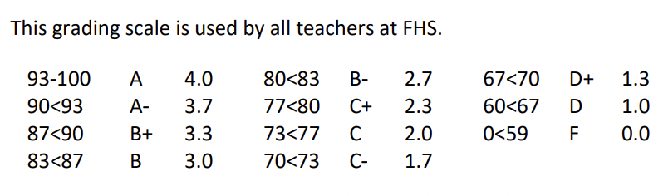

**Tutoring**

Students desiring extra practice or assistance should schedule a time to meet with the teacher either before school, during Scottie time, or after school.

**Classroom Expectations**

**M**ath class is for math – put away all things that could distract you from doing your best in this class such as cell phones and homework for other classes.

**A**ccept responsibility for your choices. You are free to choose, but you are not free of the consequences that result from your choices.

**T**reat everyone the way you want to be treated. You will be respected if you give respect first.

**H**ave an open mind. If you work hard and believe that you can be successful in this class, then you will be successful.

**Make-Up Work**

It is **your** responsibility to make up all work missed as a result of being absent. When you return, you will need to check the unit calendar and Google Classroom for what you missed. If you are absent for an assessment, you should plan on taking it within two days of returning to school, either before school or after school. If you choose not to make up an assessment, you will forfeit that grade and it will be inserted as an F into Skyward. Any make-ups for a unit need to be completed before the end of the unit.

**Cheating and Plagiarism**

Under no circumstances will cheating be tolerated. Cheating on an assessment (exam, test, quiz, project, etc.) will result in an automatic zero in the grade book. If two (or more) identical assignments or assessments are turned in, both students will receive a zero. Any student talking or being disruptive while there are tests out will automatically receive a **ZERO** on the test and a **REFERRAL**. Please show respect. Any student found using an electronic device other than a calculator without prior approval will also receive a **ZERO** on the test and a **REFERRAL**.