UNIT 7 PHYSICS

WAVES AND ENERGY TRANSFER

What is a wave?

A rhythmic disturbance that carries energy.

1. Wavelength ( λ ):

The distance between identical points on two waves

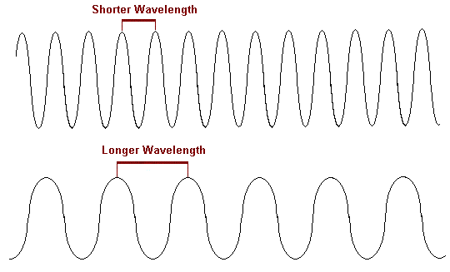

1. Amplitude:

How much energy a wave carries

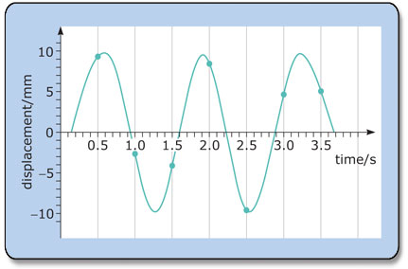

1. Frequency ( *f* )

The number of waves that pass a point in a given time. (usually measured in hertz hz waves/second)

1. Speed : V = ( λ) *f*
2. TYPES OF WAVES
3. Mechanical Waves:

Waves that need a medium to pass through.

Ex. Water, sound, springs, rope

1. Electromagnetic waves: ( all travel @ 3.0 X 108m/s)

Waves composed of alternating electric and magnetic currents.

(need no medium to pass through )

Ex. Light , electric, radio, uv, ir

WAVES MAY BE CLASSIFIED INTO TWO TYPES BY THEIR MOTION.

1. Transverse : causes particles of a medium to vibrate perpendicular to the direction of the wave.

Ex. Water waves

1. Longitudinal waves: causes the particles of the medium to vibrate in a parallel direction to the wave motion. ( springs) ( sound waves) - compression of air

**Pulse**: is a single disturbance traveling through a

medium.

PERIOD OF A WAVE:

The time required for one pulse to pass a given point.

The frequency of a wave determines its period ( along w/

the λ and speed of the wave)

T= 1

*f*

Ex. If the frequency of a wave is 10Hz , what is the period of the wave series?

NOTE: period of a wave is the reciprocal of its frequency

WAVE SPEED IN A MEDIUM

1. For mechanical waves: the denser the medium the faster the wave moves.
2. For EM waves:

The more dense medium the slower the wave (light)

BEHAVIOR OF WAVES AT BOUNDARIES

REFLECTION OF WAVES

* Waves goes to a more rigid medium it is reflected inverted or out of phase
* Waves goes to a less rigid medium it is reflected erect or in phase.

TRANSMISSION OF WAVES

* When a wave passes into a new medium its speed changes .

Frequency remains the same ( never changes) so the λ is adusted to keep the same frequency.

* The denser the medium the slower the velocity of EMR
* The denser the medium the faster the velocity of mechanical .

INTERFERENCE OF WAVES:

Waves can interfere constructively or destructively

1. Constructive interference:

Occurs when two pulses combine to produce a pulse of greater amplitude.

Once the two have passed they continue on w/ their original energy unchanged

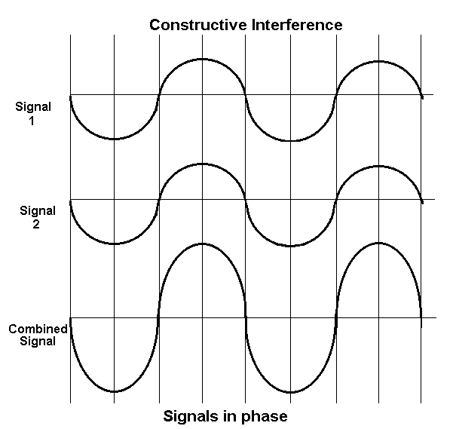

Destructive interference:

When two pulses out of phase w/ one another

decrease eachothers amplitude as they pass. Once again the waves are unchanged after passing one another.

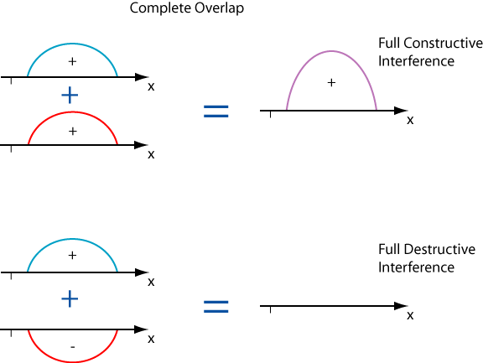

Node:

A point in a medium that never undergoes displacement as two equal but opposite waves interfere.

Standing Waves:

Caused by two series of waves interfering w/ eachother

constructively and destructively.

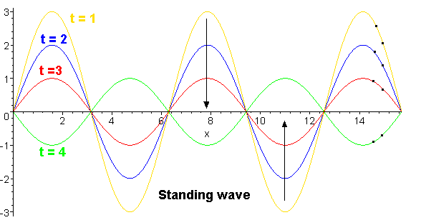

**The Law of Reflection:**

States that the angle of incidence is always equal to the

angle of reflection.

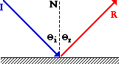

**Refraction:**

When a wave front approaches a boundary to

another medium at an angle , the wave fronts

direction is changed.

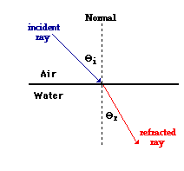

**Index of Refraction**:

Is a measure of how much the speed of light or sound

slows down when it enters a new media.

|  |  |  |  |
| --- | --- | --- | --- |
| Vacuum | 1.00000 | Fused quartz | 1.46 |
| Air at STP | 1.00029 | Glycerine | 1.473 |
| Ice | 1.31 | Sugar solution (80%) | 1.49 |
| Water at 20 C | 1.33 | Typical crown glass | 1.52 |
| Acetone | 1.36 | Crown glasses | 1.52-1.62 |
| Ethyl alcohol | 1.36 | Spectacle crown, C-1 | 1.523 |
| Sugar solution(30%) | 1.38 | Sodium chloride | 1.54 |
| Fluorite | 1.433 | Polystyrene | 1.55-1.59 |
| Sapphire | 1.77 |  |  |
| Diamond | 2.417 |  |  |
| Flint glasses | 1.57-1.75 |  |  |
| Heavy flint glass | 1.65 |  |  |
|  |  |  |  |

Snell’s Law: The index of refraction of a medium is equal to the ratio of the angle of incidence and the angle of refraction

**Diffraction:**

Is the bending of waves around obstacles place in

their path.

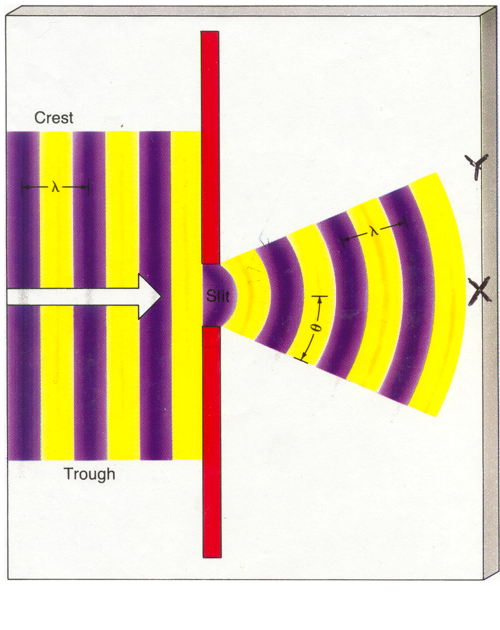

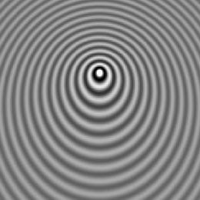

DOPPLER SHIFT : ( EFFECT);

The change in the observed frequency of a wave

when a source and an observer are in relative

motion to one another.

Ex. Stars : red shift siren passing a stationary person

The λ in front of an object moving toward you is

shorter .

The λ behind the object is longer.

**Light** is electromagnetic waves that are able to stimulate

the human eye. ( it is electromagnetic waves

are made up of both an electric and magnetic

vector)

ELECTROMAGNETIC SPECTRUM

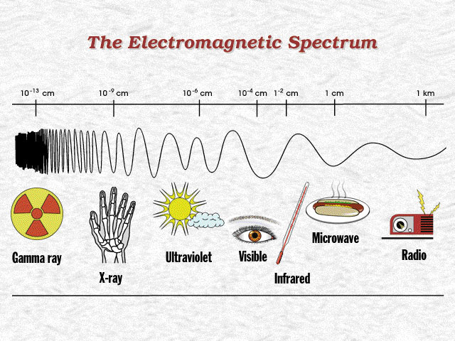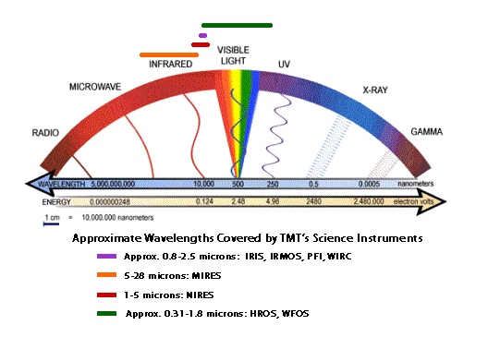

LIGHT ;

Electromagnetic radiation that can stimulate the retina of

the human eye. ( λ 3.8 x 10-7m to 7.6 x 10-7m)

LUMINOUS VS. ILLUMINATED :

LUMINOUS BODY: A body that emits light waves.

( sun, stars, Jupiter, light bulbs)

ILLUMINATED BODY: Body that reflects light.(moon)

**TRANSMISSION AND ABSORPTION OF LIGHT:**

1. Transparent Materials:

* Transmit light without distorting the rays
  + (Objects may be seen clearly through glass, quartz, air)

1. Transluscent Materials:

* Transmits light but distorts the rays during transmission.

Ex. Lampshades , colored glass, most light bulbs

1. Opaque Materials:

* Objects that either reflect or absorb light but don’t transmit light .

Speed of light = 3 x 108 m/s in a vacuum.

Illumination by a point source:

What is illuminance?

The rate at which light energy falls on a unit area some

distance from the light source.

E = __I__ Equation for illuminance E = lux

d2

I = Luminous intensity measured in candelas.

( used to be a candle)

D is the distance the light source is from the object it is

illuminating.

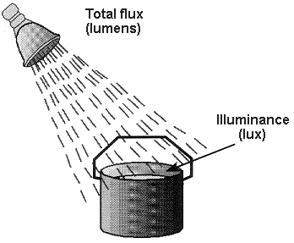

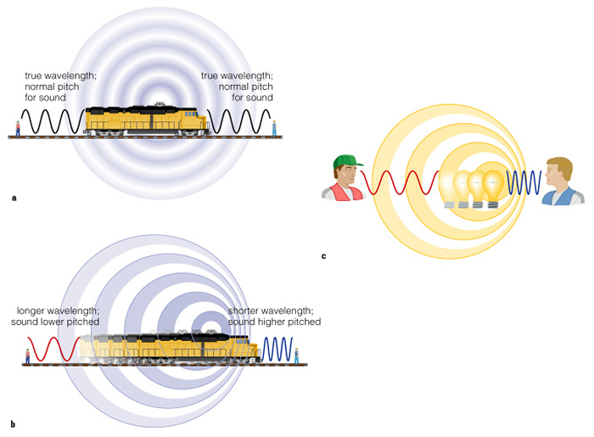

Sonic Boom:

The jet as it reaches the speed of sound the waves

compress in front of it until it is one giant wave of

sound

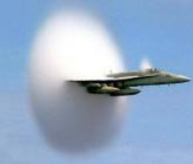 This fighter jet has just accelerated past the speed of sound. The sudden decompression of the air causes water droplets to condense, forming a cloud.

**COLOR AND LIGHT**

Color is a property of light . ( electromagnetic spectrum)

Light is defined as λ of the electromagnetic spectrum

Violet light waves are the shortest

Red light has the longest λ.

Why does a red shirt appear black @ night?

What color would a green shirt be if only red λ were shone upon it?

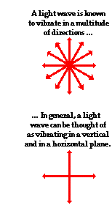

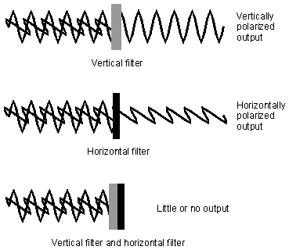

**Polarization of light:** Light can be resolved into two planes.

Vertical and horizontal.

Light waves that reflect off of water and glass generally become polarized in the horizontal plane causing glare. Using a sunglass with vertical diffraction grating it only allows rays oriented in the perpendicular plane through eliminating the glare. ( eliminates approx. 50% of the light)

Note: Reflected light is also polarized .

Polarization supports the wave theory.

NEWTON’S PARTICLE THEORY OF LIGHT

Sir Isaac Newton in 1704 proposed his treatise “ Opticks”

He waited for Robert Hooke to die so he wouldn’t be criticized by him. The three main components of his theory were

1. Light is made up of little particles.
2. They obey the same laws of physics as other masses

like baseballs and planets.

1. They are tiny so the particles in two intersecting

beams do not scatter off each other.

IS LIGHT WAVE OR PARTICLE

Particle Theory Wave Theory

1. Law of Reflection 1. Law of Reflection
2. Photo-electric effect 2. Diffraction
3. Newton’s Opticks 3. Polarization: plane
4. Quantum theory 1905

The Photoelectric Effect:

When light falls on a metal surface electrons are ejected

from the surface of the metal. This ejection of electrons is

known as the Photo-electric effect.

The electrons are ejected w/ increasing K.E. as the frequency of light increases. This suggests that light energy is not distributed evenly . Possibly light is packaged into small bundles of energy. ( called photons) .

Light has both Wave and Particle properties.

**Quantum Theory : 1905 Einstein**

-Proposed that light is emitted from a source in

discrete packages of energy called photons.

-Each photon is related to a light wave of specific frequency

-Energy of a photon is proportional to its wave frequency in

accordance with the following equation

Max Planck at about the same time as Einstein came up with the following equation

E = h *f*  h= 6.6 X 10-34J/Hz

E = energy in Joules

*f* = frequency

Assignment : Pg 274

Questions: 1- 16

Problem: 1- 15