Lymphocytes are one of the five kinds of **white blood cells** or **leukocytes**), circulating in the blood.

5 TYPES OF LEUKOCYTES :

* five kinds of **white blood cells** (**WBC**s) or **leukocytes**
  + - [**neutrophils**](http://users.rcn.com/jkimball.ma.ultranet/BiologyPages/B/Blood.html#neutrophils): Phagocytic
    - (go out of blood and into infected tissues)
    - [**eosinophils**](http://users.rcn.com/jkimball.ma.ultranet/BiologyPages/B/Blood.html#eosinophils) : related to inflammation
    - [**basophils**](http://users.rcn.com/jkimball.ma.ultranet/BiologyPages/B/Blood.html#basophils)**:** release histamine (mast cells related)
    - [**lymphocytes**](http://users.rcn.com/jkimball.ma.ultranet/BiologyPages/B/Blood.html#lymphocytes)**:** B and T
    - [**monocytes**](http://users.rcn.com/jkimball.ma.ultranet/BiologyPages/B/Blood.html#monocytes)**: phagocytic ( engulf foreign s.)**
* [**B lymphocytes**](http://users.rcn.com/jkimball.ma.ultranet/BiologyPages/B/B_and_Tcells.html) ("B cells"). These are responsible for making antibodies.
* **T lymphocytes** ("T cells"). There are several subsets of these:
  + [**inflammatory T cells**](http://users.rcn.com/jkimball.ma.ultranet/BiologyPages/B/B_and_Tcells.html#cd4) **(Pyrogens)** that recruit macrophages and neutrophils to the site of infection or other tissue damage
  + [**cytotoxic T lymphocytes**](http://users.rcn.com/jkimball.ma.ultranet/BiologyPages/H/HLA.html#cd8) (CTLs) that kill virus-infected and, perhaps, tumor cells
  + [**helper T cells**](http://users.rcn.com/jkimball.ma.ultranet/BiologyPages/A/AntigenPresentation.html#bcr) that enhance the production of antibodies by B cells

Lymphocytes, are extraordinarily diverse in their functions.

**B lymphocytes** (often simply called **B cells**) and

B cells are not only produced in the **bone marrow** but also mature there

**T lymphocytes** (likewise called **T cells**).

.

However, the precursors of T cells leave the bone marrow and mature in the **thymus**

Each B cell and T cell is [**specific**](http://users.rcn.com/jkimball.ma.ultranet/BiologyPages/S/S.html#specific) for a particular [**antigen**](http://users.rcn.com/jkimball.ma.ultranet/BiologyPages/A/AntigenPresentation.html). What this means is that each is able to **bind to** a particular molecular structure.

The specificity of binding resides in a **receptor** for antigen:

* the B cell receptor (**BCR**) for antigen and
* the T cell receptor (**TCR**) respectively.

Both BCRs and TCRs **share** these properties:

* They are [membrane](http://users.rcn.com/jkimball.ma.ultranet/BiologyPages/P/Proteins.html#integral) proteins.
* They are present in thousands of identical copies exposed at the cell surface.
* They are made before the cell ever encounters an antigen.

ERYTHROCYTES (RBCS) HAVE NO ROLE IN IMMUNITY RECOGNITION

EPO: Erythropoetin produced by the kidneys is a major promoter of RBC production (cyclists tested for EPO)

CELLULAR RESPONSE BY T-LYMPHOCYTES

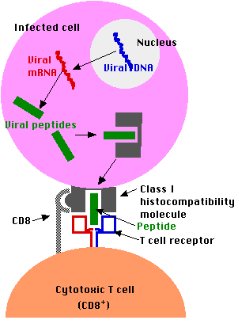The best understood T cells are **cytotoxic T lymphocytes** (**CTL**s). They secrete molecules that destroy the cell to which they have bound.

Except while in transit from their old homes to their new, the viruses work inside of your cells safe from antibodies that might be present in blood, and lymph.

But early in the process, infected cells display fragments of the viral proteins in their surface class I molecules. CTLs specific for that antigen bind to the infected cell and often will be able to destroy it before it can release a fresh crop of viruses.

In general, the role of the T cells is to monitor all the cells of the body, ready to destroy any that express foreign antigen fragments in their class I molecules.

LYMPHOCYTE AMONG ERYTHROCYTES

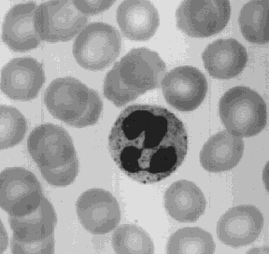

HUMORAL IMMUNE RESPONSE ( B LYMPHOCYTES)

**Humoral Immunity**

B-cells are responsible for humoral immunity. They arise from a separate population of stem cells of the bone marrow than that which gives rise to T-cells and don’t differentiate and mature in the thymus like T-cells.

1. SPECIFICITY:

B-cells, like T-cells, have surface receptors that recognize a specific antigen, but do not themselves interact to neutralize or destroy the antigen.

2. RECOGNITION:

On recognition of the antigen they take up residence in secondary lymphoid tissue and proliferate to form daughter lymphocytes, processed in the same way as themselves. These B-cells then develop into short-lived plasma cells. (clones by mitosis)   
The plasma cells produce antibodies and release them into the circulation at the lymph nodes and blood.

3. Memory

Some of the activated B-cells do not become plasma cells instead they turn into memory cells which continue to produce small amounts of the antibody long after the infection has been overcome.

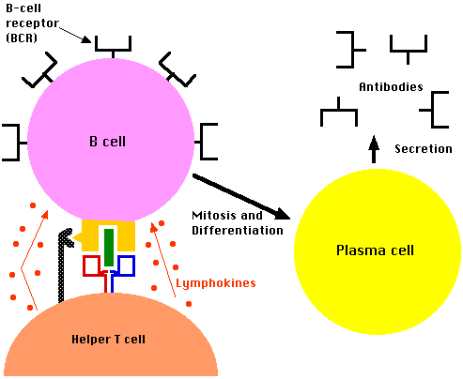

There are 5 classes of antibodies.

Each is called an **immunoglobulin** and then allocated a code letter.

They are normally written as IgA with the Ig standing for immunoglobulin.

IgA stands for immunoglobulin A.

IgG 75% of antibodies in blood – binds neutrophils for phagocytosing of cell.

[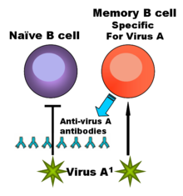](http://en.wikipedia.org/wiki/Image:Original_antigenic_sin.png)

[http://en.wikipedia.org/skins-1.5/common/images/magnify-clip.png](http://en.wikipedia.org/wiki/Image:Original_antigenic_sin.png)

The cells of the immune system that make antibodies to invading pathogens like viruses. They form memory cells that remember the same pathogen for faster antibody production in future infections.

**B cells** are [lymphocytes](http://en.wikipedia.org/wiki/Lymphocyte) that play a large role in the [humoral immune response](http://en.wikipedia.org/wiki/Humoral_immunity) (as

[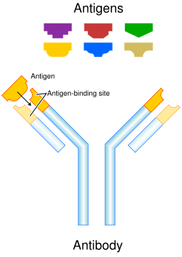](http://en.wikipedia.org/wiki/Image:Antibody.svg)

[http://en.wikipedia.org/skins-1.5/common/images/magnify-clip.png](http://en.wikipedia.org/wiki/Image:Antibody.svg)

Each antibody binds to a specific antigen; an interaction similar to a lock and key.

**Antibodies** (also known as **immunoglobulins**) are [proteins](http://en.wikipedia.org/wiki/Protein)

